Ivan Saric (L) - Maxime Vachier-Lagrave (R)
(2015 Tata Steel, Rd 7):
White plays 1.Rd2? giving Black a spectacular mate in 4.
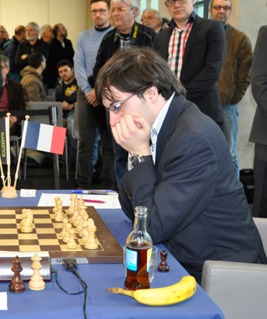
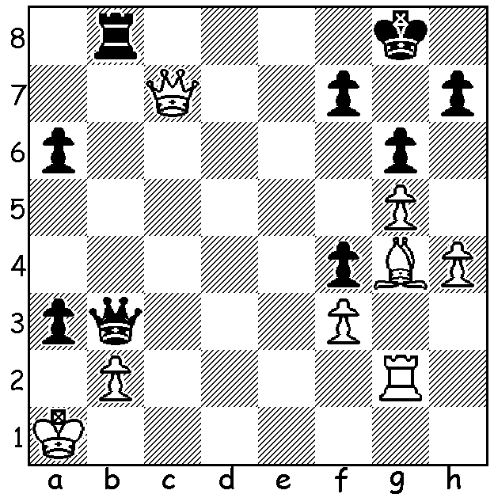
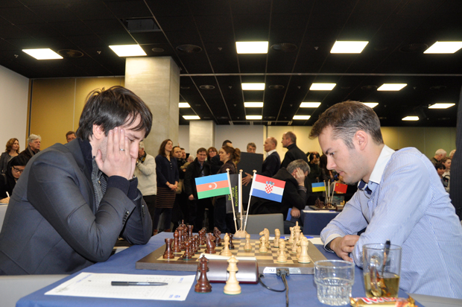

The 77th Tata Steel (14 player) held at Wijk aan Zee, Netherlands, 15-31 January, was won by world champion Magnus Carlsen with 9/11 followed by Maxime Vachier-Lagrave (France), Anish Giri (Netherlands), Wesley So (US) and Liren Ding (China) all 8.5, Vassily Ivanchuk (Ukraine) 7.5, World number 2 Fabiano Caruana (Italy) 7. Ivanchuk, the oldest player at 45, had a pleasing return to form and led for the first 6 rounds. In the Challengers winner was 15 year old Wei Yi (China) with 10.5/13 ensuring him entry to the main event next year. Here is Carlsen’s impressive Round 9 game, his sixth win in a row:
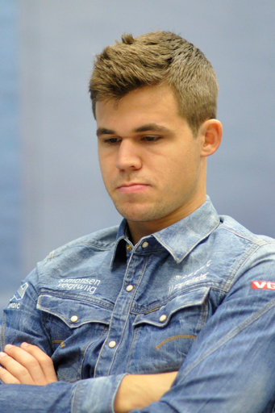
Magnus Carlsen - Teimour Radjabov
2015 Tata Steel, Rd 9
Ruy Lopez, Berlin Defence
1.e4 e5 2.Nf3 Nc6
3.Bb5 Nf6 4.d3(a) Bc5
5.0-0 d6 6.Nbd2 0-0
7.Bxc6 bxc6 8.h3 h6
9.Re1 Re8 10.Nf1 a5(b)
11.Ng3 Rb8 12.b3 Bb4
13.Bd2 Ra8 14.c3 Bc5
15.d4 Bb6 16.dxe dxe
17.c4 Nh7 18.Qe2 Nf8 Magnus Carlsen
19.Be3 c5(c) 20.Rad1 Qf6
21.Nh5 Qe7 22.Nh2 Kh7
23.Qf3 f6 24.Ng4 Bxg4
25.Qxg4 Red8(d) 26.Qf5+! Kh8(e)
27.f4 Rxd1 28.Rxd1 exf
29.Bxf4 Qe6 30.Rd3 Re8
31.Nxg7! Kxg7 32.Qh5!(f) Nh7
33.Bxh6+ Kh8 34.Qg6 Qg8
35.Bg7+!(g) Qxg7 36.Qxe8+ Qf8
37.Qe6 Qh6 38.e5 Qc1+
39.Kh2 Qf4+ 40.Rg3 resigns

Teimour Radjabov
a) With White so often failing to gain an advantage in the main line 4.0-0 Nxe4 5.d4 Nd6 6.Bxc6 dxc6 7.dxe Nf5 8.Qxd8+ Kxd8 and other dynamic variations White players are increasingly playing this quiet line.
b) 10…d5 is a good alternative.
c) A voluntary entombment of his bishop which Black hopes will be only temporary.
d) Carlsen asserted Black had to play 25…g6.
e) If 26…g6 27.Qxf6.
f) Preventing a king escape to the queenside.
g) The point of the combination which started on move 31.

The new Southern Suburbs club based at Leeming Primary, Meharry Rd, opens on Tues 3 Feb and will hold an Open Championship starting on 17 Feb. If you are living south of the river you would be assured of a welcome and even if you are a member of another club please consider entering the Open to help the club get off the ground.

The first WA Grand Prix and Australian Grand Prix event, the Perth Open, will be played at Leeming Primary on Sat 14 and Sun 15 Feb (10.30 – 6.00 both days). Information for both events cawa.org.au and enquiries andrewhardegen@iinet.net.au

SOLUTION: 1.Rd2 axb+ 2.Kb1 Qa2+!! (deflection) White resigns (3.Kxa2 b1=Q+ 4.Ka3 Qb3#). White had to play 1.Qc1 when Black would have to be satisfied with a draw by perpetual.

