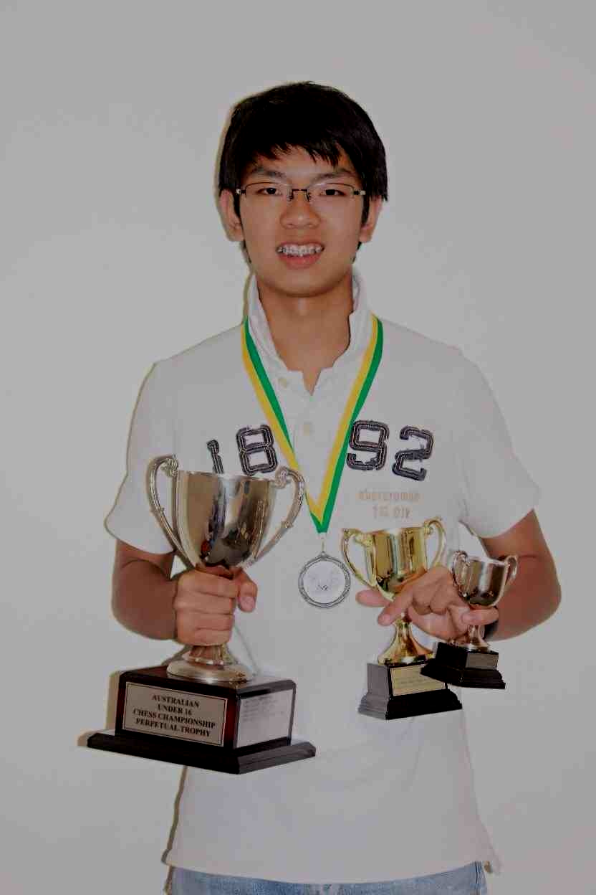
Below one of the problems from the 2015 Australian
Junior Problem Solving Competition won by WA’s
Patrick Gong who also won the Australian Under 16
Championship: White to play and draw:

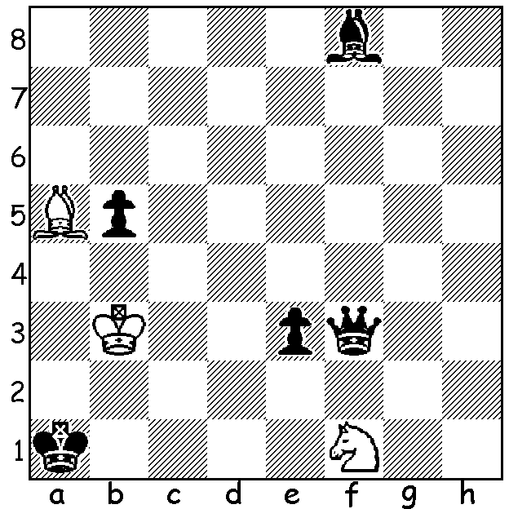

Last week we reported on the 77th Tata Steel tournaments in Wijk aan Zee, Netherlands, where the main event was won by world champion Magnus Carlsen with 9/13. Mention was also made of the Challengers winner, 15 year old Wei Yi (China), with 10.5/13, who is assured of entry to the main event next year. Here is one of his impressive wins:
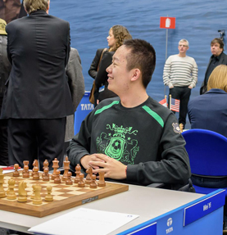
WEI YI - ANNE HAAST
2015 Tata Steel Challengers, Rd 12
Sicilian Defence, Taimanov Variation
1.e4 c5 2.Nf3 e6
3.d4 cxd 4.Nxd4 Nc6
5.Nc3 Qc7 6.Be3 a6
7.Qf3 Ne5 8.Qg3 h5
9.0-0-0 h4 10.Qh3 b5
11.f4 Nc4 12.bxc4 Qxc4
13.f5 Bb7 14.Rhf1 e5
15.Nb3 Qc7 16.Kb1 Rc8
17.f6! Nxf6 18.Rxf6!(a) gxf6
19.Bb6! Qc6 20.Na5! Qe6

21.Nxb7 Rb8(b) 22.Nd5!!(c) Rxb7
23.Qc3 Qc6 24.Nxf6+ Ke7
25.Bd8+! Ke6(d) 26.Qh3#

This ‘Destroying the Guard’ sacrifice is immediately followed
by two deflection sacrifice offers to threaten d7.
b) If 21…Qxh3 22.gxh3 Rb8 23.Nd6+ Bxd6 24.Rxd6 wins.
c) What brilliance! If 22….Qxh3 23.Nc7+ Ke7 24.Bc5+ d6
25.Rxd6!! (25…Qxg2/Rxb7 26.Rd5# or 25…Qe6 26.Rd5+
Qd6 27.Rxd6!)
d) 25…Kxd8 26.Qxc6.

Earlier Wei Yi had to take some of his own attacking medicine against Australian teenager 16 year old Ari Dale when he managed to hold on to draw:

ARI DALE - WEI YI
Tata Steel Challengers, Rd 3
Nimzoindian Defence, Rubinstein Variation
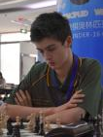
1.d4 Nf6 2.c4 e6
3.Nc3 Bb4 4.e3 0-0
5.Bd3 d5 6.Nf3 b6
7.0-0 Bb7 8.cxd exd
9.Ne5 Bd6 10.Nb5 Be7
11.f4 c5 12.Nc3 Nc6
13.Qf3 Re8 14.g4 cxd
15.g5 dxc3 16.gxf6 Bxf6
17.Bxh7+! Kf8(a) 18.bxc3 g6
19.Ba3+ Kg7 20.Nxf7 Kxf7
21.Qg4 Ne7 22.f5! g5
23.Qh5+ Kg7 24.Rf3 Rh8
25.Rh3 Rc8 26.Qh6+ Kf7
27.Bg6+ Kg8 28.Bh7+ Kf7
29.Bg6+ Kg8 30.Bh7+ Kf7
DRAW

a) If 17…Kxh7 18.Qh5+ Kg8 19.Qxf7+ Draw

The new Southern Suburbs club based at Leeming Primary, Meharry Rd, will hold an Open Championship starting on 17 Feb. If you are living south of the river you would be assured of a welcome and even if you are a member of another club please consider entering the Open to help the club get off the ground.

The first WA Grand Prix and Australian Grand Prix event, the Perth Open, will be played at Leeming Primary tomorrow, Sat 14 and Sun 15 Feb (10.30 – 6.00 both days). Information for both events cawa.org.au and enquiries andrewhardegen@iinet.net.au

SOLUTION: 1.Bc3+ Kb1 2.Nd2+! draw (2…exd2 Stalemate or 2….Kc1 3.Nxf3).

