
The Perth Open, played last weekend with 28 players,
was won by Patrick Gong (5/6), who earlier this year
won the Australian Under 16 Championship and the
Australian Junior Problem Solving Competition.
Below is another of the problems from the competition:
White to play and win:

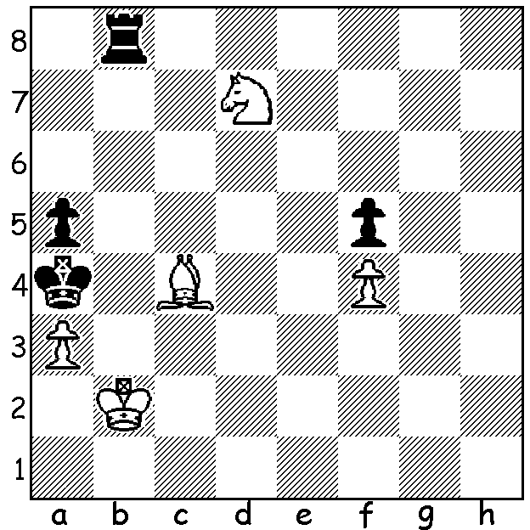

The recently completed Gibraltar Open, with a field of 257 players that included Veselin Topalov, many times Russian champion Peter Svidler and recent Tata Challengers winner 15 year old Wei Yi (China), was won by Hikaru Nakamura (US). Nakamura won his first five games and went through undefeated with 8.5/11 to take out the $20,000 first prize. Second was David Howell (UK) with 8 followed by eight players on 7.5 including Women’s World Champion Hou Yifan (China). Such a large Swiss tournament gave Nakamura the opportunity to indulge in obscure opening lines he would be unlikely to essay against the world’s best:
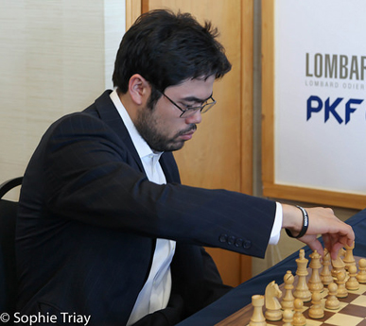
Baskaran Adhiban - Hikaru Nakamura
2015 Gibraltar Open, Rd 5
Queens Gambit Accepted
1.d4 d5 2.c4 dxc
3.e4 b5 4.a4 c6
5.Nc3 a6(a) 6.axb cxb
7.Nxb5 axb5 8.Rxa8 Bb7
9.Ra1 e6 10.Ne2(b) Bxe4
11.b3 Nc6 12.Nc3 Bb4
13.Bd2 Bxc3 14.Bxc3 b4 Nakamura at Gibraltar
15.d5! bxc3 16.dxc6 Qxd1+
17.Kxd1 cxb 18.c7 Kd7 19.Ra3 b2
20.c8=Q+ Kxc8 21.Rxc3+ Kd7 22.Bd3 b1=Q
23.Bxb1 Bxb1(c)

a) Black plays a line most schoolchildren would have been taught to avoid as Black either loses his extra pawn and has the inferior pawn structure or loses the exchange.
b) White refrains from slowing his development with 10.f3 but allows Black to re-establish material equality.
c) With two pieces for the rook Black has a winning advantage, only needing to develop his remaining kingside pieces: 24.Rb3 Be4 25.Rb8 g5 26.Ke2 Ke7 27.h4 gxh 28.Rxh4 Bc6 29.Rc4 Be8 30.Rc7+ Kd6 31.Ra7 Ne7 32.Rd8+ Ke5 33.Rb7 Kf6 34.Rdb8 Ng6 35.Rb6 h5 36.f3 Ba4 37.Rxh8 Nxh8 & White resigns after 42 moves.

Nakamura was even more provocative in the following game, breaking the maxim not to bring out one’s queen and have it chased around the board resulting in backward development:

Jovana Vojanovic – Hikaru Nakamura
2015 Gibraltar Open, Rd 1
Dutch Defence: 2.Bg5
1.d4 f5 2.Bg5 c6
3.e3 Qb6 4.Nd2 Qxb2(a)
5.Rb1 Qc3 6.g4 Qa5
7.gxf Qxf5 8.h4 Qa5(b)
9.Nh3 g6 10.Bd3 d6
11.Qf3 Nd7 12.h5 Ndf6
13.hxg hxg 14.Bxg6+ Kd8
15.Bf4 Kc7 16.Ng5 Rxh1
17.Qxh1 Bh6 18.Qh4 Bd7
19.Bd3 Nd5 20.Ne6+ Bxe6
21.Bxh6 Nc3 22.Rc1 Qb4
23.Kf1 Nxa2 24.Rd1 Nc3(c)

a) Is this a poisoned pawn?
b) Six successive queen moves and no other pieces developed.
c) With the more secure king and the passed a pawn Black had no trouble winning from here.

SOLUTION: White must be careful not to allow stalemate (1.Nxb8 stalemate). 1.Ka2 allows 1…Rb2+! (2.Kxb2 stalemate or 2.Ka1 Kxa3). So the deflection sacrifice 1.Bb5+!! Rxb5+ (1…Kxb5 2.Nxb8) 2.Ka2 when Black’s rook is trapped (2…Rb7/b3 3.Nc5+ or 2…Rd5 3.Nb6+).

