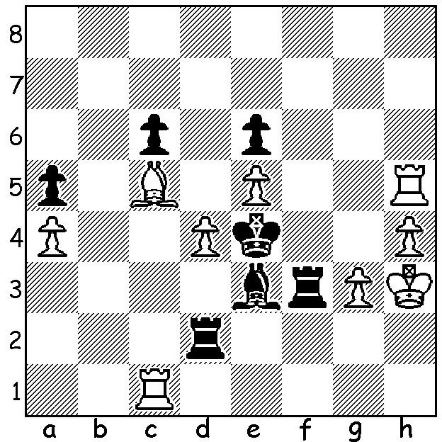

Sergey Karjakin – Vladimir Kramnik
(2015 Zurich Challenge, Rapidplay):
Black to play:

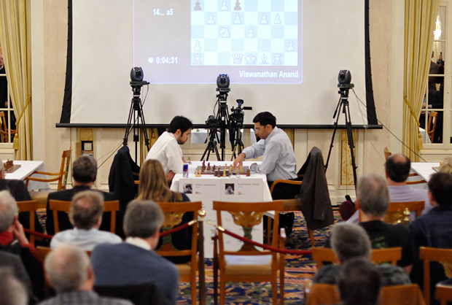
Last week we reported Hikaru Nakamura’s win at
the 257 player Gibraltar Open. He followed this up
with first place in the exclusive Zurich Challenge
where six of the world’s best competed in Blitz,
Classic and Rapidplay events. The Blitz (which did
not count towards final score) was won by Levon
Aronian (4/5), the Classic section (2 pts a win) by
ex-world champion Viswanathan Anand with 7/10 followed by Nakamura (6) and the Rapidplay by another former world champion Vladimir Kramnik (3.5/5) closely followed by Aronian and Nakamura (3). Final combined scores had Anand and Nakamura level on 9/15 followed by Kramnik (8.5), Aronian (7), Sergey Karjakin (6) & Fabiano Caruana (5.5). The event concluded with Nakamura comfortably winning the Armageddon Blitz play-off game (see picture).

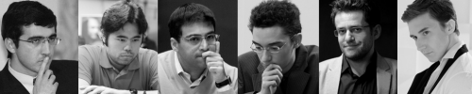

The players at Zurich. Can you name them?

Our game from the event features an example of the delightfully imaginative play of
Armenian Levon Aronian:

Sergey Karjakin - Levon Aronian
2015 Zurich Challenge (Rapidplay)
Kings Indian Attack
1.Nf3 d5 2.g3 Nf6 3.Bg2 e6
4.0-0 Be7 5.d3 0-0 6.Nbd2 Nc6
7.e4 dxe 8.dxe e5 9.c3 a5
10.Qc2 Be6 11.Ng5 Bd7 12.Rd1 Ng4
13.Ngf3 Bc5 14.Rf1 Qc8 15.a4 h6
16.Nc4 Be6 17.Qe2 b6 18.b3 Re8
19.Nh4 Nf6 20.Kh1 Qa6 21.Nf5 Bxf5 22.exf5 e4 23.f3 e3!(a) 24.f4 Ne7
25.Bxa8 Qxa8+ 26.Qg2 Ned5 27.Ne5 Nxc3 28.Qxa8 Rxa8 29.Re1 e2 30.Bb2 Nfe4
31.Kg2 Rd8 32.Rac1 Bb4 33.Bxc3 Nxc3
34.Rc2 Rd5 35.Nf3 Rd3 36.Ne5 Rd5
37.Kf3 b5 38.axb Rd3+ 39.Kg2 Rd5
40.Kf3 Rxb5 41.Kg4 Rd5 42.h4 Kf8
43.h5 f6 44.Nf3?(b) Rd3(c) 45.Ng1 c5 46.Kh4(d) Nd5 47.Rexe2 Ne3 48.Rb2 Nxf5+
49.Kg4 Nxg3 50.Re6 f5+ 51.Kh4 Ne4
52.Re2 Bc3 53.Nh3 Bf6+ 54.Rxf6+ Nxf6 & wins

a) White would hardly have expected this move which loses the exchange. However Black’s passed e pawn will severely cramp White.
b) 44.Ng6+ Kf7 45.Rxc3 Bxc3 46.Rxe2 is equal.
c) Threatening 45…g6! (46.fxg f5+! or 46.hxg h5+! winning the knight).
d) If 46.Nxe2 Nd5 threatens 47…Bxe1 & 47…Ne3+.

As reported last week the Perth Open was won by Australian Under 16 champion Patrick Gong with 5/6. =2nd were WA Champion Yita Choong (who was surprisingly defeated in Rd 1 by Adam Kelly), George Carolin-Unkovich & Dennis Holland (4.5). Other prize winners included: Under 1800 – 1st Gavin Adam 4, 2nd George France 3.5: Under 1400 - =1st Robert Cunningham & Marlon Apostal 3, 3rd Steward Hunt 2.5: Junior award Jeremy Mounsey 3.
The next CAWA event will be the WA Allegro (Rapidplay) Championship on March 15.

SOLUTION: 1…Rxg3+!! 2.Kxg3 Bf4+ 3.Kg4 Rg2+ 4.Kh3 and now, rather than take the draw by perpetual by 4…Rh2+, 4…Rg3+! 5.Kh2 Rc3+ 6.Kg2 Rxc1 when Black’s R, B & K will combine to mate. Unfortunately for Kramnik he missed the opportunity and lost.
Players in picture (l-r) Kramnik, Nakamura, Anand, Caruana, Aronian, Karjakin.

