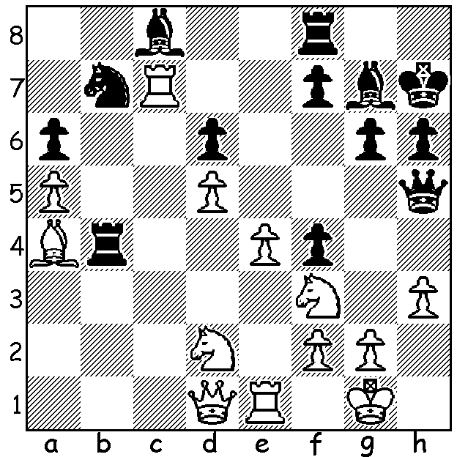

Luke McShane – Robert Mc Farland 2000:
White to play and win (3 moves):

Two weeks ago I published a win by Hikaru Nakamura in which he accepted the Queens Gambit and hung on to the pawn at the cost of the exchange to gain an impressive win. Looking through chess web sites on the game I saw reference to a similar strategy used by Luke McShane to defeat the then world number 2 Levon Aronian in 2012. McShane, now 31, was a former World Youth Champion and was the UK’s youngest Grandmaster. Sadly for the chess world he has played little over the past few years, instead concentrating on his career as a trader. Here then is that McShane win:

Levon Aronian - Luke McShane
7th Tal Memorial 2012
Slav Defence, Chebanenko Variation (4…a6)
1.d4 d5 2.Nf3 Nf6
3.c4 c6 4.Nc3 a6
5.Bg5 dxc 6.a4 h6
7.Bh4 b5! 8.axb cxb
9.Nxb5 axb5! 10.Rxa8 Bb7
11.Ra1 g5 12.Bg3 e6(a)
13.e3 Bb4+ 14.Ke2(b) Nc6
15.Ne1 Na5 16.Be5 0-0
17.h4(c) g4 18.Nc2 Be7
19.Ke1 Nb3 20. Ra2 h5
21.Be2 Bd6 22.f3 Nd5
23.fxg4 Bxe5 24.dxe5 Qb6
25.Bf3(e) Nxe3 26.Nxe3 Qxe3+
27.Qe2 Qc1+ 28.Qd1 Qe3+
29.Qe2 Qc1+ 30.Qd1 Bxf3
31.gxf3(f) Qe3+ 32.Qe2 Qc1+
33.Qd1 Qe3+(g) 34.Qe2 Qf4!
35.Qh2(h) Qxf3 36.Rf1 Qe4+
37.Kf2(i) Nd2 38.Rg1 Qf3+
White resigns (j)

a) For the exchange Black is able to misplace White’s king
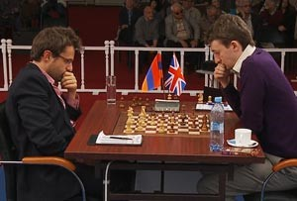
and hinder his development (now if 13.Qd2 Nc6 threatening
14…Bb4).
b) Not 14.Nd2 Ne4.
c) If 17.f3 Nd7 18.Bg3 f5 is good for Black as is 17…Nd5.
d) If 20.Bxf6 Bxf6 21.Qxg4+ Kh8 22.Rd1 (22.Ra2 e5!)
22…Qa2.
e) If 25.Rh3 Rd8 26.Qb1 Nf4! or 25.Kf2 Rd8 26.Qe1 Nf4.
f) Not 31.Qxc1? Nxc1 32.Ra1 Nd3+ winning.
g) Black’s repetition of moves between 26 and 33 has
gained him valuable time on the clock (for much of the
game McShane was in serious time trouble and had
consumed over an hour more than Aronian).
h) If 35.Kf2 Rd8 36.Rd1 Qh2+ 37.Ke3 Qxe5+ 38.Kf2 Aronian v McShane
Qh2+ 39.Ke3 Qxh4 winning.
i) Not 37.Qe2? Qb1+
j) 39.Ke1 Qe3+ 40.Qe2 Nf3+ wins.

WA ALLEGRO CHAMPIONSHIP (15 min) will be played on Sunday 15 March, 11am – 5pm, at Leeming Primary, Meharry Rd. Please enter by next Friday. Details cawa.or.au and enquiries andrewhardegen@iinet.net.au

SOLUTION: 1.Rxc8 (destroying the guard) & Black resigns: if 1…Rxc8 2.Bd7 Rd8 3.Bg4 traps the queen.

.

