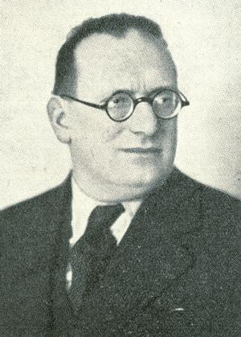
Ernst Grunfeld – Albert Becker 1934:
White to play and win (4 moves):

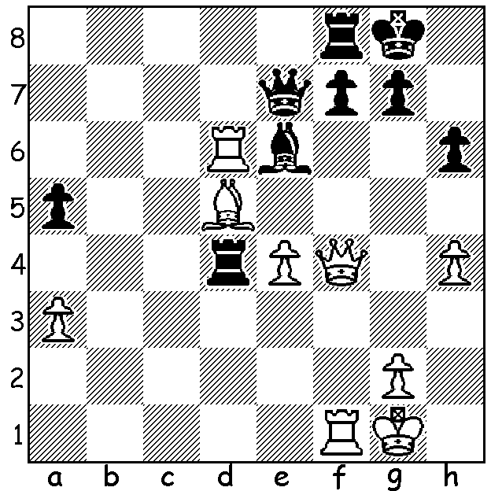

In our Alphabet series on players who have given their names to openings and defences we come to G and the Austrian GM Ernst Grunfeld (1893-1962). A profound theoretician and a careful scientific player who shunned incalculable complications, Grunfeld had a very successful tournament record without winning any of the major events. He published a book on Queen Pawn Openings in 1924 and a general opening manual in 1953. He is of course remembered mainly for originating the Grunfeld Defence (1.d4 Nf6 2.c4 g6 3.Nc3 d5) which has proved a favourite of many of the world’s best players including world champions Smyslov, Fischer and Kasparov while today many times Russian champion Peter Svidler plays it at virtually every opportunity. The defence is hyper-modern in that it allows White an imposing centre with the intention of putting pressure on the central pawns or establishing an advantageous ending with a 2 -1 queenside pawn majority. While Black’s wins are often long drawn-out struggles, White’s wins, based on a kingside attack, are frequently shorter and more entertaining. Here is the first use of the defence, played against a world champion-to-be:

ALEXANDER ALEKHINE - ERNST GRUNFELD
Vienna 1922: Grunfeld Defence
1.d4 Nf6 2.c4 g6
3.Nc3 d5 4.Bg5 Ne4
5.cxd Nxc3(a) 6.bxc3 Qxd5
7.Nf3 Bg7 8.e3 c5
9.Bb5+(b) Bd7 10c4 Qe4
11.0-0 Bxb5 12.cxb5 Nd7
13.Rc1 b6 14.Qb3 h6
15.Bh4 0-0 16.Rc4 Qe6
17.Rd1 Rfe8 18.d5 Qd6
19.Bg3 e5 20.dxe6 Qxe6
21.Rd6 Qe7 22.Ra4(c) Nf8
23.Qd5 Rad8 24.Nd2 Rxd6
25.Bxd6(d) Rd8! 26.Nc4(e) Qd7
27.h3 Ne6 28.Qe4(f) Bf8.
29.Bxf8 Qd1+ 30.Kh2 Qxa4
31.Be7(g) Re8 32.Bf6 Ng7
33.Qd3 Qxa2 34.Bb2 Re6
35.Qc3 f6 36.Qd3 h5
37.e4 Qa4 38.Nd6 Qb4
39.Nc4 Qxb5 40.f4 Qc6
41.e5 f5 42.Nd6 Re7(h)

a) If 5…Nxg5 6.h4 recovers the piece.
b) Alekhine refrains from 9.Qb3 not wanting a queen exchange although it would leave him with a small advantage.
c) Putting pressure on a7 but leaving the rook out on a limb: better was 22.Rc6 when 22…Nb8 loses to 23.Rxg6!! (23…fxg6 24.Re4+ Qf7 25.Rxe8+)
d) Safer though leaving Black with a better ending is 25.Qxd6 Qxd6 26.Bxd6 Rd8 27.Nc4
e) White gives up the exchange rather than face the inferior ending after 26.Bxe7 Rxd5 27.Nf1 Rd7.
f) Trying to support the bishop with the e pawn loses the b pawn - 28.e4 Nd4 while if 28.Qf3 a5! (29.Qc6 Qxc6 30.bxc6 b5! 31.c7 Nxc7 32.Rxa5 Ne8 33.Be7
Rd1+ 34.Kh2 bxc4 35.Ra8 Kh7 36.Rxe8 c3 and the passed c pawn will decide).
g) White hopes he can conjure up a mating attack with his queen and bishop via the weakened black squares around Black’s king but the shortage of pieces
enables Black to defend without too much trouble.
h) White has failed to produce any telling threats and is clearly lost. The remaining moves were 43.Qg3 Kh7 44.Qg5 Qd7 45.Qg3 Ne6 46.Qf3 b5 47.Qa8 Qd8 48.Qd5 b4 49.g3 a5 50.Qc6 Qd7 51.Qa6 a4 52.Ba1 a3 53.Qc4 Qc6 54.Kg1 Qf3 55.Kh2 Qf2+ At this point, it has been reported, Alekhine resigned by hurling his king across the room. This was Alekhine’s only loss to Grunfeld (+4 =5 -1) – an impressive debut for the Grunfeld!

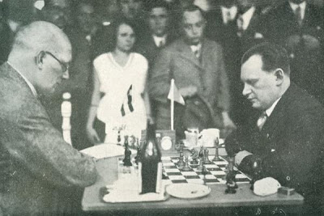
WA ALLEGRO CHAMPIONSHIP (15 min) will be played this Sunday,
15 March, 11am – 5pm, at Leeming Primary, Meharry Rd. Please enter today.
Details cawa.or.au and enquiries andrewhardegen@iinet.net.au

SOLUTION: 1.Rxe6! fxe6 2.Qxf8+! Qxf8 3.Bxe6+ Kh7 4.Rxf8 –
White has won a piece.

Grunfeld (L) v Alekhine

.

