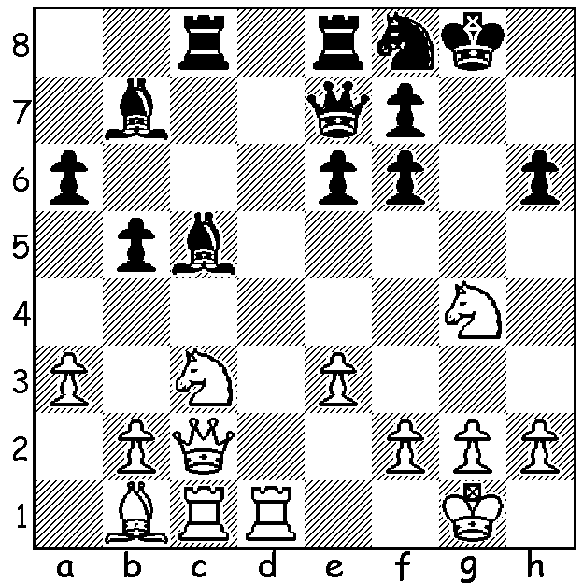
Ernst Grunfeld – Geza Maroczy 1922:
Black’s kingside weakness leads to immediate loss:
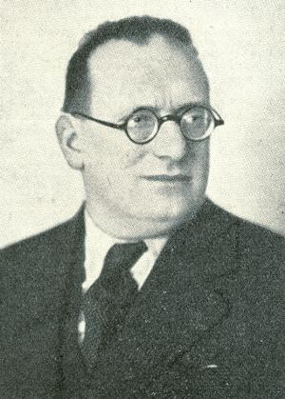

Continuing our look at the Grunfeld Defence named after Austrian GM Ernst Grunfeld (1893 – 1962) we look at White’s most obvious attempt at refutation, the Exchange Variation (1.d4 Nf6 2.c4 Bg7 3.Nc3 d5 4.cxd) which enables White to set up an imposing centre with Black looking to attack White’s centre or to utilize his 2-1 queenside majority in the endgame. Today’s game features two of the Soviet Union’s greatest players of the 20th Century, Efim Geller, a renowned master of attack, and Vasily Smyslov, World Champion 1957-8:

Efim Geller - Vasily Smyslov
World Championship Candidates Match 1965, Game 5
Grunfeld Defence: Exchange Variation
1.d4 Nf6 2.c4 g6
3.Nc3 d5 4.cxd Nxd5
5.e4 Nxc3 6.bxc3 Bg7
7.Bc4 c5 8.Ne2 0-0
9.0-0 Nc6 10.Be3 Qc7(a)
11.Rc1 Rd8 12.f4 e6(b)
13.Kh1 b6 14.f5! Na5(c)
15.Bd3 exf 16.exf Bb7
17.Qd2 Re8 18.Ng3 Qc6
19.Rf2(d) Rad8(e) 20.Bh6 Bh8
21.Qf4 Rd7 22.Ne4 c4(f)
23.Bc2 Rde7(g) 24.Rcf1! Rxe4
25.fxg! f6(h) 26.Qg5!(i) Qd7
27.Kg1(j) Bg7 28.Rxf6! Rg4(k)
29.gxh7+ Kh8 30.Bxg7+ Qxg7
31.Qxg4! resigns(l)

- 10…Bg4 11.f3 Na5 12.Bd3 has become the main line (Karpov’s variation is 12.Bxf7+ Rxf7 13.fxg4)
12...cxd 13cxd Be6 when White may well offer a pawn with 14.Rc1 or the exchange with 14.d5.
b) More critical and ambitious is 12…Bg4 (13.f5 gxf 14.h3).
c) 14….exf gives white two good options: 16.d5 Na5 17.d6 or 16.Nf4 fxe 17.Nd5 with excellent compensation for the pawns.
d) Both preparing to double rooks on the f file and freeing the queen from defence of g2.
e) The exchange sacrifice 19…Rxe3 20.Qxe3 cxd 21.Qf4 dxc is insufficient (22.f6 Bf8 23.Nf5! Kh8 24.Nh6 Qe6 25.Rxc3! Qe1+ 26.Rf1 Qxc3 27.Nxf7+ Kg8 28.Ne5 Qc5 29.f7+ Kh8 30.Qf6+ Bg7 31.Nxg6+ hxg6 32. Qxg6 Bxg2+ 33.Qxg2 Qc6 34.Be4 winning).
f) Black can ease his defence with 22…Qc7 23.Re1 Bxe4 removing the dangerous knight.
g) Black is generating enormous pressure on the e file and the a8-h1 diagonal.
h) If 25…Rxf4 26.gxh7# or 25…Qxg6 26.Bxe4 Bxe4 27.Qxf7+ Qxf7 28.Rxf7 wins.
i) Threat 27.g7 and if 26…fxg5 27.Rf8+ mates.
j) Preparing the coming finish, not possible with the king on h1 due to a back row mate.
k) If 28…Bxf6 29.Qxf6 hxg6 30.Qxg6+ Kh8 31.Bg5 R4e6 32.Bf6+ Rxf6 33.Rxf6 winning (no back row mate for Black).
l) 31…Qxg4 32.Rf8+ Rxf8 33.Rxf8+ Kg7 34.h8=Q#.

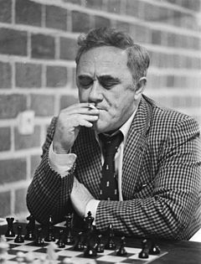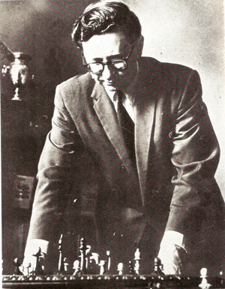
Geller 1977 Smyslov 1957

WA ALLEGRO CHAMPIONSHIP (15 min) played last Sunday with 40 entrants ended in a tie between WA’s top two players, Tristan Boyd and Yita Choong. Full report next week.

SOLUTION: 1.Rd7! (deflection sacrifice) Black resigns (1…Nxd7 2.Qh7# or 1.Qxd7 2.Nxf6+).

