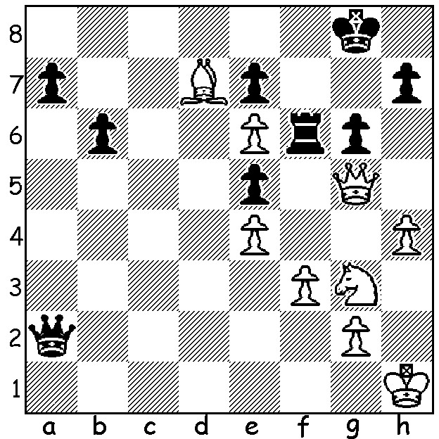

From a Gufeld Defence (Bronstein – Boleslavsky 1950):
while Black has united passed pawns on the queenside
White has concentrated his attack in the centre and on
the kingside and now wins quickly (3 moves):

As of last week we look at a Gufeld Defence, Exchange Variation. Typically White concentrates on the kingside and centre while Black banks on his queenside pawn majority (the finish is fantastic, especially considering this was a Rapidplay game:

Boris Gelfand - Alexy Shirov
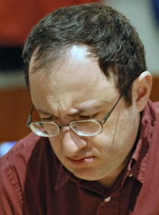
Pivdenny Bank Chess Cup 2007
Grunfeld Defence: Exchange Variation
1.d4 Nf6 2.c4 g6
3.Nc3 d5 4.cxd Nxd5
5.e4 Nxc3 6.bxc3 Bg7
7.Nf3 c5 8.Rb1(a) 0-0
9.Be2 cxd 10.cxd Qa5+
11.Bd2 Qxa2 12.0-0 Bg4
13.Be3 Nc6 14.d5 Na5
15.Bg5 b6 16.Bxe7 Rfe8
17.d6 Nc6 18.Bb5 Nxe7
19.h3 Bxf3 20.Bxf3 Qe6
21.Bxe8 Rxe8 22.dxe7 Rxe7(b) Boris Gelfand

23.Rfe1 Bd4 24.Rbd1 Qe5
25.Rd3 a5 26.Qd1 Bc5
27.Re2 Re6 28.g3 Rd6!
29.Kg2(c) Rxd3 30.Qxd3 a4
31.Rd2 a3 32.Qc4 Kg7
33.Rd7 Qf6 34.f4 Qb2+
35.Kf3 Qf2+ 36.Kg4 h5+
37.Kh4 g5+! 38.fxg5 Kg6
39.Qc3 f6(d) 40.Rd5 a2
41.Rf5 Qf4!!+(e) 42.gxf4 Bf2+
43.Qg3 Bxg3+ 44.Kxg3 a1+Q
& Black’s b pawn ensures a win
(45.Rxf6+ Kg7 46. Rxb6? Qg1+) Alexy Shirov

a) A modern and popular line, sacrificing the a pawn to gain time for central play and possibly a kingside attack.
b) White’s central pressure has forced Black to give up the exchange for a pawn (B + p v R) but his queenside united passed pawns provide sufficient compensation.
c) Not 29.Rxd6? Qxg3+! (zwichenzug) (30.Kf1 Qxh3+ 31.Ke1 Qh1+ 32.Ke2 Qxd1+ 33.Kxd1 Bxd6 or 30.Kh1 Qxh3+ 31.Kg1 Qg6+ 32.Kh1 Qf6+ 33.Kh1 Bxd6).
d) Black could play 39…a2!! and if 40.Rd8 Qf4+!! (a recurring theme) 41.gxf4 Bf2+ 42.Qg3 Bxg3+ 43.Kxg3
a1=Q. Now 40.fxf6 Qxf6+ 41.Qxf6+ Kxf6 42.Kxh5 b5 43.Rd5! (or 43.Rc7) 43…a2 44.Rxc5 a1=Q 45.Rxb5 draws.
e) A great move (42.Rxf4? fxg#) but even better is 41.a1+Q!! (42.Rxf6+ Qxf6+ 43.Qxf6+ Qxf6+ 44.fxf6 Be3 & mate next move on g5 or f2).

WA ALLEGRO CHAMPIONSHIP (15 min) played earlier this month attracted 40 entrants with both a large number of juniors and some of the best players in WA including three past winners. Joint winners were WA’s top two players Tristan Boyd and Yita Choong with 7.5/9 followed by Bozidar Mandic (7). Other prize winners: Under 1900 – 1st Ned Tomic (6), =2nd Katherine Hardegen & Edic Gilmetdinov (5.5): Under 1600 – 1st Alex Ridley (6), =2nd Piotr Kowalczyk, Allan Natividad, Andrey Lugovsky, Colin Koehler (5): Junior – 1st George Carolin-Unkovich (6), =2nd Patrick Gong & Paddy Koh (5.5).

WA CHAMPIONSHIPS: The WA Closed & Reserve Championships commence 11 April and the WA Junior Championships on April 13. Check cawa.org.au for details.

SOLUTION: 1.Qxf6! resigns (1…exf6 2.e7 and queens).

