Again from a Gufeld Defence
(Maxime Vachier-Lagrave – Ian Nepomniachtchi 2011): Vachier-Lagrave
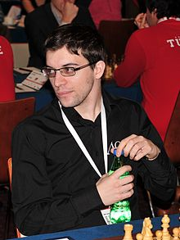
White’s attack on the kingside now brings about a very quick end:

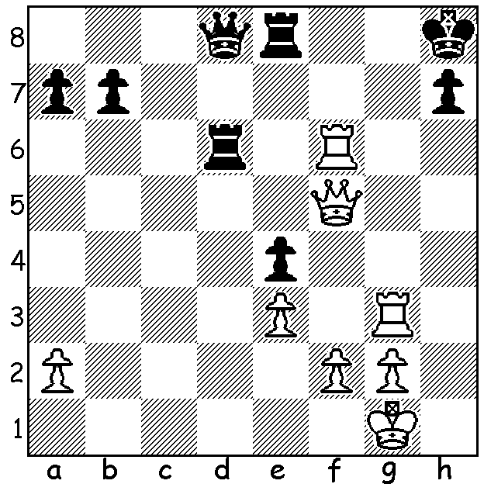

This week we look at a popular alternative (4.Bf4) to the Exchange Variation when facing the Gufeld Defence. And what better players to follow than world champions Anatoly Karpov and Gary Kasparov who engaged in so many hard fought matches for the title?

Anatoly Karpov - Gary Kasparov
World Championship, Match 3, Game 11, 1986
Grunfeld Defence 4.Bf4
1.d4 Nf6 2.c4 g6
3.Nc3 d5 4.Bf4 Bg7
5.e3 c5 6.dxc Qa5
7.Rc1(a) dxc 8.Bxc4 0-0
9.Nf3 Qxc5 10.Bb3 Nc6
11.0-0 Qa5 12.h3 Bf5
13.Qe2 Ne4 14.Nd5 e5
15.Rxc6!?(b) exf4(c) 16.Rc7! Be6
17.Qe1 Qb5! 18.Ne7+ Kh8
19.Bxe6(d) fxe6 20.Qb1(e) Ng5
21.Nh4 Nxh3+!(f) 22.Kh2 Qh5(g)
23.Nexg6+(h) hxg6 24.Qxg6 Qe5!(i)
25.Rf7! Rxf7(j) 26.Qxf7 Ng5
27.Ng6+(k) Kh7 28.Nxe5 Nxf7
29.Nxf7 Kg6 30.Nd6 fxe
31.Nc4 exf 32.Rxf2 b5
33.Ne3 a5 34.Kg3 a4
35.Rc2 Rf8 36.Kg4 Bd4
37.Re2 Bxe3 38.Rxe3 Rf2
39.b3 Rxg2+ 40.Kf3 Rxa2
41.bxa DRAW(l)

a) 7.cxd Nxd5! 8.Qxd5 Bxc3+ 9.bxc3 Qxc3+ 10.Ke2 Qxa1 11.Be5 Qc1 12.Bxh8 Be6!13.Qxb7 Qc2+ 14.Kf3 Qf5+ 15.Ke2 was Vaughan – Cecil Purdy 1945 (corrres).
b) A new move prepared by Karpov’s team.
c) Declining the sacrifice after 5 minutes thought – 15…bxc6 16.Ne7+ Kh8 17.Nxc6 Qb6 18.Ncxe5 with 2 pawns for the exchange.
d) 19.exf? is met by 19…Ng3! (20.fxg3 Qb6+)
e) The start of a dangerous kingside attack by the queen & knights.
f) Not giving White a draw with 21…fxe 22.Nhxg6+ hxg6 23.Nxg6+ Kg8 24.Ne7+. White cannot now play 22.gxh3? Qg5+ 23.Ng2 f3 winning.
g) 22…fxe3 23.Kxh3 e2 and 22...Nxf2 23.Rxf2 fxe3 were viable alternatives.
h) Better 23.Nhxg6+ hxg6 24.Qxg6 (24…Qe5 25.Kxh3 Rf6 26.Kg4!! (threat 27.Rh1+) 26…Rxg6 27.Nxg6+ Kg8 28.Nxe5 winning or 24…Qh7 25.gxh3 Rf6 – 25…fxe 26.Qxe6 Rf6 27.Qxe3 with 2 extra pawns - 26.Qg4 Rh6 27.Nc8! fxe 28.fxe Rxh3+ 29.Qxh3 Be5+ 30.Kg1!! winning).
i) 24…Qh7 25.Rxg7! Qxg7 26.Qh5+ Kg8 27.gxh! fxe! 28.Rg1 exf 29.Rxg7+ Kxg7 30.Qg6+ draw.
j) 25…Kg8? loses - 26.Nf3! Qxb2 27.Rb1.
k) If 27.Qxb7 fxe+ 28.f4 Qe4.
l) A marvelous cut and thrust game for which the two players were given a standing ovation and shared a prize of British gold sovereigns to the value of £10,000.

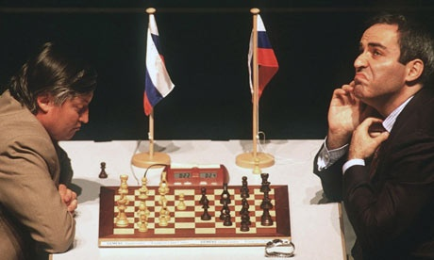
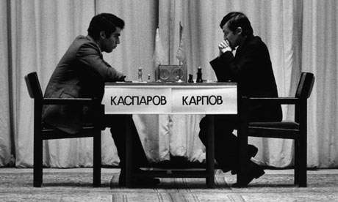

World Championship: Kasparov – Karpov 1985 & Karpov – Kaparov 1999

WA JUNIOR CHAMPIONSHIPS commence on April 13 with age divisions Under 10, 12, 14, 16 & 18. Check cawa.org.au for details.

SOLUTION: 1.Rg7! (1.Rf7 is met by 1…Rh6 threatening 2…Qd1#) resigns (1…Kxg7 2.Rf7+ Kg/h8 3.Qxh7# or 2.Kh6 3.Rxh7#).

