Again from a Gufeld Defence (Feigin – Flohr 1937): Salo Flohr
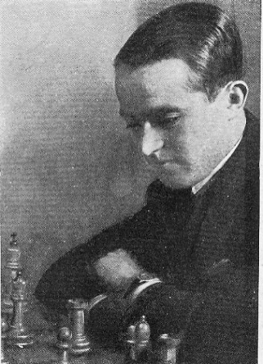
After Black’s next move White resigns:
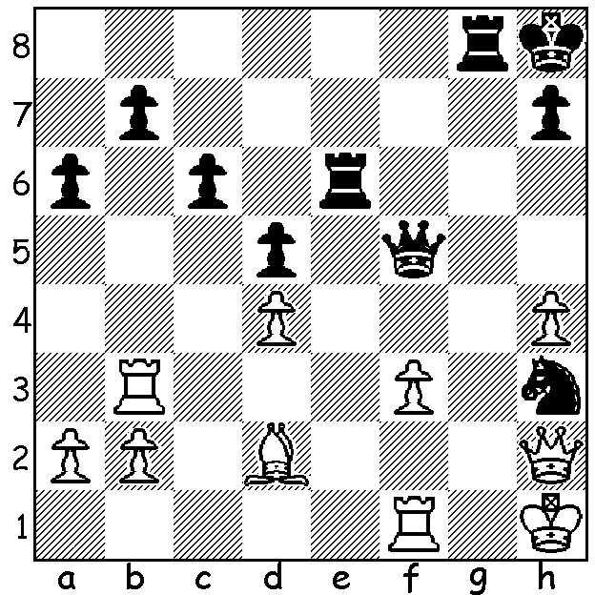

Last week we looked at an exciting World Championship game between Anatoly Karpov and Gary Kasparov. This week our look at the Grunfeld Defence takes us to another World Championship game, this time between challenger Max Euwe and champion Alexander Alekhine in another important line, the Russian Variation Accelerated (4.Qb3):

Max Euwe - Alexander Alekhine
1935 World Championship, Match 1, Game 4
Grunfeld Defence 4.Qb3
1.d4 Nf6 2.c4 g6
3.Nc3 d4 4.Qb3(a) dxc
5.Qxc4 Bg7 6.Bf4(b) c6
7.Rd1 Qa5 8.Bd2 b5(c)
9.Qb3 b4 10.Na4 Na6
11.e3 Be6 12.Qc2 0-0
13.b3(d) Rab8 14.Bd3(e) Rfc8
15.Ne2(f) c5! 16.Bxa6 Qxa6
17.Nxc5 Qb5 18.Nf4?(g) Bg4
19.f3 e5! 20.Nfd3 exd!!(h)
21.fxg4 dxe3 22.Bxe3?(i) Nxg4
23.Bf4 Bc3+ 24.Rd2(j) Rxc5
25.Nxc5(k) Qxc5(l) 26.Bxb8(m) Qe7+
27.Kd1 Nd3+ 28.Kc1 Nxc2(n)

a) First played by Botvinnik v Levenfish in 1933.
b) Euwe chose 6.e4 0-0 7.Nf3 in Game 12 which became the main line in this variation.
c) An inferior move leaving Black with serious queenside weaknesses: better was 8…Qb6.
d) 13.Qxc6 is met by 13…Nc7 with the threat of 14…Bd7 with initiative.
e) Again avoiding 14.Qxc6 (14…Bc8! followed by …Bb7 & Rfc8).
f) 15.Bxa6 Qxa6 16.Nc5 Qb5 17.Nf3 Nd7 18.Rc1 leaves White better.
g) 18.e4 Nd7 19.Be3 Bxd4! 20.Nxd4 Qxc5 =.
h) At the cost of a piece Black traps the White king in the centre.
i) 22.Bxb4 would make Black’s task much harder – 22…Nd5 23.a3 a5 24.Qc4! axb4! 25.Qxd5 bxa 26.Rf1 a2! 27.Rxf7? Bc3+ 28.Ke2 Rxc5! & wins.
j) If 24.Ke2 Rxc5! 25.Bxb8 Qe8+ 26.Be5 Rxe5+ 27.Nxe5 Qxe5+ wins.
k) If 25.Bxb8 Qe8+!.
l) Even better was 25…Re8+! – 26.Ne4 (26.Kd1 Bxd2 27.Bxd2 Nf2+) 26…f5 27.Kd1 Rxe4 28.Rd8+ Kf7 29.Bg5 f4! 30.Kc1 Re2 31.Qd3 Qxg5 & wins.
m) If 26.Kf1 Re8 threatening 27…Qf2+!! 28.Rxf2 Re1# (27.Qc1 Bxd2! 28.Qxd2 Qb5+ 29.Kg1 Qb6+ 30.Kf1 Rd8 31.Qe2 Rd1+! wins or 27.g3 Qc6 etc wins).
n) and wins: 29.Rxc2 h5 30.Rd1 Bg7 31.h3 a5 32.Bf4 Qe4 33.Bc7 Qe3+ 34.Kb1 a4! 35.bxa b3 36.axb Qxb3+ 37.Kc1 Bh6+ 38.Rdd2 Qxa4 39.Be5 Kh7 40.Bc3 Qb5 41.Bd4 Qe2 42.g4 Qe1+ 43.Kb2 Bxd2 44.Rc8 Bc1+! White resigns

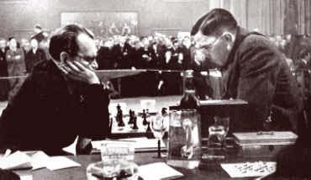

World Championship – Alekhine (L) v Euwe

SOLUTION: 1…Nf2+! White resigns (2.Rxf2 Qb1+ or 2.Qxf2 Qh3+ 3.Qh2 Qxf1+).

