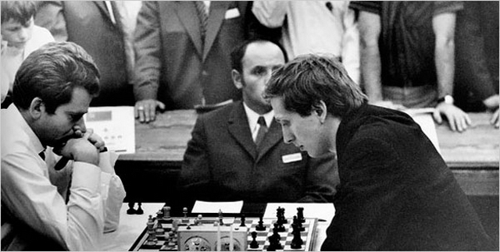
From a Gufeld Defence, Exchange Variation,
(Spassky – Fischer, Olympiad 1970):
White to play and win (4 moves):
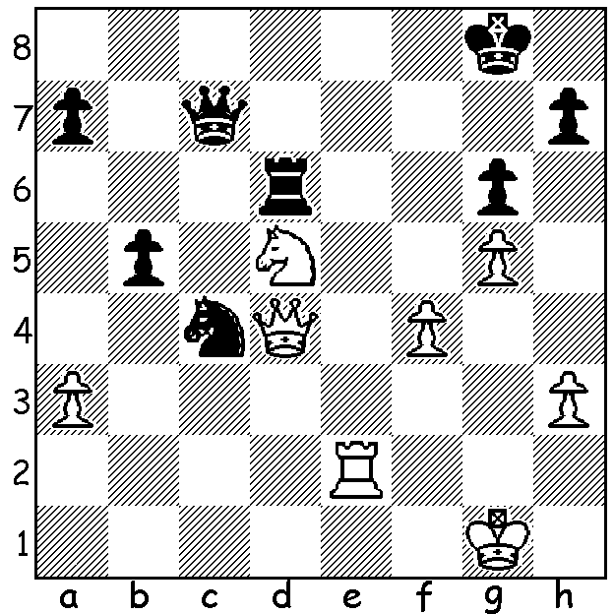

Spassky – Fischer (Olympiad, Germany 1970)

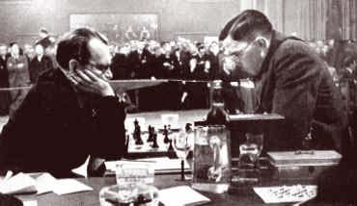
Last week we looked at a win by defending world champion
Alexander Alekhine against challenger Max Euwe with
the Gufeld Defence. This week the other side of the coin
with Euwe winning with the white pieces. Of the four
Gufeld games in the 1935 match Euwe won three which
contributed massively to his surprise victory 15.5 – 14.5
(+9 =13 -8). In the return match in 1937, which Alekhine
won 15.5 – 9.5 (+10 =11 -4) to regain the title, he didn’t
once essay the Grunfeld.
World Championship, Alekhine (L) v Euwe

Max Euwe - Alexander Alekhine
1935 World Championship, Match 1, Game 2
Grunfeld Defence 4.Qb3
1.d4 Nf6 2.c4 g6
3.Nc3 d5 4.Qb3 dxc
5.Qxc4 Be6 6.Qb5+ Nc6
7.Nf3 Rb8(a) 8.Ne5(b) Bd7
9.Nxd7 Qxd7 10.d5 Nd4
11.Qd3 e5 12.e3 Nf5
13.e4(c) Nd6 14.f4 Qe7
15.Be3 Ng4(d) 16.Bxa7 Ra8
17.h3 Rxa7 18.hxg4 Bg7(e)
19.Qe3 Ra5 20.f5 Bf6
21.a4 Bh4+ 22.g3 Bg5
23.Qf3 0-0 24.b4 Raa8
25.Ra2 Ne8 26.Rb2 Nf6
27.Be2 c6 28.dxc bxc
29.0-0 Rad8(f) 30.Kg2 Rd4
31.b5 cxb 32.axb Rb8
33.fxg fxg 34.b6 Qb7
35.Kh3 Rd6 36.Nd5 Kg7
37.Rc2 Nxd5 38.exd5 Rxb6
39.Rc6 Rxc6 40.dxc6 Qe7
41.Bc4 Kh6 42.Qh1 Rb2
43.Rf7 Qe8 44.c7 Rc2
45.Qb7! resigns(g)

- Better was 7…Nd5 (8.Qxb7 Ndb4).
b) Euwe wanted to gain the two bishops but even better was 8.e4 (8…a6 9.Qd3 Bg4 10.d5 Bxf3 11.gxf3 Ne5 12.Qd1 led to a crushing win to Najdorf v Szabo 1948 in 24 moves).
c) This allows Black to reestablish the knight on d4 (which Black declines). Better 13.Be2 (13…Bg7 14.g4 Nd6 15.g5 Nh5 16.Bxh5 gxh5 17.e4).
d) 15…exf is met strongly by 16.Bxa7 Ra8 17.Bd4. Fritz gives 15…Nd7 16.g3 Bg7 17.Bg2 exf 18.gxf
0-0 and if 19.e5 Bxe5! 20 fxe5 Nxe5 21.Qe2 Rfe8).
e) 18…exf?? 19.Qd4.
f) 29…Rfd8 is more logical leaving the queen’s rook to watch the wing pawns but Black was doubtless concerned about possible threats on the f file.
g) If 45…Rxc4 White wins with 46.Rxh7+! Kxh7 47.c8=Q+ but not 46.c8=Q? Qxf7 47.Qxf7 Rxc8.

WA JUNIOR CHAMPIONSHIPS were played during the recent school holiday. Ignatius Yap is the new junior champion. The Under 16 championship was won by Asadullah Aljunied with Darcy Frazer second, the Under 14 by Sri Krishna Dharmapuri with Rahel Wijesuriya and Saffiya Aljunied runners up, the Under 12 by Benjamin Hurst with Adam Healy second and Aaron Gibson-John third and finally the Under 10 by Kundan Dharmapuri with Andrew Walker and Haydar Iljunied runners up.

SOLUTION: 1.Re8+ Kf7 2.Rf8+! (deflection) resigns (2…Kxf8 3.Qh8+ Kf7 4.Nxc7).

