Bhopade Swapnil – Max Illingworth Max Illingworth

(Thai Open 2015):
Black to play and win (3 moves):

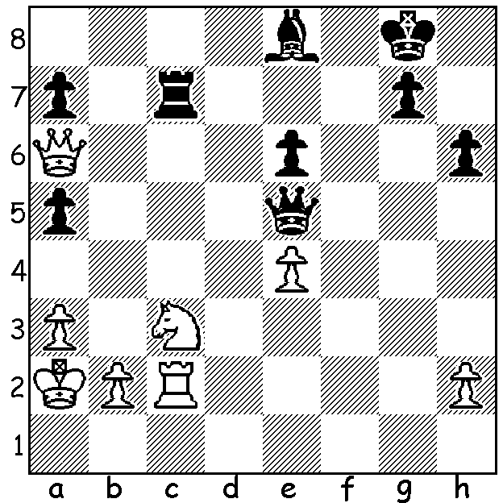

Quite a number of newsworthy tournaments have been played recently and I’ve chosen to concentrate this week on the Thai Open in Bangkok with nearly 200 competitors which included an Australian contingent of 13 (+2 in the Reserves). Winner on countback was Nigel Short (UK) from Surya Ganguly (India) and Kamil Dragun (Poland), all with 7.5/9. This was Short’s second success in Bangkok. The best scoring Aussies were Max Illingworth =5th on 6.5, teenager Anton Smirnov 6, another teenager Ari Dale, Ikeda Junta, Matthew Drummond, Jack Puccini all 5.5. WA’s sole competitor, Australian Under 16 champion Patrick Gong scored a very credible 5/9 coming =60th in a tournament with a number of GM & IMs competing. Below are a couple of games from the event with both games concluding with snappy combinations:
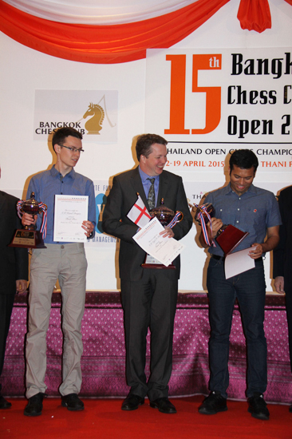
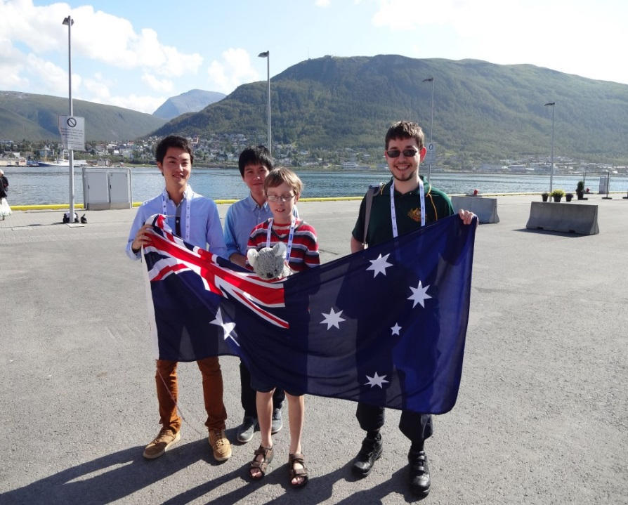

Proud Aussies at 2014 Olympiad
Winners at Bangkok (l-r) Junta Ikeda, Moulthon Li, Anton Smirnov
(l –r) – Dragun, Short, Ganguly (holding mascot Sheila the koala), Max Illingworth

Junta Ikeda - Kamil Dragun
Sicilan, Scheveningen
1.e4 c5 2.Nf3 e6
3.Be2 Nc6 4.0-0 Nf6
5.Nc3 Qc7 6.d4 cxd
7.Nxd4 a6 8.Be3 Be7
9.f4 d6 10.Kh1 0-0
11.a4 Rd8 12.Bf3 Na5
13.Nde2 b6 14.b3 Bb7
15.Qd4 Nd7 16.Bd2 Rac8
17.Rac1 Nc6 18.Qf2 Nb4
19.f5 exf 20.exf d5
21.Nd4 Nf6 22.Nce2 Qd7
23.Qg3 Bd6 24.Qh4 Re8
25.Ng3 Na2 26.Rce1 Nc3
27.Rxe8 Qxe8 28.Bg5 Nce4
29.Bxe4 Nxe4 30.f6 Bxg3
31.hxg3 g6 32.g4 Rc3
33.Kg1 Qf8 34.Ne6! resigns(a)

a) If 34...fxe6 35.f7+ wins or if 34...Q moves 35.Qh6 mates.

Surya Ganguly - Somak Palit
Philidors Defence, Hanham Variation
1.e4 d6 2.d4 Nf6
3.Nc3 e5 4.Nf3 Nbd7
5.Bc4 Be7 6.a4 0-0
7.0-0 c6 8.h3 b6
9.Qe2 Bb7 10.Rd1 Qc7
11.Ba2 a6 12.Nh4 b5
13.Nf5 Rfe8 14.Bg5 exd
15.Rxd4 d5 16.exd Bc5
17.d6 Qb8(a) 18.Re4 Nxe4
19.Nxe4 Re5 20.Qg4 h5
21.Bxf7+! Kxf7 22.Qxh5+ Kg8
23.Nh6+! Kh7(a) 24.Ng4+ Kg8
25.Ngf6+ resigns(b)

a) If 23…gxh6 24.Qg6+ Kh8 25.Nf6 mates.
b) 25…Nxf6 26.Nxf6+ Kf8 (26…gxf6 27.Qg6+) 27.Nd7+ wins.

Nigel Short was also in the news after claiming in New in Chess magazine that women lacked the brain power to succeed in chess and other sports. He qualified his assertion by stating, ‘One (sex) is not better than the other, we just have different skills.’ Naturally there was a backlash against his comments with reference to his 3-8 score against Judit Polgar and a claim such views were ‘incredibly damaging when someone so respected basically endorses sexism’. Gary Kasparov similarly stated,
‘Women by their nature are not exceptional chess players, they are not great fighters’, while Bobby Fischer unwisely claimed he could beat any woman giving them a piece start.

SOLUTION: 1…Bb5! & White resigns (2.Qxb5 Qxb5 3.Nxb5 Rxc2 or 2.Nxb5 Rxc2.

