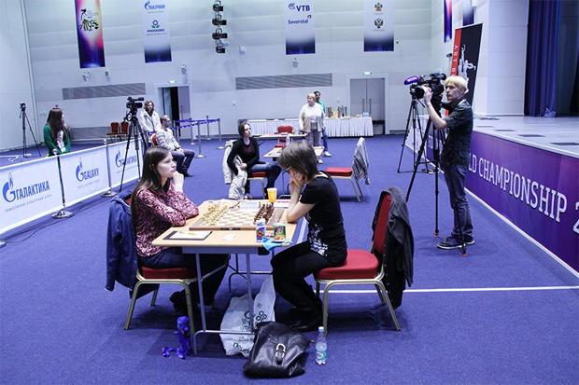
After reporting on Nigel Short’s less than flattering comments on the abilities of female players it seems appropriate today to highlight some of the top level women’s chess. Here is a position from the semi-final clash in the 2015 Womens World Championship
between Natalija Pogonina (left) and the oldest
competitor Pia Cramling from Sweden: White
to play and win (4 moves):

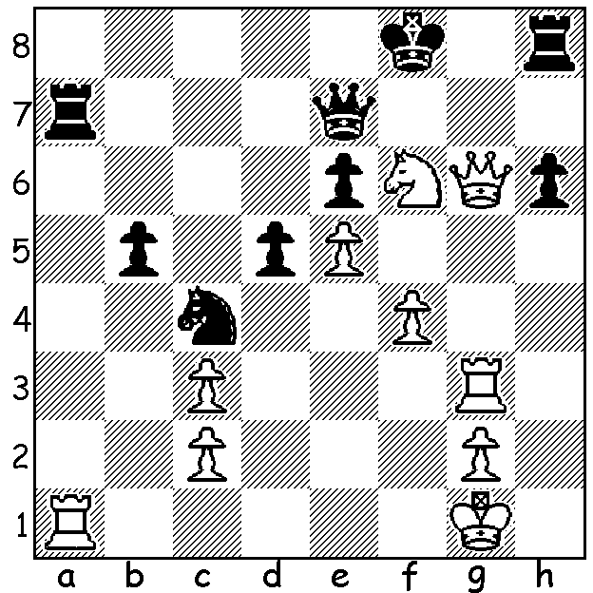

The 2015 Womens World Championship played in Sochi, Russia, last month was run as a 64-player Knock-Out with two games each round until the final, played over four rounds. If matches were tied after the two games further sets of two games were played, each set with a faster time limit until a victor emerged. 2014 champion and the top ranked woman Hou Youfan (China) was unable to compete due to a prior tournament engagement (the Womens Championship had previously been postponed). Australia’s qualifier Irina Berezina lost in the first round to Russian Alexandra Kosteniuk, world champion 2008-210. The final was won by Mariya Muzychuk (Ukraine) who defeated Natalija Pogonina (Russia) 2.5 – 1.5 (+1 =3). Pogonina showed great fighting qualities throughout the tournament consistently coming back from a Game 1 loss to reach the final. Here is Muzychuk’s fine win against the top ranked player in the tournament, Humpy Koneru (India).

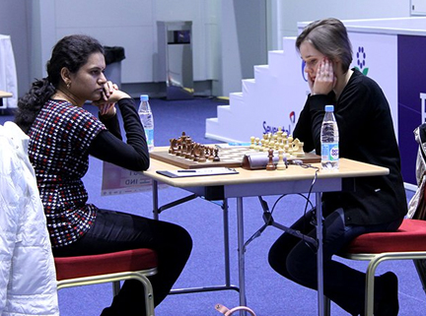

Koneru (left) v Muzychuk

Mariya Muzychuk - Humpy Koneru
2015 Womens World Ch., Rd 4, Game 1
Scotch Game
1.e4 e5 2.Nf3 Nc6
3.d4 exd 4.Nxd4 Bc5
5.Be3 Qf6 6.c3 Nge7
7.g3 d5 8.Bg2 dxe
9.0-0 0-0 10.Nd2 Bb6
11.Re1 Nxd4 12.Nxe4 Qf5
13.Bxd4 Nc6 14.Bxb6 axb6
15.f4 Be6 16.b3 h6
17.h3(a) Ra3 18.Qd2 Qa5
19.b4 Qa4 20.g4 Rd8
21.Qf2 Rxa2 22.Rxa2 Bxa2
23.b5 Na7(b) 24.g5 h xg
25.Nxg5 f6(c) 26.Qd2!! Rf8
27.Bxd5+ Bxd5 28.Qxd5+ Kh8
29.Qf7! resigns(d)

a) Black is now able to build up pressure on the a file and win the weak pawn on a2. 17.a4 would have prevented this.
b) A poor move leaving the knight away from the action on the edge of the board. 23…Ne7 should be played when 24.Nf6+ can be met by 24…Kf8.
c) The losing move with White now able to set up back row mating threats. Best is 25…Rd1 26.Qf1 Rxe1 27.Qxe1 Qxb5 28.Qd2 Qb1+ 29.Kh2 g6 30.Qd8+ Kg7 31.Qd4+ draw.
d) A spectacular finish: 29….Rxf7 30.Re8+ mates or 29…Rd8 30.Re8+ or 29…Qa3 30.Qh5+ Kg8 31.Qh7#.

The SOUTH WEST OPEN (WA Grand Prix event) will be played at Bridgetown June 13/14. With the town hosting other events over that weekend intending entrants should book accommodation very quickly.

The WA LIGHTNING CHAMPIONSHIP will be played at N. Woodvale Primary, Trappers Lane, on Sunday 17 May. Prizes from the state championship will be presented upon conclusion. Details cawa.org.au & entries can be phoned in to me 0439798607.

SOLUTION: 1.Nd7+! (clearance & deflection sacrifice) Black resigns (1…Rxd7 2.Ra8+ Rd8 3.Rxd8+ Qxd8 4.Qg7+ or 1…Qxd7 2.Qf6+)

