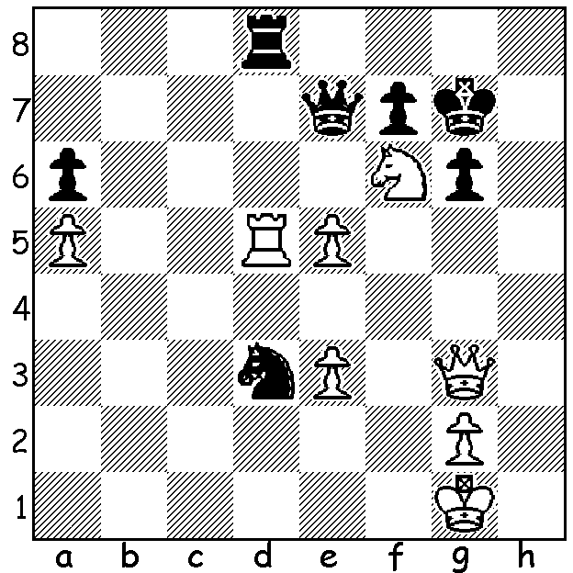

Gata Kamsky – Ray Robson
(US Championship 2015):
White to play and win
(3-4 moves):

The recent US Championship held in St Louis last month has been described as ‘the youngest and strongest in history’. World number 2 Hikaru Nakamura won the title for the fourth time, scoring 8/11. Second was 20 year old Ray Robson (7.5) and third 21 year old Wesley So (6.5). Perhaps the sensation of the tournament was the Rd 9 forfeiture of So, formerly from the Philippines, for writing extraneous notes on his scoresheet. He had been regularly writing words of advice and had received two official warnings. In Rd 1 he had written ‘use your time, you have a lot of it’ and in Rd 2 ‘sit down for entire game, never get up’ and after a complaint by his opponent he had crossed out the words. However he again put advice on his scoresheet in Rd 3 and received a second official warning. Then in Rd 9 he wrote ‘double check and triple check’ and ‘use your time’ and after a complaint from his opponent he was forfeited. While his actions cannot be construed as cheating his continuing with this practice in breach of rules seems very foolish. In the US Womens Championship Irina Krush won her fourth title in a row and her seventh in all.

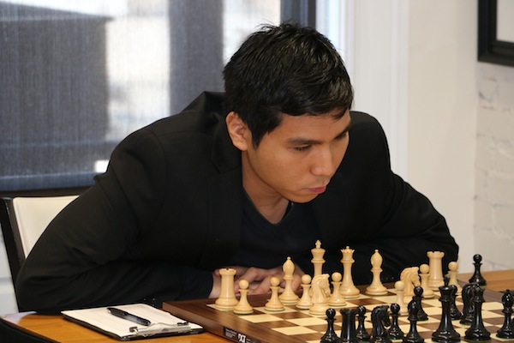


US Champions, Hikaru Nakamura and Irina Krush Wesley So in Rd 9 before forfeiture

Conrad Holt - Hikaru Nakamura
2015 US Championship, Rd 1
Kings Indian Defence
1.d4 Nf6 2.c4 g6
3.Nc3 Bg7 4.e4 d6
5.Nf3 0-0 6.h3 e5
7.d5 Nh5 8.g3(a) Na6
9.Nd2 Qe8(b) 10.Be2 Nf6
11.h4 Nd7 12.h5 f5
13.hxg hxg 14.exf Nf6!(c)
15.fxg Qxg6(d) 16.Nf3 Nb4
17.Nh4 Qh7 18.Kf1 Bf5
19.Kg1 Bc2 20.Qd2 Ne4
21.Nxe4 Qxe4 22.Bf1(e) Bd3
23.Bh3 Nc2! 24.Be6+ Rf7
25.Nf5?(f) Ne1!! 26.Ne7+(g) Kf8
27.Ng6+ Ke8 White resigns(h)

a) 8.Nh2 is the more popular move.
b) Planning …f5, this defends the knight on h5 after exf gxf. However White immediately prevents this advance (temporarily).
c) Black gains the initiative at the cost of a pawn and a complete loss of pawn protection for his king. d) 15…e4 first would deprive the knight of the f3 square.
e) White has better in 22.Ng2 (22…Bd3 23.Bh5 Nc2 24.Rh4 Qf5 25.Ne1! breaking the attack and remaining a pawn up).
f) Expecting Black to capture the rook on a1, White pursues an attack but it’s White’s king that’s in danger.
g) If White prevents mate on g2 with 26.Nh4 Black still plays 26…Qg2+!! (27.Nxg2 Nf3#).
h) In view of the threats of …Qg2# and …Nf3+ winning the queen.

The SOUTH WEST OPEN (WA Grand Prix event) will be played at Bridgetown June 13/14. With the town hosting other events over that weekend intending entrants should book accommodation very quickly.

The WA LIGHTNING CHAMPIONSHIP will be played at N. Woodvale Primary, Trappers Lane, this Sunday 17 May starting at 1pm. Prizes from the state championship will be presented upon conclusion. Details cawa.org.au & entries can be submitted today or tomorrow (0439798607). Late entries can be accepted on Sunday at venue by 12.30 ($10 additional fee).

SOLUTION: 1.Qh4! If 1…Rxd5 2.Qh7+ Kg8 3.Qg/h8#: if 1…Nxe5 2.Rxd8 Qxd8 (2.Qxf6 Qh8#) 3.Nh5+ wins queen: if 1…Rh8 2.Nh5+ Rxh5 (2…Kf8 3.Qxh8#) 3.Qxe7.

