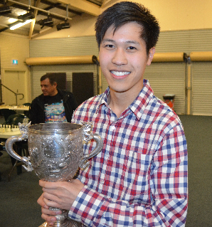
Yita Choong - Matt Burke
(Doerberl Cup 2014):
White to play and win (6 moves):

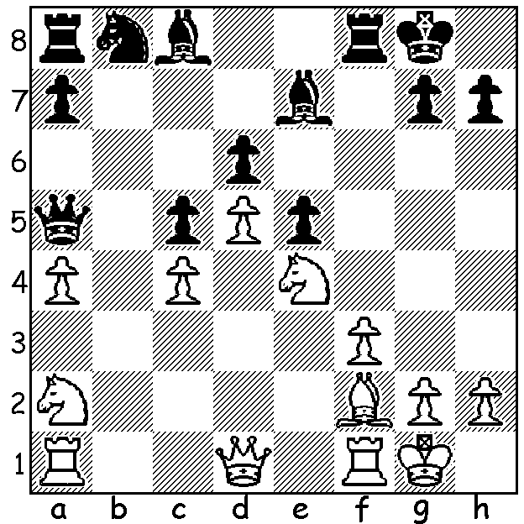

The 2015 WA Championship which was played last month was won decisively by Yita Choong with a perfect score of 7/7. Not only did Yita win all his games, he won them surprisingly easily with four of his victories coming in less than 25 moves. This follows his titles last year and in 2011 and 2012. Second with 5/7 was Ihsan Ferozkohi and third Marc Vlietstra on 4.5. Other scores: Akef Saleh, Rob Maris & Robin Shaw 2.5, Ned Tomic and George Carolin-Unkovich 2. Here are two of these miniatures:

Rob Maris - Yita Choong
Hippopotamus Defence
1.d4 b6 2.e4 Bb7 3.Nc3 e6
4.a3 g6 5.Bd3 Bg7 6.Nf3 d6
7.Bg5 Ne7 8.Qd2 h6 9.Be3 Nd7
10.h3 a6 11.Ne2 c5 12.c4 Nc6
13.Rc1(a) cxd 14.Nexd4 Nc5 15.Qc2 Ne5
White resigns(b)

a) 13.d5 should be played: now White has serious holes at b3 & d3.
b) 16.Nxe5 dxe5 loses a piece and if 16.Be2 Bxe4.

Yita Choong - Ihsan Ferozkohi
Sicilian, Morra Gambit
1.e4 c5 2.d4 cxd 3.c3 dxc
4.Nxc3 Nc6 5.Nf3 g6(a) 6.Bc4 Bg7
7.e5! Qa5 8.0-0! Nxe5(b) 9.Nxe5 Bxe5
10.Nb5 Nf6 11.Re1 Bxh2+(c) 12.Kxh2 d5
13.Bd2 Ng4+ 14.Qxg4 Qxd2 15.Qh4 0-0
16.Nc7 Rb8 17.Nxd5 Be6 18.Re2 Qa5
19.Nxe7+ Kg7 20.Qd4+ Kh6 21.Re4 Qc7+
22.Kg1 Qxc4 23.Qe3+ resigns

a) Better defences are systems incorporating …e6 and …a6.
b) Needing a win to catch Yita, Ihsan grabs a second pawn but White is now able to create a winning attack.
c) Desperation but neither 11…Bb8 nor 11…a6 will bring relief.

Ihsan had fallen behind following a shock loss to Ned Tomic in a game in which he was unable to counter White’s unusual opening play:

Ned Tomic - Ihsan Ferozkohi
Reti Opening, Advance Variation
1.Nf3 d5 2.c4 d4 3.c5(a) Nc6
4.Qa4 Qd5 5.b4 Bd7 6.Na3 Ne5
7.Qb3 Qxb3 8.axb3 Nxf3 9.exf3 Nf6(b)
10.Bc4(c) 0-0-0 11.Bb2 Be8 12.Nc2 d3
13.Ne3 Kb8 14.b5 e6 15.b4 c6?
16.Be5+ Kc8 17.bxc Bxc6 18.Rxa7 Kd7
19.b5 Bxc5 20.bxc6+ Kxc6 21.Ra1 White wins in 60 moves

a) A move not found in any opening book but there is logic behind it, preventing Black from supporting the d pawn with …c5.
b) Better 9…e5 and be ready to meet Bb2 & f4 with …f6.
c) White has emerged with a dominating position and has a massive attack once Black castles.

The WA Reserves Championships played concurrently with the Championship will be reported on next week.

SOLUTION: 1.Bxc5! dxc5 2.d6 Bb7 (2…Bxd6/d8/f6 3.Qd5+) 3.dxe7 Re8 4.Nd6 Rxe7 5.Nxb7 & wins (if 5…Rxb7 6.Qd5+).

