A brilliant finish by the current WAchampion:
Megan Setiabudi - Yita Choong (Aus Op 2013):
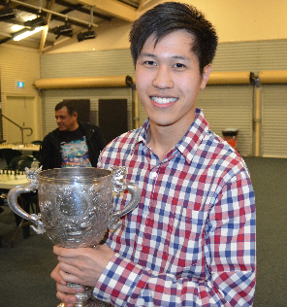
Black to play and win (5 moves):

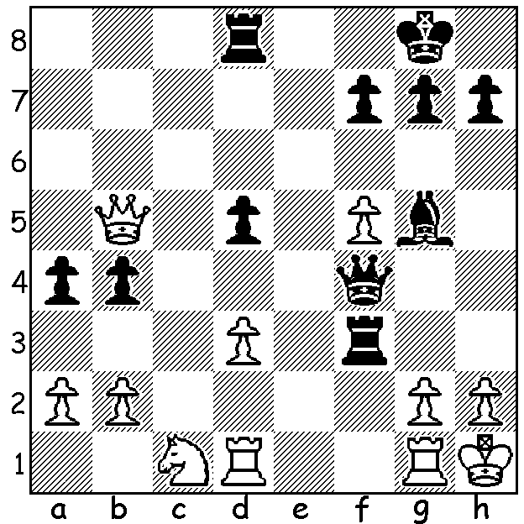

The 2015 WA Reserves Championship which was played last month concurrently with the state championship was won by Kathryn Hardegen who went through unbeaten with 5.5/7. Equal second were Reserves Champion for the past three years Natalie Taylor, Kathryn’s husband Andrew Hardegen, WA Junior Champion Ignatius Yap and Under 14 Champion Sri Krishnan Dharmapuri, all on 5. The final round had Kathryn leading on 5/6 and, with closest rivals Andrew and Natalie drawing, her draw v Brian Gale was enough to see her over the line. It’s Ladies Day here today with games by our top two female players:

Kathryn Hardegen - Gordon Dunlop

2015 WA Reserves Championship, Round 3
Queens Indian Defence
1.d4 Nf6 2.c4 e6 3.Nf3 b6
4.Nc3 Ba6 5.e3 Bb4 6.Bd3 0-0
7.0-0 d5 8.cxd Bxd3 9.Qxd3 exd 10.Bd2 Re8 11.Rac1 Nbd7 12.Nb4 Bxd2
13.Nxd2 c5 14.b3 a6 15.Nc3 b5
16.Qf5 cxd 17.exd(a) Qb6 18.Nf3 Qd6
19.h3 Rac8 20.g4 g6 21.Qg5 Kg7 22.Nh4 Kh8 23.Ng2 b4 24.Na4 Ne4
25.Qf4 Qf8 26.Ne3 Nd2 27.Rxc8 Rxc8 28.Rd1 Ne4 29.Nxd5 Nc3 30.Ndxc3 bxc3
31.Rc1 Qe7 32.Qe3 Qxe3 33.fxe3 c2 34.Nc5! Nf6(b) 35.Rxc2 Nd5 36.Kf2 Nb4
37.Rd2 resigns

- Although both sides now have isolated d pawns, it’s Black’s that’s much
more vulnerable.
- 34…Nxc5 35.Rxc2!


Derek Elkington - Natalie Maris
2015 WA Reserves Championship, Round 4
Scandinavian Defence
1.e4 d5 2.exd Qxd5 3.Nc3 Qd6
4.Nf3 Bg4 5.Be2 Bxf3 6.Bxf3 c6
7.0-0 Nf6 8.Re1 e6 9.d4 Be7 10.g3 Qc7 11.Bf4 Bd6 12.Be5 Nbd7
13.Qe2 0-0 14.Rad1 Rad8 15.Rd3 Rfe8 16.Re3 h6 17.h4 Bxe5 18.dxe5 Nh7(a)
19.Re4 Nhf8 20.Rg4?(b) Ng6 21.Re4 Nc5 22.Re3 Rd4 23.h5 Ne7 24.Nb1(c) Nf5
25.Ra3 Qb6 26.c3 Rd7 27.Rd1?(d) Rxd1+ 28.Qxd1 Qxb2 29.Rxa7 Qb6 30.Ra3 Nxg3!
31.fxg3 Ne4+ 32.Qd4 (e) Qxb1+ 33.Bd1 Nxg3 34.Qd7 Rf8 35.Rb3 Qf5 36.Rxb7 Qf1+
37.Kh2+ Qf2+ 38.Kh3 Nf5 39.Qd3 Qh4+ 40.Kg2 Qg5+ 41.Kh3 Rd8 White resigns

- Looks odd but logical aiming for g6 to pressure the e pawn.
- Losing time as Black’s knights harass the rook putting it out of play.
- 24.g4 would keep the knight from f5.
- If 27.b4 Black might try 27...Nxg3! 28.fxg3 Nd3+ 29.Kg2 Nxe1
30.Qxe1 Red8 with a dominating position.
- Little better is 32.Kh2 Qf2+ 33.Bg2 Qxg3+ 35.Kg1 Qf2+ 36.Kh2 Qh4+ 37.Kg1
Rd8 with a winning attack (38.Qe2 Ng3 39.Qe1 Qg4).

SOLUTION: 1… Rh3!! 2.gxh3 Qf3+ 3.Rg2 Qxd1+ 4.Rg1 Qf3+ 5.Rg2 Bxc1 White resigns.

