Justin Tan – Surya Ganguly (Doeberl Cup 2015): the king of former Asian and many times Indian champion Ganguly is fatally exposed by Australian junior Tan (4 moves):
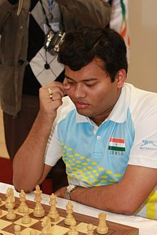

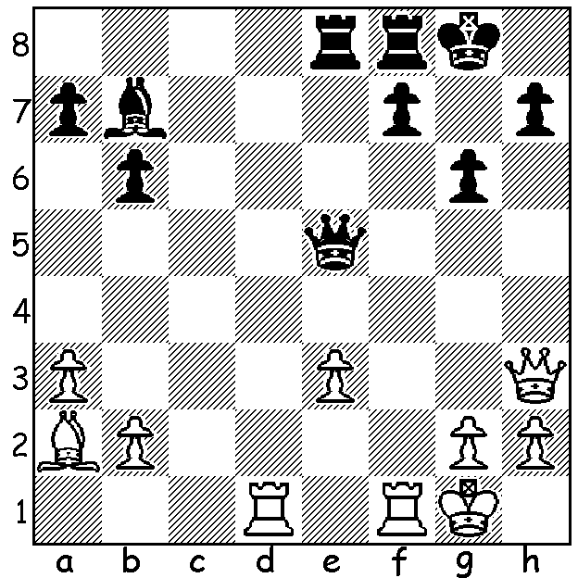
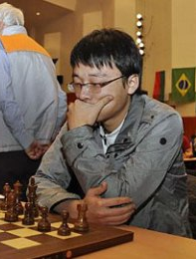

The Doeberl Cup, played over Easter in Canberra, is Australia’s premier
weekender attracting among its nearly 250 competitors in four divisions
a number of overseas GMs as well as many of Australia’s top players.
Winner was Zhou Weiqi (China) who could afford a final round loss in
scoring 7.5/9. Six times Australian champion, veteran Darryl Johansen GM,
came =2nd with Surya Ganguly (India) on 7/9, losing only to Australian
prodigy Anton Smirnov who came =7th with 6. Also on 6 was Australian
junior Karl Zelesco (b 1999), a result which secured him the IM (International
Master) title. West Australian scores: Yita Choong 5 (=20/70), Edik
Gilmetdinov 3.5, Dennis Holland 3, Leon Taylor 2.5. Former Australian Zhou Weiqi
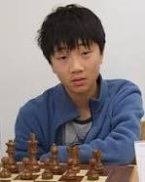
Open, Australian Junior and World Under 12 champion Bobby Cheng won
the Blitz event with 7.5/9.

Bobby Cheng - Darryl Johansen
2015 Doeberl Cup
Philidors Defence, Hanham Variation
1.d4 d6 2.e4 Nf6 3.Nc3 e5(a)
4.Nf3 Nbd7 5.Bc4 Be7 6.0-0 0-0
8.Re1 b6 8.b3 Bb7 9.Bb2 c6
10.d5 a6 11.a4 c5(b) 12.Qe2 Nh5
13.Bc1 g6 14.Bh6 Ng7 15.Rab1 f5 Bobby Cheng
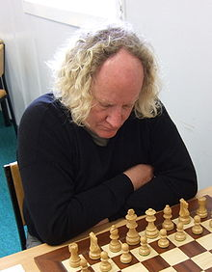
16.g3 Kh8 17.h4(c) Bc8 18.Ng5 Bxg5
19.Bxg5 Qe8 20.exf gxf 21.Bd2 Qg6
22.Qd1 Nf6 23.Bd3 Ngh5 24.Bg5 h6
25.Bxf6+ Nxf6 26.Qd2 Ra7 27.Kh1 Rg7
28.Rg1 Rfg8 29.Be2(d) f4 30.Bf3 e4
31.Bg2 e3 32.fxe Qxg3 33.Be4 Nxe4!
34.Rxg3 Nxd2 35.Rxg7 Rxg7 36.Re1 f3
37.Nd1 Ne4 38.Rg1 f2 White resigns

Darryl Johansen

a) Black appeared to be heading for a Pirc Defence (3…g6) but instead transposes into the Philidor, a near obsolete defence which is enjoying something of a revival. White could now play 4.dxe dxe 5.Qxd8+ Kxd8 but his advantage is miniscule without the queens.
b) With pawns on e5, d6, c5 & bishop on e7, Black’s position is now akin to the Czech Benoni.
c) Secures g5 but weakens the kingside.
d) Allowing a winning pawn storm of his castled position.

The WA LIGHTNING (Blitz) CHAMPIONSHIP, held 17 May at Woodvale, attracted 26 entries. Winner was Ihsan Ferozkohi (9.5/11) with Marc Vlietstra (9) second and WA champion Yita Choong (8.5) third. Yita was equal with Ihsan going into the final round but suffered a surprise defeat at the hands of Alex Janceski. Other prizewinners: Under 1850 – Piotr Kowalczyk (7), Alex Janceski (6.5), Gordon Dunlop (5.5): Under 1500 – two juniors, Benjamin Hurst and Darcy Frazer (6), Colin Koehler and another junior Asadullah Aljunied (5.5).

The SOUTH WEST OPEN (WA Grand Prix) will be played on the weekend of 13/14 June in Bridgetown. Details on cawa.org.au or 0419950619.

SOLUTION: 1.Rxf7! Rxf7 2.Bxf7+ Kxf7 3.Qxh7+ Kf6 (3…Qg7 4.Rd7+ Re7 5.Rxe7+ wins) 4.Qxb7: although Black avoided material loss with 4…Qxe3+ his exposed king spelled defeat – 5.Kh1 Qe2 6.Qc6+ Ke7 7.Qc1 Rc8! 8.Qg5+ Kd7 9.Qd5+ Ke8 10.Qf7+ Kd8 11.Qf8+ Kd7 12.Rf7+ Ke6 13.Qe7+ Kd5 & resigns).

