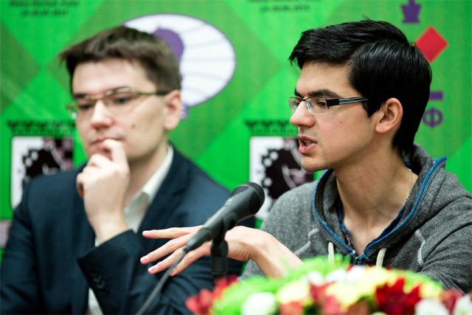
GIRI - TOMASHEVSKY (GP 2015):
How does White retains his piece advantage?

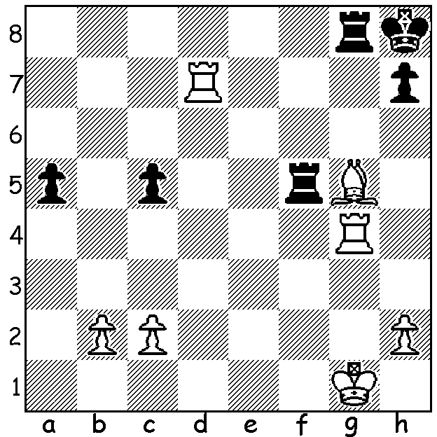 Tomashevsky (L) & Giri discuss their game

The recent 12 player Grand Prix event played in Khanty-Mansiysk, Russia, resulted in a 3-way tie between Dmitry Jakovenko (Russia), Fabiano Caruana (Italy) & Hikaru Nakamura (US), all with 6.5/11. This together with previous GP results enabled Caruana and Nakamura to qualify for the forthcoming Candidates tournament to decide the next challenger to world champion Magnus Carlsen (Norway). From the event I’ve chosen two games played by 11th place getter Georgian GM Baadur Jobava who has been called a maverick because of his liking for irregular and out of fashion openings and defences.
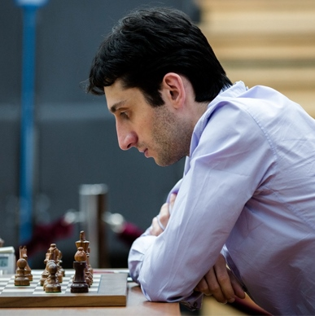
SERGEY KARJAKIN - BAADUR JOBAVA
2015 Grand Prix Khanty-Mansiysk, Rd 7
Nimzovitsch Defence
1.e4 e6 2.d4 d5
3.Nc3 Nc6 4.e5 Nge7
5.Nf3 Bd7 6.Ne2 Nf5
7.Ng3 Nh4(a) 8.c3 g6(b)
9.Bf4 f6!? 10.Nxh4 fxe
11.Nxg6 hxg6 12.dxe Qh4
13.Ne2(c) 0-0-0 14.Qd2 Rh5
15.Ng3 Rxe5+!(d) 16.Bxe5 Nxe5 Baadur Jobava
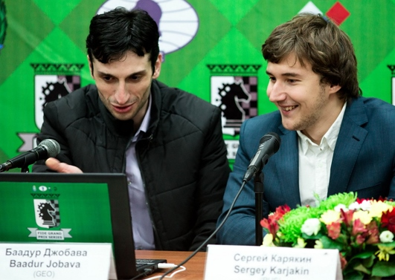
17.Qe3!(e) Nc6 18.Bb5 Bh6
19.Qe2 e5 20.Rd1 a6
21.Bxa6! Ne7(f) 22.Bb5(g) c6
23.Qxe5 Bf4 24.Rd4(h) Bxe5
25.Rxh4 cxb5 26.0-0 Kc7
27.Re1 Kd6 28.Rh7 Nc6
29.Rd1 Ke6 30.Re1 Kd6
31.Rd1 Ke6 32.Re1 DRAW

- 7…Nxg3 8.hxg3 favours White.
- Preventing 9.Nh5. Jobava & Karjakin in post game interview
- Better the immediate 13.Qd2.
- After giving up a pawn Black now sacrifices the exchange. His compensation lies in a strong centre and White’s king stuck in the centre (castling kingside gives Black a winning attack due to the half open h file).
- White didn’t like 17.Qd4 Qxd4 18.cxd4 Bb4+ 19.Ke2 (19.Kd1 Ng4) 19…Nc6 20.Rd1 e5.
- Not 21…bxa6 22.Qxa6+ Kb8 23.Rxd5 Ne7 24.Ra5 winning.
- White thought 22.Bd3 Bf4 was too dangerous.
- Playable was 24.Qd4 cxb5 25.Ne2 Bg5 26.Qxh4 Bxh4 27.0-0.

BAADUR JOBAVA - ALEXANDER GRISCHUK
2015 Grand Prix Khanty-Mansiysk, Rd 4
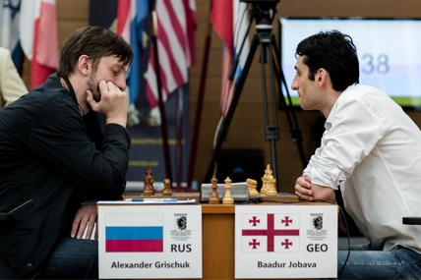
Giuoco Piano
1.e4 e5 2.Nf3 Nc6
3.Bc4 Bc5 4.c3 Nf6
5.d4(a) exd 6.e5 d5
7.Bb5 Ne4 8.cxd Bb6
9.h3 0-0 10.0-0 f6
11.Bxc6 bxc6 12.Be3 fxe
13.Nxe5 Ba6 14.Re1 Ba5(b)
15.Nxc6 Qh4 16.Nxa5 Rxf2!
17.Nc3(c) Rxg2+! 18.Kxg2 Qg3+
DRAW

- While some players have been choosing the Giuoco Piano (3.Bc4) as a change from the Ruy Lopez (Bb5), they have continued 5.d3 here.
- Ensuring a draw.
- 17.Bxf2 Qxf2+ 18.Kh1 Bf1! 19.Rxf1 Ng3+ DRAW.

SOLUTION: 1.Rd5! (1.h4 fails against 1…h6) Black resigns (1…Rxd5 2.Bf6+):

