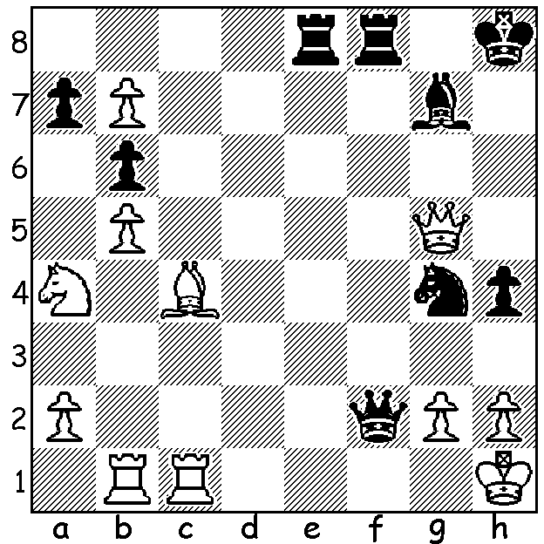

Jagadeesh Aadirya - Xiangi Liu
(Asian Schools Championship 2015):
Black has a chance to bring off a brilliant
mating finish using every one of his pieces
(6/7 moves):

The 11th Asian Schools Championships were held in Singapore 30 May to 8 June with 360 players from 19 countries. There were Open and Girls’ sections ranging from Under 7 to Under 17. Australia was represented in the Open Under 17 by WA’s Patrick Gong, the Australian Under 16 champion. Winner was Liu Xiangi from Singapore with 7/9 while Patrick finished =8/23 with 5 pts. The first game below shows Patrick’s skill in developing thematic queenside pressure in the Benoni while the second shows the champion developing pressure with his queen, knights and rooks while confining Black’s queen to the back rank central squares.


Altankhuyag Dulguun - Patrick Gong
2015 Asian Schools Under 17 Championship
Benoni Defence
1.d4 Nf6 2.c4 c5
3.d5 e6 4.Nc3 exd
5.cxd d6 6.e4 g6
7.f4 Bg7 8.Nf3 0-0
9.Bd3 Bg4 10.0-0 Nbd7
11.h3 Bxf3 12.Qxf3 a6
13.a4 Qc7 14.a5 c4
15.Bc2 b5 16.axb6 Qxb6+
17.Kh1 Ne8 18.Qg4 Nc5
19.Na4 Qa5 20.Be3 Nxa4
21.Rxa4 Qb5 22.Qe2 Rc8
23.Bc1?(a) c3! 24.Qd1 cxb
25.Bxb2 Rxc2! 26.Bxg7 Qxa4
27.Bxf8 Qxe4 28.Qg4 Kxf8
29.Qg5 a5 30.Rf3 Qf5
31.Qd8 Qxd5 32.Kg1 a4
33.f5 a3 34.f6 Rc1+ Patrick receiving prizes at the 2015
35.Kf2 Qe4 36.Qb6 Qe1# Australian Junior Championships.
a) 23.Ra2 would avoid the coming disaster.

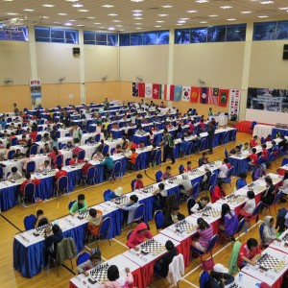
Liy Xiangi - Chingys Isaev
2015 Asian Schools Under 17 Championship, Rd 9
Ruy Lopez, Fianchetto Defence
1.e4 e5 2.Nf3 Nc6
3.Bb5 g6 4.0-0 Bg7
5.c3 a6 6.Ba4 d6
7.d4 Bd7 8.Re1 Nf6
9.Bg5 0-0 10.Bxc6 Bxc6
11.dxe dxe 12.Nbd2 Qe8
13.Qb3 Nd7 14.Be3 Rd8
15.Qc4 Rc8 16.Nb3 Qe7
17.Na5 Bb5 18.Qb3 b6
19.a4 Bd3 20.Nc6 Qe8
21.Bg5 Bf6 22.Bh6 Bg7
23.Bg5 Bf6 24.Bxf6 Nxf6
25.Nfxe5 Bxe4 26.Qc4 Bd5
27.Qh4 Kg7 28.Nd4 Qd8
29.Rad1 Nd7 30. Nf5+! gxf5
31.Qg3+ Kh8 32.Rxd5 resigns

SOUTH WEST OPEN: Last week Bridgetown was again the host for the annual S W Open. In shared first place were last year’s winner Marc Vlietstra and Adam Kelly followed by Gordon Dunlop, Paul Whitehead, Brian Gale and Steve Wood from Bridgetown who becomes WA Country champion.
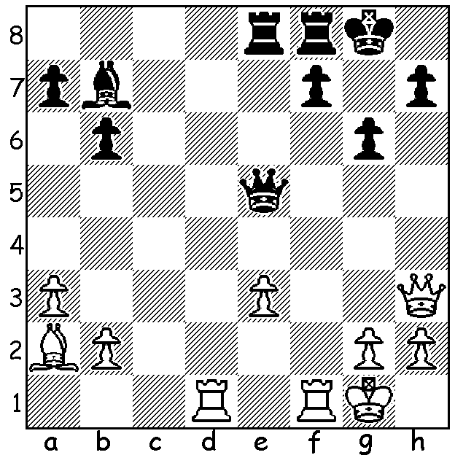

CORRECTION: I wonder how many readers spotted the error
in the solution to Tan – Ganguly position two weeks ago –
I gave 1.Rxf7 Rxf7 2.Bxf7+ Kxf7 3.Qxh7+ Kf6 4.Qxb7 Qxe3+ 5.Kh1
which, as Bill Rochow pointed out, loses to 5...Qe1+!
White in fact prevented the mate by playing 4.Rf1+
before capturing the bishop.

SOLUTION: 1.Qg1+!! 2.Kxg1 Be4+ 3.Kh1 Nf2+ 4.Kg1 Nd1+ 5.Kh1 Re1+ 6.Bf1 R either Rxf1#.
White can delay mate with 3.Qe3! Rxe3 (threat 4…Re1#) 4.Kh1 (4.g3 Rxg3+ 5.Kh1 Nf2#) 4…Nf2+ etc.

