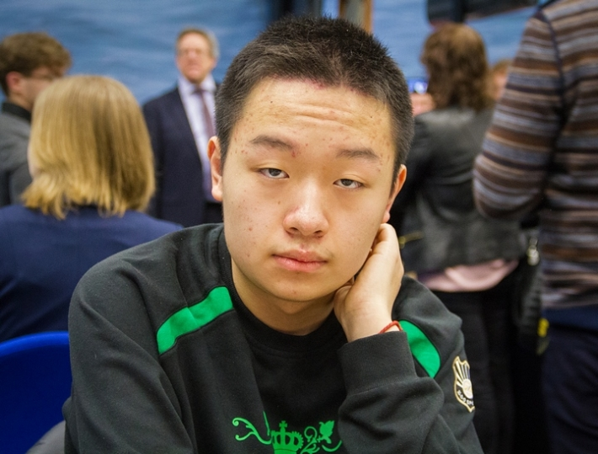
Wei Li – Jun Zhao (2013): White mates quickly:

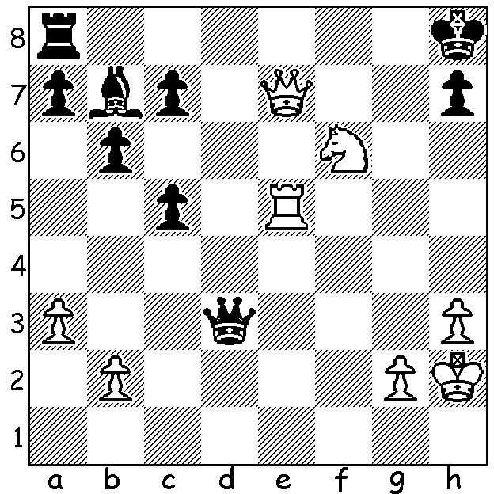 Wei Li


In the latest FIDE ratings China had 8 players in the top 50
(starting with Ding Liren in 15^{th)}, bettered only by Russia
with 13. The situation was similar in Women’s ratings
with 10 of the top 50 (headed by Hou Yifan at number 1)
compared to 15 for Russia. Clearly then, it will be expected
that some very good games will have been played at the
Chinese Championships, played 18-29 May. Winner was
Wei Yi aged 15 with a score of 7.5/11, followed by Ding
Liren (7), Yu Yangyi & Wang Hao (6.5). Here are two games
from the event, both featuring exchange sacrifices (rook for
bishop or knight), one the pivotal game between winner and
runner-up: Ding Liren

WEI YI - DING LIREN
2015 Chinese Championship
Ruy Lopez: Berlin Defence
1.e4 e5 2.Nf3 Nc6
3.Bb5 Nf6 4.0-0 Nxe4
5.d4 Nd6 6.Bxc6 dxc6
7.dxe Nf5 8.Qxd8+ Kxd8
9.h3 Bd7 10.Rd1 Be7
11.g4 Nh4 12.Nxh4 Bxh4
13.Nd2 Kc8 14.Nf3 Be7
15.Rd3 h6 16.Nd4 b6
17.Rf3 Be8 18.Nf5 Bf8
19.b3 Bd7 20.Bb2 Be6
21.Nd4 Bd5 22.Re3 Bc5
23.c4 Be6 24.f4 g6
25.Rf1 Kb7 26.Kg2 Rad8
27.Rd3 h5 28.Nxe6! Rxd3
29.Nxc5+ bxc5 30.e6 Rhd8
31.exf Rd2+(a) 32.Rf2 Rxf2+
33.Kxf2 Rf8 34.f5 Rxf7
35.Kg3 gxf 36.g5 resigns

a) Black has good drawing chances keeping both rooks on with 31.Rf8.

LIU QINGNAN - LIN CHEN
2015 Chinese Championship
Sicilian Defence, Scheveningen
1.e4 c5 2.Nf3 d6
3.d4 cxd 4.Nxd4 Nf6
5.Nc3 e6 6.Be3 Be7
7.f4 Nc6 8.Qf3 e5
9.Nxc6 bxc6 10.f5 0-0
11.0-0-0 Qa5 12.Bc4 Rb8
13.Bb3 d5! 14.exd5 Rxb3!
15.axb3 cxd 16.Nxd5 Nxd5
17.Qxd5 Qa1+ 18.Kd2 Qxb2
19.Qe4 Ba6 20.Ke1 Rc8
21.Kf2(a) Rxc2+ 22.Kg3 g6
23.f6(b) Bxf6! 24.Rd6 Rxg2+!
25.Qxg2 Bh4+ 26.Kh3 Bc8+
27.Qg4 Bxg4+ 28.Kxh4 Qg2
29.Bh6 f6 White resigns

a) 21.Rc1 Bc5 22.Bd2 Rd8= is an equally good alternative.
b) A losing combination: 23.Rb1 left White with reasonable chances.

SOLUTION: 1.Ne8! Qg6 (1…Rxe8 2.Qf6+) 2.Qf8+ Qg8 3.Qf6+ Qg7 4.Qxg7#.

