Ding Liren – Rui Gao 2014: Ding Liren
White to play and win (5 moves):

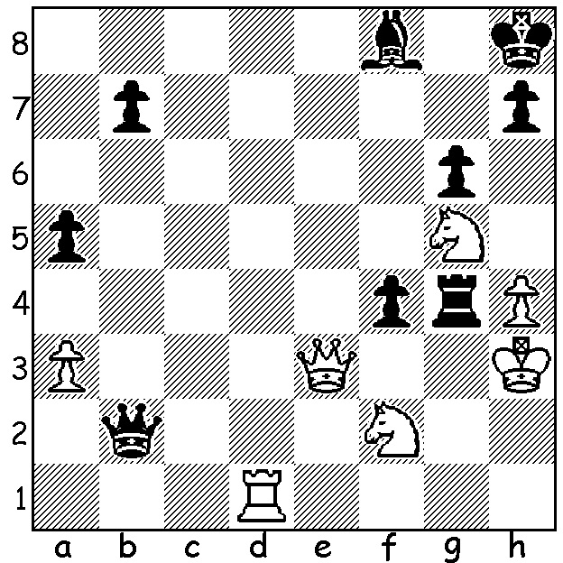

We continue from last week with more games played at the Chinese Championships, 18-29 May, which was won by the then 15 year old Wei Yi with a score of 7.5/11, followed by Ding Liren (7), Yu Yangyi & Wang Hao (6.5). As last week we see two games involving exchange sacrifices:

YU YANGYI - DING LIREN
2015 Chinese Championship, Rd 3
Ruy Lopez, Berlin Defence
1.e4 e5 2.Nf3 Nc6
3.Bb5 Nf6 4.d3 Bc5
5.c3 0-0 6.0-0 Re8
7.b4 Bb6 8.Bc4 d6
9.a4 a5 10.b5 Ne7
11.Qb3 Rf8 12.Nbd2 Ng6
13.d4 Nh5 14.dxe Nxe5
15.Nxe5 dxe5 16.Nf3 Qf6
17.Bg5 Qg6 18.Be7(a) Nf4
19.Nh4 Qg4 20.g3(b) g5(c)
21.Ng2 Nh3+ 22.Kh1 Qf3
23.Bxf8 Kxf8 24.Qa2 Bg4
25.Rae1 Rd8 26.Be2(d) Nxf2+
27.Kg1 Qxc3 28.Rxf2 Bxf2+
29.Kxf2 Rd2 White resigns(e)

a) Risky, allowing Black to establish a knight on f4.
b) If 20.Bxf8 Qxh4 21.Ba3 Bh3 22.g3 Ne2+ 23.Kh1 Qxe4+ 24.f3 Qe3 with a winning attack.
c) Stronger is 20…Nh3+ 21.Kg2 Nxf2! 22.Rxf2 Qh3+ 23.Kh1 Bxf2 24.Bf1 Qe6 25.Qxe6 Bxe6 26.Bxf8 Kxf8.
d) Necessary was 26.Bd5 although Black is on top after 26…Nxf2 27.Rxf2 Qxf2 28.Qxf2 Bxf2.
e) After 30.Qb1 Rxe2+! 31.Rxe2 Qf3+ 32.Kg1 Qxe2 33.Qc1 Qd1+ wins.

LIU QINGNAN - ZHAO JUN
2015 Chinese Championship, Rd 2
Sicilian, Taimanov Variation
1.e4 c5 2.Nf3 e6
3.d4 cxd 4.Nxd4 Nc6
5.Nc3 Qc7 6.Be3 a6
7.Qd2 Nf6 8.f3 Bb4
9.0-0-0 Ne5 10.Nb3 b5
11.Qe1 Be7 12.f4 Ng6
13.e5 Ng4 14.Bd2 Bb7
15.Bd3 Rc8 16.Qe2 f5
17.exf6 Nxf6 18.Rhf1 0-0
19.f5 Ne5 20.Bf4 Nxd3+
21.Rxd3 Qb6 22.fxe dxe
23.Be3 Qc7 24.Bf4 Qb6
25.Rg3 b4 26.Be3 Qd6
27.Bf4 Qd7 28.Rd1 Qe8
29.Qxe6+ Qf7 30.Qxf7+ Rxf7
31.Ne2 Nh5 32.Re3 Nxf4
33.Nxf4 Bg5 34.g3 Rxf4!
35.gxf4 Bxf4 36.Kd2 Bf3
White resigns(a)

a) If 37.Re1 Rd8+ 38.Kc1 Bxe3+ 39.Rxe3 Rd1#.

THE PRIMARY & SECONDARY SCHOOLS CHAMPIONSHIPS will be held 13-15 July at Leeming Primary School. Details cawa.org.au and enquiries 94099579.

The death at 66 has been reported of Australian born GM Walter Browne, a former Australian and six times US champion. Articles next month will feature games of this brilliant player.

SOLUTION: 1.Rd8!! if 1…fxe3 2.Rxf8+ Kg7 3.Ne6+ Kh6 4.Nxg4+ Kh5 5.Nf4#.

