Another finish by top-rated Chinese player Ding Liren, White v Anton Filippov 2010:


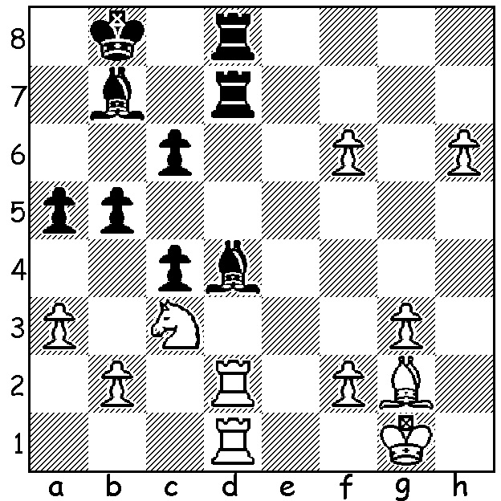

A final look at the 2015 Chinese Championship won by 15 year old Wei Yi with the game again containing exchange sacrifices as well as a fierce attack, a resolute defence and a fascinating ending with an extra piece attempting to hold back a pawn mass:

WAN YUNGUO - LU SHANGLEI
2015 Chinese Championship, Rd 2
Sicilian Dragon, Yugoslav Attack
1.e4 c5 2.Nf3 d6
3.d4 cxd 4.Nxd4 Nf6
5.Nc3 g6 6.Be3 Bg7
7.f3 Nc6 8.Qd2 0-0
9.Bc4 Bd7 10.h4 Ne5
11.Bb3 h5 12.0-0-0 Rc8
13.Bg5 Rc5 14.Kb1 b5
15.g4!?(a) hxg 16.h5 Nxh5
17.Nd5 Re8 18.Rxh5 gxh5
19.Qh2 Rxd5(b) 20.Bxd5 gxf3
21.Qxh5 f2!(c) 22.Nf5 Bxf5
23.exf5 Qa5 24.Bf4 Rf8
25.f6! Bxf6 26.Be4 Rd8
27.Qh6(d) Bg7 28.Qh7+ Kf8
29.Bh6 Ke8(e) 30.Bxg7(f) Qe1!
31.Qh1 Qxh1 32.Bxh1 f6
33.Bh6 Ng4 34.Bf4 Kd7
35.Bf3 f5 36.Be2(g) a6
37.Bg3 Rf8 38.Kc1 e5
39.Kd2 e4 40.Bxg4 fxg4
41.Ke2 e3! 42.Rxd6+ Ke7
43.Rd1 Ke6 44.c3 Rf3
45.Bc7 Kf5 46.Rd5+ Ke6
47.Rd1 Kf5 48.b3?(h) b4!
49.Ba5(i) Kf4(j) 50.Bc7+ Ke4
51.cxb g3 52.Bxg3 Rxg3
White resigns

a) White is prepared to invest the exchange and pawns to break through against Black’s king.
b) A circumspect return of the exchange, removing a dominant White piece.
c) How important this move turns out to be.
d) White wins a piece through the mate threat of 28.Bxe5 d/Rxe5 29.Bh7+ Kh8 30.Bg6+ Kg8 31.Qh7+ Kf8 32.Qxf7#.
e) 29…Bxh6?? 30.Qh8#.
f) Not 30.Qxg7 Qe1! winning.
g) Better 36.Rf1 e5 37.Bg3 Rg8 38.Bxg4 Rxg4 39.Bxf2 a6 (39…Rf4 40.Kc1 e4 41.Kd2 d5 42.Ke1 saves the bishop) with some hopes of a White win.
h) White could draw by repeating (48.Rd5+ Ke6 49.Rd1) but wanting more commits a fatal blunder.
i) If 49.cxb Ke4 wins as White can no longer drive the king back with Rd4+.
j) 49…Rg3 also wins.

THE PRIMARY & SECONDARY SCHOOLS CHAMPIONSHIPS will be held next week, 13-15 July, at Leeming Primary. Details / entry cawa.org.au & enquiries 94099579.

SOLUTION: 1.Rxd4! Rxd4 2.Rxd4 Rxd4 3.Nd5! & the h pawn queens.

