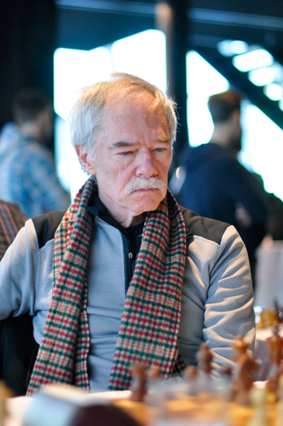
Walter Browne - Arthur Bisguier 1974: after long thought Browne unleashed a brilliant over-the-board innovation in this known position from the Petroff:
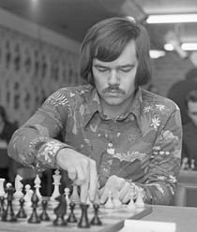
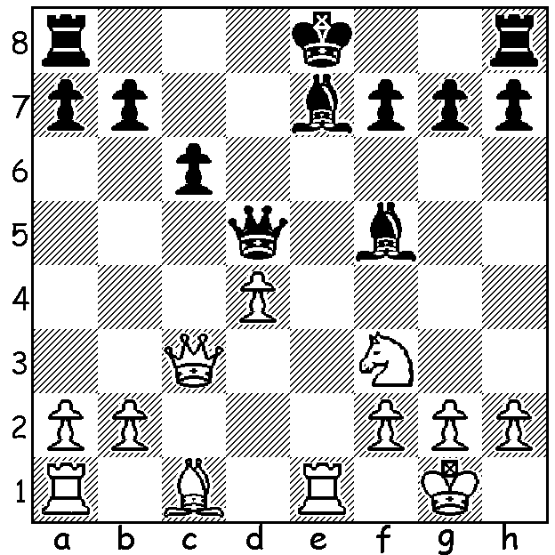

GM Walter Browne, who was born in Sydney of an Australian mother and American father in 1949, died last month at the age of 66 in USA. Browne went with his family at the age of 3 to live in New York but was active in Australian chess, winning the Australian championship in 1969 and representing Australia in two Olympiads, one of which, in 1972, he played in every round scoring the phenomenal 17.5/22 on top board, a score that only earned a bronze medal as individual medal places were decided on percentages. He also represented USA in four Olympiads, once on Board 1, and won the US championship a total of six times between 1974 and 1983, with only Bobby Fischer and Samuel Reshevsky winning the title on more occasions. Browne also won a number of international tournaments, including Wijk aan Zee in 1974 & 1980. His style was aggressive and he was prepared to spend considerable time on the opening and middle game, resulting in frequent time-trouble. In the game below, as Black, he sacrifices a pawn to gain the initiative before unleashing a brilliant long term queen sacrifice:

John van der Wiel - Walter Browne
Wijk aan Zee 1980
Sicilian, Najdorf Variation
1.e4 c5 2.Nf3 d6 3.d4 cxd 4.Nxd4 Nf6 5.Nc3 a6 6.f4 Nbd7
7.Be2 e5 8.Nb3 b5 9.Bf3 Bb7 10.Qe2 Be7 11.a3 0-0 12.0-0 Re
13.Kh1 Rc8 14.f5 d5 15.exd e4 16.Nxe4 Bxd5 17.Ned2 Qc7 18.Bxd5 Nxd5
19.Qd3 N5f6 20.Nd4 Ne5 21.Qh3 Bc5 22.N2b3 Bxd4 23.Nxd4 Qc4 24.Be3 Neg4
25.Bg1 Re4 26.Rad1 Qa2 27.Rb1 Qd5 28.c3 Rce8 29.Rbd1 h5 30.Ne2 Qb3
31.Ng3 Qxd1!! 32.Rxd1 Re1 33.Rxe1 Rxe1 34.Nf1! Rxf1 35.Qh4 Ne4 36.g3 Nef2+
37.Kg2 Ne3+ 38.Kf3 Nfd1+ 39.Ke4 Rxg1
With such material advantage Black soon won (53 moves).

SOLUTION: 14…Bh6!! This move was include in Tim Krabbe’s ‘The 101 Most Fantastic Moves Ever Played’. Bisguier thought for a long time in reply before playing 14…Rg8
(14…gxh6 leaves the exposed h8 rook in danger - 15.Re5 Qd7 16.Rae1 Be6 17.d5! cxd 18.Rxe6! fxe6 19.Qxh8+ Bf8 20.Qf6 Be7 21.Rxe6 winning or 14…Be4 15.Bxg7 Rg8 16.Bf6! Bxf6 17.Rxe4+ Qxe4 18.Re1).
Play continued
15.Re5 Qd7 16.Rae1 Be6 17.Ng5!
(17…if Bf6 18.Nxe6 Bxe5 19.Nc5 winning or 17…Bxg5 18.Bxg5 h6 19.Bh4 g5 20.Bg3 Kf8 21.Rxe6! fxe6 22.d5 wins – 22…cxd 23.Qf6+ Qf7 24.Bd6+ Ke8 25.Rxe6+)
17… 0-0-0 18.Nxf7! Bxf7 19.Rxe7 Qxd4
20.Rxf7 Qxc3 21.bxc3 gxh6 22.Rb1 Rg5
23.h4 Rb5 24.Rxb5 cxb5 25.Rxh7 with a winning endgame.

