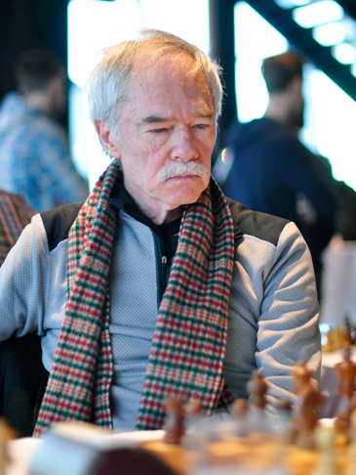
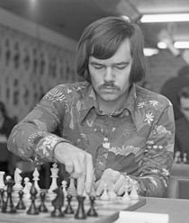
Browne - Kovacs 1970: White mates in 4:

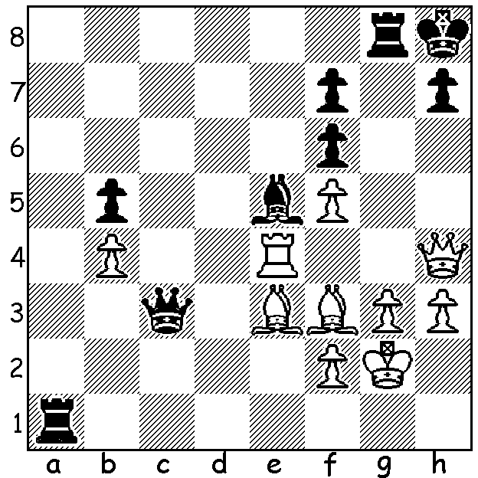

Last week we looked at the career of Australian born GM Walter Browne, an Australian and six times US Champion, who died last month at the age of 66. Today some more information on this fascinating character. A motor bike rider, Browne was immensely talented and competitive at everything he tried, whether tennis, table-tennis, snooker, backgammon or scrabble. However his main competitive love outside of chess was poker which he played professionally. I recollect reading some years ago that he liked to go into a chess game feeling hungry, believing this made him more aggressive. He was certainly confident, a trait shown in an anecdote from the 1980 Wijk aan Zee tournament which he won. He was told by a fellow competitor, ‘You’ve got a big game tomorrow, Walter. You’re White with Korchnoi’ (Korchnoi was then Number 2 in the world after world champion Karpov). Browne replied, ‘No, he’s the one who’s got a big game.’ His passion for the game can be summed up in another anecdote after a fellow player told Browne he was contemplating retiring. Browne retorted, ‘There is no such thing, retiring from chess. If you love chess it will always be with you. You will be dreaming about chess. You cannot retire from chess.’ Here then are two more brilliant Browne victories:

Walter Browne - Bernard Zuckerman
New York 1973
Queens Gambit Declined: Orthodox Defence
1.d4 d5 2.c4 e6 3.Nc3 Be7
4.Nf3 Nf6 5.Bg5 0-0 6.e3 Nbd7
7.Bd3 dxc 8.Bxc4 c5 9.0-0 a6 10.a4 cxd 11.exd Nb6 12.Bb3 Bd7
13.Ne5 Bc6 14.Bc2 Nbd5 15.Bb1 Nb4 16.Re1 g6 17.Bh6 Re8 18.Ra3 Qd6
19.Ne2 Rad8 20.Rh3 Qd5 21.Nf3 Qa5 22.Nc3 Nbd5 23.Ne5 Nxc3 24.bxc3 Bxa4
25.Qe2 Bd7 26.Bg5 Nd5 27.Nxf7! Bxg5 28.Rxh7! Nf6(a) 29.Bxg6 Nxh7 30.Qh5 Qxc3
31.Qxh7+ Kf8 32.Rf1 Qxd4 33.Ne5! Qf4 34.Nxd7+ Rxd7 35.Qh8+ Ke7 36.Qxe8 & wins

a) 28…e5! seems to draw – 29.Bxg6 Nf4 30.Qe4 exd 31.Rh8+ Kg7 32.Rh7+ Kg8 (32…Kf6?? 33.Qxd4+ Kxg6 34.Qg7+ Kf5 35.Qxg5#).

Walter Browne - Larry Christiansen
1977 US Championship
Owens Defence
1.d4 e6 2.c4 b6
3.d5 Ba6 4.e4 exd
5.exd Nf6 6.Nc3 Bb4
7.Qe2+ Be7 8.Qc2 c6
9.Bd3 b5 10.cxb cxb
11.Nge2 b4 12.Ne4 Nxd5
13.0-0 0-0 14.Rd1 Qa5
15.N2g3 g6 16.Bh6 Re8
17.Qd2 Nf6 18.Qf4 Qb6
19.Bxa6 Nxa6 20.Rd6!! Bxd6
21.Nxf6+ Kh8 22.Bg7+!! Kxg7
23.Ngh5+! gxh5(a) 24.Qg5+ Kh8
25.Qh6 Bxh2+ 26.Kh1 Qxf6
27.Qxf6+ & wins

a) If 23…Kf8 (23…Kh8 24.Qh6 mates) 24.Nxh7+ Kg8 25.N7f6+ Kf8 26.Qh6+ Ke7 27.Nd5+ wins Queen.

SOLUTION: 1.Qxh7+! Kxh7 2.Rh4+ Kg7 3.Bh6+ Kh7/8 4.Bf8#.

