Everyone following chess loves a king hunt involving sacrifices where the opponent’s monarch is driven around the board to its doom. Here is perhaps the most famous king hunt of all time. Many readers will be familiar with the position but it still needs considerable calculation to find the mate in 8 with every move a check (Edward Lasker – Sir George Thomas 1912):

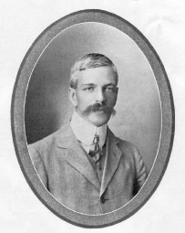
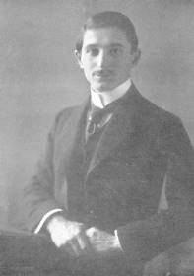
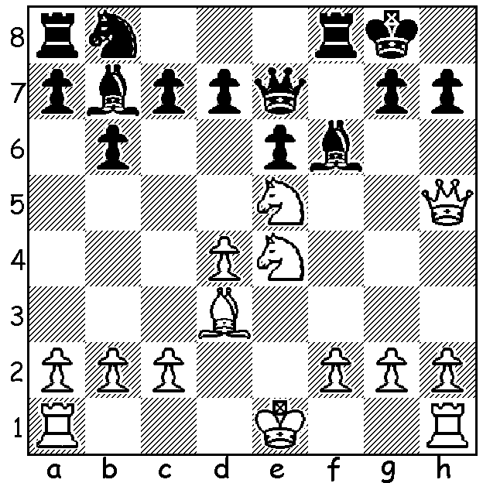
Edward Lasker Sir George Thomas

Here is a king hunt played by Chinese teenage sensation Wei Yi in the recent 6th Hainan Danzhon GM tournament in China in which eight leading Chinese players were joined by two international GMs. The tournament was won by Wang Yue with 8/9 with Wei Yi coming 4th with 5/9. However Wei Yi certainly enhanced his reputation with the following game described in Chess Vibes as a ‘21st Century Immortal’. The game is particularly memorable in view of the number of non-checking (quiet) moves after the sacrifices.

WEI YI - BATISTA BRUZON
6th Hainan Danzhon GM Tournament
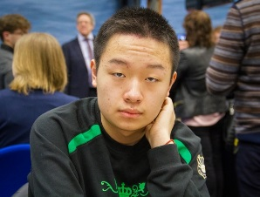
Sicilian Sheveningen
1.e4 c5 2.Nf3 e6
3.Nc3 a6 4.Be2 Nc6
5.d4 cxd 6.Nxd4 Qc7
7.0-0 Nf6 8.Be3 Be7
9.f4 d6 10.Kh1 0-0
11.Qe1 Nxd4 12.Bxd4 b5
13.Qg3 Bb7 14.a3 Rad8
15.Rae1 Rd7 16.Bd3 Qd8
17.Qh3 g6 18.f5 e5 Wei Yi

19.Be3 Re8 20.fxg hxg
21.Nd5!(a) Nxd5(b) 22.Rxf7!!(c) Kxf7
23.Qh7+ Ke6 24.exd5+ Kxd5(d)
25.Be4+!! Kxe4(e) 26.Qf7!(f) Bf6
27.Bd2+ Kd4 28.Be3+ Ke4
29.Qb3(g) Kf5 30.Rf1+ Kg4
31.Qd3! Bxg2+(h) 32.Kxg2 Qa8+
33.Kg1 Bg5(i) 34.Qe2+ Kh4
35.Bf2+ Kh3 36.Be1! resigns(j) Batista Bruzon

a) A strong novelty.
b) This loses – 21…Bxd5 was necessary although White remains better.
c) This move was missed by computers at the time.
d) If 24…Bxd5 25.Bxg6 Rf8 26.Qh3+ Kf6 27.Rf1+ Kg7 28.Qh7#.
e) If 25…Ke6 26.Qxg6+ Bf6 27.Qf5+ Ke7 28.Qh7+ Kf8 29.Bh6+ Rg7 30.Rf1! wins.
f) The first of the quiet moves (threat 27.Qf3#) – note too moves 29, 31, 36.
g) Threat 30.Qd3#.
h) If 31…Rg7 32.Qe2+ Kh4 33.h3! Qd7 34.Kh2! Bxg2 35.Qxg2 Bd8 36.Rg1 wins.
i) If 33…Rg7 34.Qe2+ Kh4 35.Bf2+ Kh3 (35…Kg5 36.Qe3+ Kf5 37.Qh3+ Ke4 38.Qd3+ Kf4 39.Be1+ Kg4/5 40.Qg3+ Kh5/6 41.Qh3+ Kg5 42.Qh4#) 36.Qd3+ Kg4 37.Qg3+ Kf5 38.Qh3+ Ke4 39.Qd3+ Kf4 40.Be1+ etc.
j) If 36…Rf8 37.Qd3+ Kg4 38.Qg3+ Kh5 39.Qh3+ Bh4 40.Qxh4#.

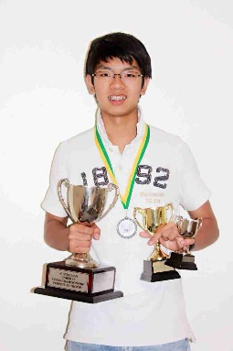
PRIMARY & SECONDARY STUDENTS CHAMPIONSHIPS:
The championships, held at Leeming Primary over the recent school
holiday, attracted 34 entries. Primary winner was Christian Bezuidenhout
with Patrick Scally 2nd while Australian Under 16 champion Patrick
Gong won the Secondary with WA Junior champion Ignatius Yap 2nd.
Girls’ co-champions were Josephine Mower & Maia Harlop while
Chidlow Primary and Willetton SHS won the schools’ awards.

OCEANIA CHESS ZONAL: Patrick Gong scored a fine 5.5/9 just filed
to gain a FM norm but gaining a Candidates Masters title as did Adam Kelly
who scored 4.5.

SOLUTION: 1.Qxh7+! Kxh7 2.Nxf6+ Kh6 (2…Kh8 3.Ng6#) 3.N5g4+ Kg5 Patrick Gong
4.h4+ Kf4 5.g3+ Kf3 6.Be2+ Kg2 7.Rh2+ Kg1 8.0-0-0#.

