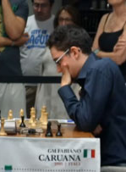
Fabiano Caruana (Black v Nispeanu) finds a
winning sequence of moves (3+) to win his
last round game and the tournament in a recently
completed tournament in Dortmund:

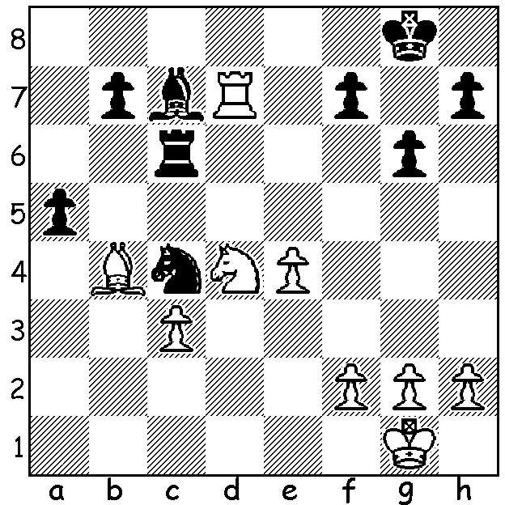

The results of the 3rd Norway Chess GM Tournament, played in Stavangar on the SW coast from 15th to 25th June, would have disappointed the Norwegian fans with world champion Magnus Carlsen failing to reach 50%, let alone challenging for top place. Unaware of a change of time controls at the start he lost to Veselin Topalov on time in a winning position. This was followed up by a Rd 2 loss to Fabiano Caruana. He also lost to ex-world champion Viswanathan Anand and compatriot, Norway’s number 2 Jon Ludvig Hammer (for the first time since the age of 10), and finished with a mere 3.5/9. Winner was a fortunate Topalov (6.5/9) who also defeated Hammer who missed a simple drawing move in an ending in their game. Anand played impressively to tie =2nd with Hikaru Nakamura on 6 points.

Viswanathan Anand - Magnus Carlsen
3rd Norway Chess, Rd 4
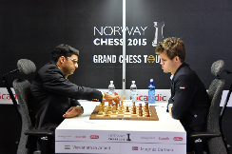
Ruy Lopez, Breyer Defence
1.e4 e5 2.Nf3 Nc6
3.Bb5 a6 4.Ba4 Nf6
5.0-0 Be7 6.d3 d6
7.c3 0-0 8.Nbd2 Re8
9.Re1 b5 10.Bc2 Bf8
11.Nf1 g6 12.h3 Bb7
13.Ng3 Nb8 14.d4 Nbd7
15.a4 c5 16.d5 c4
17.Bg5 Bg7 18.Qd2 Rb8
19.Nh2 Bc8 20.Ng4 Nc5
21.Nh6+ Bxh6 22.Bxh6 bxa Anand v Carlsen in Norway
23.Ra2 a3 24.bxa Nfd7
25.f4 a5(a) 26.Rf1 f6
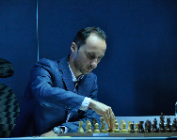
27.f5 Nd3 28.Bxd3 cxd3
29.Qd1!(b) Re7 30.Raf2 Rf7
31.Qxd3 Nc5 32.Qf3 Ba6
33.Qg4! g5(c) 34.h4! Bxf1
35.Rxf1 Qd7 36.hxg fxg
37.Qh5! Kh8 38.f6 Rg8
39.Bg7+ Rfxg7 40.fxg7+ Qxg7
41.Nf5 Qg6 42.Qxg6 Rxg6
43.Ne7 Kg7(d) 44.Nxg6 Kxg6
45.Rf8 a4 46.c4 h5 Topalov, winner in Norway
47.Kf2 resigns

a) 25…Qh4? fails to 26.Bg5 Qxg3 27.Re3 trapping the queen.
b) Clears the second rank for the QR: not 29.Qxd3 Qb6+ forcing the queen exchange with 30.Qe3 (30.Kh1? Ba6 31.c4 Qb3 with strong queenside play).
c) Clearly 33…Bxf1 would give White a winning attack with 34.fxg but better was 33…Bc8 with reasonable chances.
d) If 43…Rh6 44.Rf8+ Kg7 45.Rc8 Rf6 46.Nf5+ Kg6 47.Nxd6!

WILLETTON OPEN, a 6 round WA Grand Prix weekender, will be played 15 & 16 August at Leeming Primary, Meharry Rd., starting 10.30 each day. Details cawa.org.au: enquiries and entry ellisd19@bigpond.com or 0439798607. Please submit your entry by Friday 14th.

BLACKDRAGON BLITZ: a 5 minute Blitz tournament will be played at Centenary Park Community Centre, Belmont, on Sunday 23 August starting at noon. Enquiries blackdragonchessclub@gmail.com or 0451833186: register at blackdragochessclub.com

SOLUTION: 1…axb4 2.Nxc6 b3! 3.Rxc7 Nd6! and Black will queen.

