Hebden – Osborne (Br Ch 2015): Arkell – Summerscale (Br Ch 2015):
after White’s next move Black resigns: again White’s move is met by resignation:
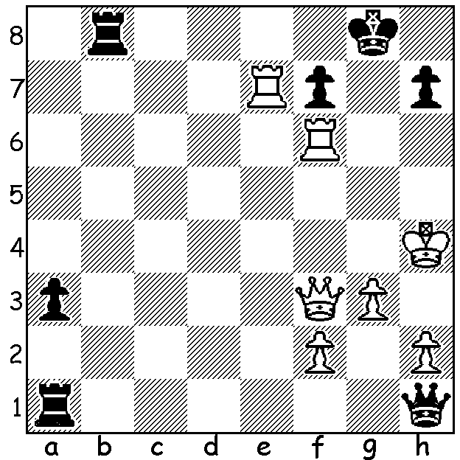
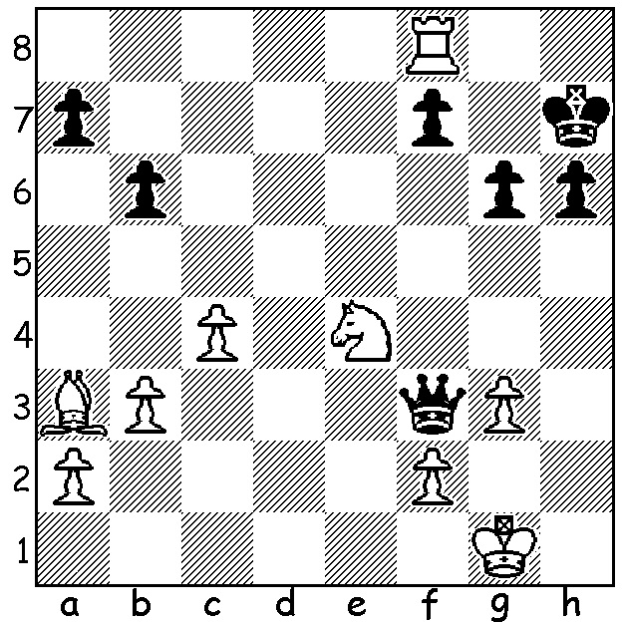

Despite missing a number of leading players, including Michael Adams, Nigel Short and Gawain Jones, there was an exciting finish to the recently completed British Championship with four players, David Howell, Jonathan Hawkins, Nicholas Pert & Danny Gormally, neck and neck on 7.5 coming into the 11th and final round. Howell was the favourite, being the top-rated player and coming off an outstanding victory in the 9th Leiden (Netherlands) Open with 8.5/9. However he failed to win his final game despite his opponent Mark Hebden blundering a pawn in time trouble. With his other rivals also drawing Hawkins, joint winner with Howell in 2014, was the only leader to win his game and with it the championship. Hawkins played aggressive chess throughout and played far fewer moves overall than his rivals.

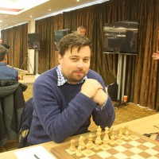
JONATHAN HAWKINS - ALISTAIR HILL
2015 British Championship, Rd 7
Grunfeld / Schlechter Slav Defence
1.d4 Nf6 2.c4 g6
3.Nc3 d5 4.Nf3 Bg7
5.h4 c6(a) 6.Bg5 dxc
7.e4 b5 8.e5 Nd5
9.h5 Bg4(b) 10.h6 Bf8
11.Be2 Nd7 12.Nd2 Be6
13.Bg4 Bxg4 14.Qxg4 f6(c)
15.Qe6! Qb6(d) 16.exf N5xf6
17.Bxf6 Nxf6 18.Nde4 Nxe4
19.Nxe4 Kd8 20.Nc5(e) Qc7 Jonathan Hawkins
21.d5! resigns(f)

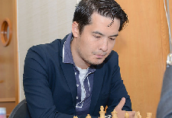
a) The logical way to face an early wing attack is to
counter in the centre – eg …dxc & …c5. White now
gambits a pawn to gain a space advantage.
b) 9…h6 10.Bd2 g5 prevents the cramping h6.
c) Rather than create a hole at e6 Black could play
14…f5, …N7b6 or …Qc8.
d) 15…fxg5 is met with 16.Nde4 / 17.Nd6+.
e) White is clearly winning with 20.Qe5 / Rd1 / Ng5
all good alternatives.
f) If 21…Qc8 22.dxc Qxe6+ 23.Nxe6+ Kc8 (23…Ke8 David Howell
24.Nc7+) 24.Rd1.

WILLETTON OPEN (6 round WA Grand Prix) will be played this weekend, 15 & 16 August, at Leeming Primary, Meharry Rd., starting 10.30 each day. Details cawa.org.au: enquiries and entry ellisd19@bigpond.com or 0439798607. Submit your entry today to assist organisation and to avoid late fee.

BLACKDRAGON BLITZ: a 5 minute Blitz tournament will be played at Centenary Park Community Centre, Belmont, on Sunday 23 August starting at noon. Enquiries blackdragonchessclub@gmail.com or 0451833186: register at blackdragochessclub.com

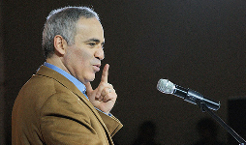
KASPAROV IN PERTH:
Did you know that Gary Kasparov was
in Perth this month, though not as a chess
player? Kasparov, who is the chairman of
the NY based Human Rights Foundation,
was the opening keynote speaker at the
recent WA Local Government Association
Conference.

AILEEN FISHER: The WA chess community will be shocked to hear of the death at 32 of prominent Perth Club player Aileen Fisher after a long battle with cancer.

AUSTRALIAN JUNIOR CHAMPIONSHIPS: WA juniors intending to play can contact CAWA re financial assistance.

SOLUTION: 1.Ng5+!! (1…hxg5 2.Bb2 mating with Rh8 - White’s obstruction sacrifice prevented 2…g5).
1.Rg6+! (1…f/h xg6 2.Qf7+).

