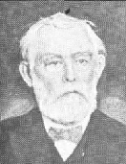
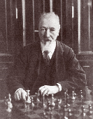
Blackburne - Hanham (NY 1889):
White to play and mate (4 moves):

Blackburne 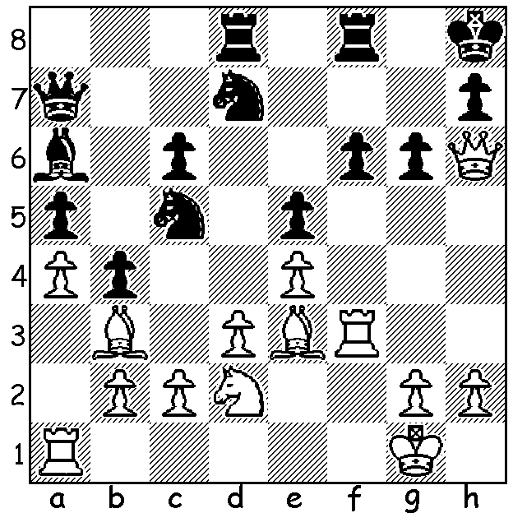 Hanham

Many readers will be unfamiliar with the name James Moore Hanham, the newest subject in our alphabet series of players who have given their names to openings or defences. Hanham (1840 – 1923) was a prominent player in USA whose main contribution to chess was a variation of Philidors Defence (1.e4 e5 2.Nf3 d6), the Hanham Variation. Philidors Defence gives Black the opportunity of employing any of the three possible responses to the tension created by White’s attempt to gain control of the centre with 3.d4 (this might be delayed) - release of the tension involving surrender of the centre with 3…exd, strong-point defence protecting the centre pawn with 3…Nd7 (Hanham Variation) or counter attack with 3…f5, favoured by Philidor but considered dubious (3…Nf6 can transpose any of these three). Hanham is also credited with introducing the Grand Prix Attack against the Sicilian (1.e4 c5 2.Nc3 Nc6 3.Bc4 and the Kings Indian Attack against the French (1.e4 e6 2.d3). Hanham had a mediocre career both in the USA and abroad, averaging just under 41% but he did have the distinction of being the oldest active US player of master rank at his death at 83. Here is one of his successes with his defence, against the attacking English player Joseph Blackburne, ‘The Black Death’ (see also diagram):

JOSEPH BLACKBURNE - JAMES HANHAM
6th American Chess Congress (NY 1889)
Philidors Defence, Hanham Variation
1.e4 e5 2.Nf3 d6 3.Bc4 Be7
4.Nc3 c6 5.d4 Nd7 6.0-0 Ngf6
7.Qe2 0-0 8.Be3 Qc7(a) 9.Bb3 h6
10.Nh4 Nb6 11.Ng6 Re8 12.dxe dxe
13.h3 Bd6 14.Rad1 Be6 15.Bxe6 Rxe6
16.Nh4 Nbd7 17.Nf5 Bf8 18.g4 Nh7
19.h4 Rg6 20.Kh1 Nc5 21.Rg1 Ne6
22.Rg3 Rd8 23.Rdg1 Nd4 24.Qf1(b) Nxc2
25.Bc1 Nd4 26.h5 Rf6 27.f4 exf
28.Bxf4 Qa5 29.Qc1 Re6 30.Bd2 Qe5
31.Bf4 Qa5 32.Be3 Nb5 33.Bd2 Nxc3
34.Bxc3 Qa4 35.Re1 Rxe4 36.b3 Rxe1+
37.Qxe1 Qxa2 38.g5 hxg 39.h6 Qc2
40.Nd4 Qg6(c ) 41.Qe5 Qxh6+ 42.Kg2 Qd6
43.Qe2 Qd5+ 44.Kh3 Qh1+ 44.Kg4 Nf6+
46.Kxg5 Rd5+ 47.Kf4 Bd6+ White resigns

a) The basic set-up of the Hanham.
b) White sacrifices a pawn to throw everything against Black’s king.
c) Black’s strong defensive position has withstood the attack and he now counterattacks against White’s exposed king.

Hanham’s most notable scalp was compatriot Harry Pillbury, winner of the great Hastings tournament of 1895, but he also defeated world champion Emmanuel Lasker, albeit in a simultaneous exhibition:

EMMANUEL LASKER - JAMES HANHAM
USA Simul Tour 1901, Kings Gambit Declined
1.e4 e5 2.f4 Bc5 3.Nf3 d6 4.Nc3 Nd7 5.Bc4 c6 6.d3 Qe7 7.d3 Qe7 8.f5 h6 9.Be3 b5 10.Bb3 b5
11.a3 Ba6 12.0-0 Bxe3 13.Qxe3 Nc5 14.Ba2 Qa7 15.Rad1?? Ng4 16.Qe2 Nd3+ 17.Kh1 Ndf2+ White resigns

LEON TAYLOR, one of Metro’s strongest player, became engaged
to Renzie Ruiz on August 9 in Kings Park. Congratulations!

BLACKDRAGON BLITZ: a 5 minute Blitz tournament will be played
at Centenary Park Community Centre, Belmont, this Sunday 23 August
starting at noon. Enquiries blackdragonchessclub@gmail.com or
0451833186: register at blackdragochessclub.com

SPEED CHESS: two 10 min tournaments are planned for Sunday 30
August (10.30 & 1.30) at Perth State Library, Francis St.. It’s hoped there
will be a large entry for this ambitious event. Information & registration
of interest christopherwalesdobson@mail.com or 0424979353.

SOLUTION: 1.Qxh7+!! resigns
(1…Kxf7 2.Rh3+ Kg7 3.Bh6+ Kh1 4.Bxf8#).

Leon & Renzie

