
Here’s one of the positions presented to
Patrick Gong when he became Australian
Junior Problem SolvingChampion last
January: White to play and draw (4 moves).
I’ve put a couple of clues in the game
notes if you need them:

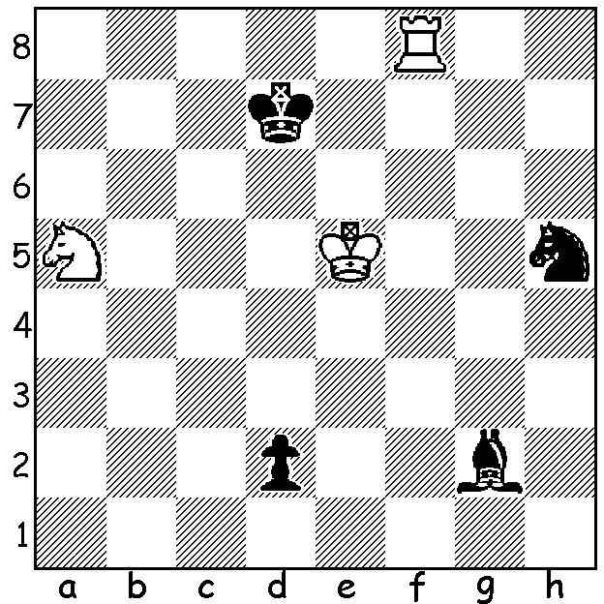

The Willetton Open, played earlier this month, resulted in another win to WA champion Yita
Choong with 5/6 (draws with Edik Gilmetdinov & Gordon Dunlop)+. 2nd = were Tim Hare making a welcome return to the Grand Prix scene, Andrew Hardegen, Gordon Dunlop and junior Paddy Goh, all on 4. Gordon and Paddy were the leading Under 1900 players while George France, Kevin Mygal and Mick Nairn, one of two players up from Albany, all on 3, shared the Under 1600 prizes. Although Tim Hare lost to both Yita and Ned Tomic (who makes a habit of defeating much higher rated players) he showed his skill in closed positions with a hard fought won against one of the state’s leading young players Adam Kelly:
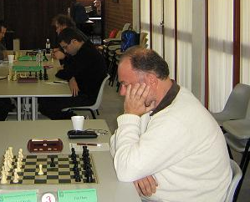
TIM HARE - ADAM KELLY
2015 Willetton Open, Rd 4
Kings Indian Attack (a)
1.Nf3 Nf6 2.g3 c5
3.Bg2 d5 4.b3 Nc6
5.Bb2 e6 6.d3 Bd6
7.Nbd2 0-0 8.0-0 e5
9.e4 d4 10.h3 h6
11.a4 Be6 12.Nc4 Bc7
13.Nh4 a6(b) 14.Nf5 b5
15.axb axb 16.Rxa8 Qxa8 Tim Hare
17.Na3 Qa6 18.Qf3 Ne8(c)
19.Ra1 Qb6 20.Kh2 Nd6 21.g4 Bxf5
22.gxf5 f6(c) 23.Rg1 Qb8(d) 24.Bc1 Qe8
25.Bf1(e) Kh7 26.Be2 Ne7 27.Qg4 Rg8
28.Qh4 Ba5 29.Bh5 Qf8 30.f4 Bb4
31.fxe fxe 32.Bg6+ Nxg6 33.Rxg6 Bxa3
34.Bxa3 b4 35.Bc1 Nf7 36.Re6 Qa8!(f)
37.Qh5 Qa1?(g) 38.Qg6+ Kh8 39.f6!(h) gxf3
40.Qxf6+ Rg7 41.Re8+ Kh7 42.Qf5+ Rg6
43.Qxf7+ Rg7 44.Qf5+ resigns

a) CLUES: White uses deflection or skewer to meet the immediate threat of 1…d1=Q.
When Black again threatens promotion an unprotected fork secures stalemate.
b) While White intends to build an attack against the king, Black plans to open up the queenside.
c) 19.Nxh6+ gxh6 20.Qxf6 was threatened.
c) Creating a severe weakness on the white squares – 22…Bd8 is a better way of preventing 23.f6.
d) 23…c4 might cause problems for White.
e) Successive aggressive undeveloping of the bishops and threatening 26.Bxh6.
f) Black has succeeded in opening up the queenside and is able to mount a counterattack with good prospects.
g) But this is the wrong square: 36…Qa2 threatening 37…Qxc2+ forces 38.Qd1 breaking White’s attack.
h) White breaks through with a sacrificial mating attack – 39…Qxc1 40.fxg+ Rxg7 41.Re8+.

SPEED CHESS: two 10 min tournaments are planned for the coming Sunday 30 August (10.30 & 1.30) at Perth State Library, Francis St.. It’s hoped there will be a large entry for this ambitious event. Information & registration of interest christopherwalesdobson@mail.com or 0424979353.

SOLUTION: 1.Nb7! (deflecting the bishop, enabling the rook to defend on the first rank) 1…Bxb7 (not 1…d1=Q? 2.Rd8+) 2.Rf1 Bf3! (threat 3…d1=Q 4.Rxd1 Bxd1 & Black will mate with B + N) 3.Rxf3!! d1=Q (3…d1=R is a draw) 4.Rd3+!! Qxd3 stalemate.

ignoring the threat to his bishop (39.Qxf7? gives Blac ka perpetual check).
If 39…Qxc1 40.fxg+ Rxg7 41.Re8+.

SOLUTION: 1.Nb7! Bxb7 (not 1…d1=Q? 2.Rd8+) 2.Rf1 Bf3 (threatening 3…d1=Q 4.Bxd1 and Black with bishop & knight has sufficient material to mate) 3.Rxf3!! d1=Q (promoting to a rook is also drawn) 4.Rd3+!! Qxd3 stalemate.

SOLUTION: 1.Rd5! (1.h4 fails against 1…h6) Black resigns (1…Rxd5 2.Bf6+):

