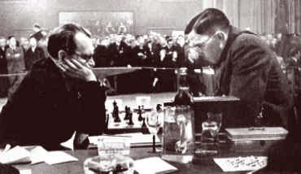
Speijer – Alekhine 1913: White plays 1.Nc4.
How does Black exploit this blunder? (4 moves)

Alekhine 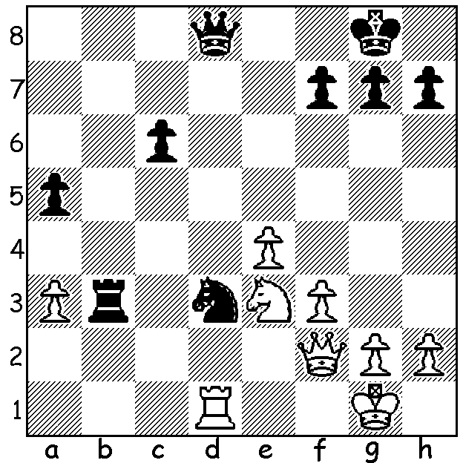
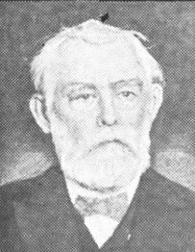

This week a return to the Hanham Defence, a variation of Philidors Defence
(1.e4 e5 2.Nf3 d6 3.d4 Nd7). This strongpoint defence, which seeks to maintain
Black’s grip of the centre, his e pawn, might enable Black to launch an attack
against White’s castled king as in the game below:

FREDERICK YATES - GEORG MARCO
The Hague 1921
1.e4 e5 2.Nf3 d6
3.d4 Nd7 4.Bc4 c6
5.Nc3 Be7 6.0-0 h6 Hanham
7.Be3 Ngf6 8.Bb3 Qc7
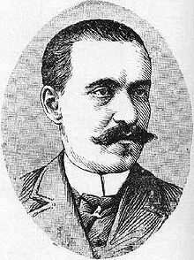
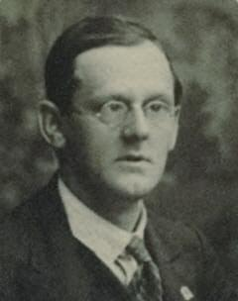
9.Nd2 g5 10.a4 Nf8
11.a5 Ng6 12.Re1 Nf4
13.f3 Rg8 14.Nf1 Be6
15.Ng3 Qd7! 16.d5 Bh3
17.gxh3 Qxh3 18.Qd2 N6h5
19.Qf2 g4 20.Kh1 gxf
21.Rg1 Bh4 22.Bxf4 exf4
23.Nxh5 Bxf2 24.Rxg8+ Ke7
25.Nxf4(a) Qh4 26.Rg7 Kf6
27.Rxf7+ Kxf7 28.dxc+ Kg7
29.Ne6+ Kh8 30.Nd5 bxc?(b)
White resigns
Yates Marco
a) Not 25.Rxa8 Qg5 mating.
b) 30…Bg3 is a more fitting conclusion.

The great Alexander Alekhine has 12 recorded tournament games with the Hanham for a +9 =2 -1 score. The puzzle is one win and here’s another:

N. Alexandrov - A. Alekhine (1910)
1.e4 e5 2.Nf3 d6 3.d4 Nd7 4.Bc4 c6
5.Ng5 Nh6 6.f4 Be7 7.0-0 0-0 8.Nf3 exd
9.Nxd4 d5! 10.exd Nb6 11.Bd3 Bc5 12.c3 Qxd5
13.Be3 Ng4 14.Qf3 Re8 15.Qxd5 Nxd5 16.Bc1 Nb4!
White resigns (17.cxb4 Bxd4+ 18.Kh1 Nf2+ 19.Rxf2 Bxf2 or 19.Kg1 Nxd3+: 17.Bc4 Nc2:
17.Be2 Bxd4+ 18.cxd4 Rxe2: 18.Rd1 Nxd3 19.Rxd3 Re1#)

Black can often enter the Hanham via 3…Nf6:
Abram Rabinovich - Alexander Ilyin-Zhenevsky (USSR 1922)
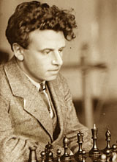
1.e4 e5 2.Nf3 d6
3.d4 Nf6 4.Nc3 Nbd7
5.Bc4 Be7 6.Bxf7+ Kxf7
7.Ng5+ Kg8 8.Ne6 Qe8
9.Nxc7 Qg6! 10.Nxa8 Qxg2
11.Rf1 exd 12.Qe2 dxc3
13.Qc4+ d5 14.Qxc8+ Kf7!
15.Qxb7(a) Qxe4+ 16.Be3 Rb8
17.Qxa7 cxb2 18.Kd2(b) Qb4+
19.c3 Ne4+ 20.Ke2 Nxc3+
White resigns (he is soon mated).
a) 15.Qxh8 would leave the queen out of play.
b) If 18.Rb1 Qxc2. Ilyin-Zhenevsky

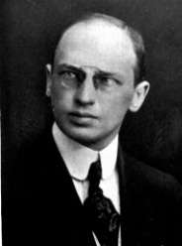
After 3…Nf6 White has the option of 4.dxe:
Ossip Bernstein - Savielly Tartakower (Paris 1937)
1.e4 e5 2.Nf3 d6
3.d4 Nf6 4.dxe Nxe4
5.Bc4 Be6 6.Bxe6 fxe6
7.Qe2 d5 8.Qb5+ Nc6
9.Nd4 Qd7 10.Qxb7 Bb4+!
11.c3 Nxd4! 12.Qxa8+ Kf7
13.Qxh8 Qb5 White resigns.

SOLUTION: 1…Rb1 pinning and deflecting the rook. If White
defends his rook with the queen 2…Rxd1(+) 3.Qxd1 Qd4+ 4.Kh1
Nf2+ or 4.Kf1 Qf2#. Play continued 2.Rxb1 Nxf2 3.Kxf2 but Tartakower
White soon resigned.

