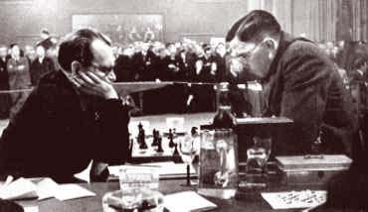
Another Alekhine win from the Hanham
(v Florian 1943): Black to play and win
(6 moves):

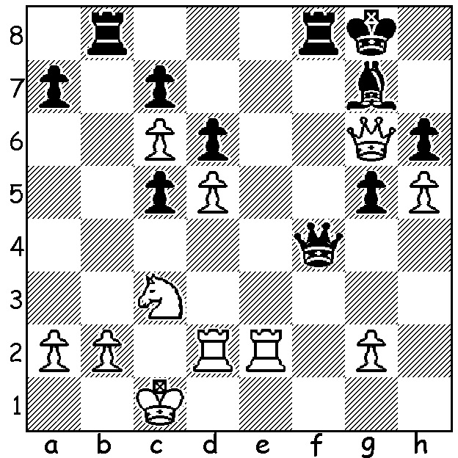

Concluding our look at the Hanham Variation in Philidors Defence (1.e4 e5 2.Nf3 d6 3.d4 Nd7) we take a look at two 21st century games. In both Black starts as if playing the Pirc but transposes to the Hanham by move 4. Again Black’s hold on the centre (pawn on e5) enables him to mount a kingside attack. The first is an extremely double-edged game while the second sees Black concluding with a spectacular sacrifice:
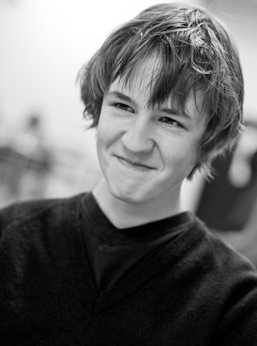
JUDE LENIER - SIMON WILLIAMS
2012 London Chess Classic Open
1.e4 d6 2.d4 Nf6
3.Nc3 Nbd7 4.Nf3 e5
5.Bc4 Be7 6.0-0 c6
7.a4 Qc7(a) 8.h3 h6
9.Be3 Nf8 10.Nd2 g5
11.b4 Ng6 12.b5 g4
13.hxg Nxg4 14.bxc bxc
15.Qf3 Bg5(b) 16.d5 c5
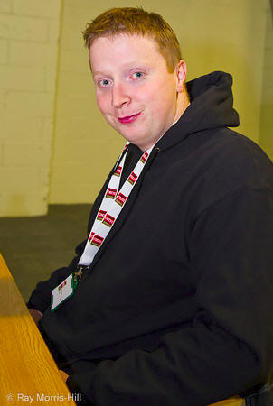
17.Bb5+ Kf8 18.Bc6 Rb8 Jude Lenie19.Nb5 19.Nb5 Qe7 20.Nc4 Bf4
21.g3 Nh4! 22.Qh1(c) Nxe3
23.fxe3(d) Bxg3(e) 24.Nbxd6 Qg5
25.Nxf7 Qg7 26.Nxe5+(f) Kg8
27.Rf7 Qg5 28.Nf3 Qg6
29.Be8 Be5+ White resigns??(g)

a) The basic Black position in the Hanham
b) 15…d5! and if 16.exd exd threatening 17…Qh2# & 17…dxe3.
c) Better 22.Qe2.
d) If 23.Nxe3 Rg8 wins. Simon Williams
e) 23…Rg8! wins (24.exf4 Rxg3+ 25.Kf2 Rh3 26.Qg1 Nf3 27.Qg2 Qh4+
28.Ke2 Rh2 29.Kxf3 Qxf4+)
f) Greed is good! 26.Nxh8+ Kg8 27.Rf7 & White may survive the attack.
g) One of Tartakower’s saying was ‘you never win a game by resigning.’ After 30.Kf1 Bxa1 32.Qxh4 (32.Rf8+? Kxf8 33.Bxg6 Rb1+) 32…Bh3+ 33.Qxh3 Rxe8 34.Rxa7 Rh7 35.Rxh7 Kxh7 36.d6 White is clearly winning.

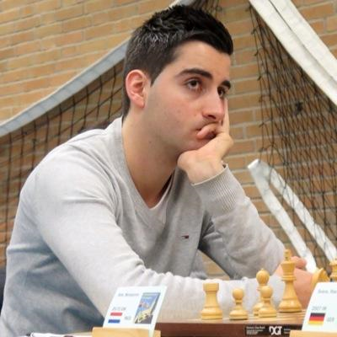
BENJAMIN BOK - RICHARD RAPPORT
2014 Riga Technical University Open
1.e4 d6 2.d4 Nf6
3.Nc3 e5 4.Nf3(a) Nbd7
5.Bc4 Be7 6.a4 c6
7.0-0 Qc7 8.Ba2 h6
9.dxe dxe 10.Nh4 Nc5
11.Nf5 Bxf5 12.exf5 0-0
13.Be3 e4 14.Qe2 Qe5
15.Rae1 Rae8 16.Qc4(b) Bd6(c) Benjamin Bok
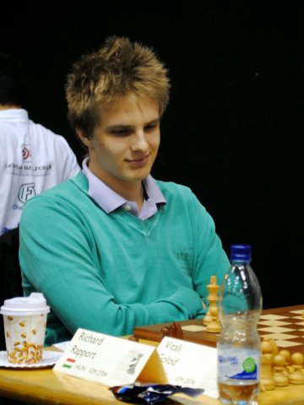
17.g3 Qxf5 18.Bd4 Ncd7
19.Re2 Be5 20.Bxa7 Bxc3
21.Qxc3 Ne5 22.Bc5 Nf3+
23.Kg2 Re5! 24.Bxf8 Qh3+!
25.Kxh3 Rh5+ 26.Kg2 Rxh2#

a) 4.dxe dxe 5.Qxd8+ Kxd8 leaves White with only a slight
advantage.
b) 16.f3 is equal.
c) Forcing White to create a serious white square weakness.

Rapport (Hungary) was rated first or second top junior at the time
while Bok (Netherlands) is one of the favourites in the current
World Junior Championships (Under 20). Richard Rapport

Guy Croft has started a Beginners Chess Group at the Dome Café, Maylands, each Saturday at 12.30 until 31 October. Check out meetup.com/Perth-Chess-Meetup/ or Phone Guy on 0451833186 for details of this and other planned events which include casual chess and a film night.

SOLUTION: 1…Rxb2! & if 2.Kxb2 Qb4+ 3.Kc2 Qxc3+ 4.Kd1 Rf1+ 5.Re1 Qa1+.

