NAKAMURA – KARJAKIN 20014:
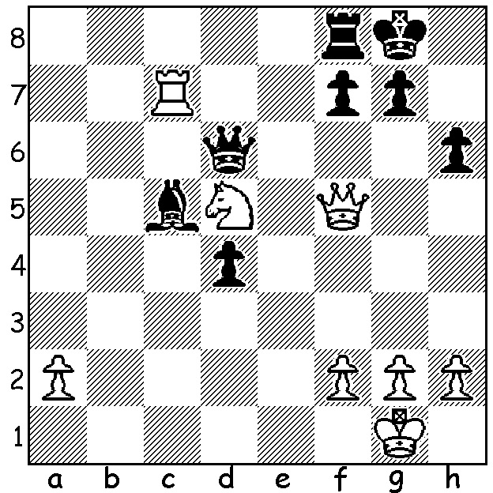
Results from the 2015 Sinquefield Cup, St Louis, USA, played White to play & win (3 moves): earlier this month, contribute towards qualification for the 2016
Candidates Tournament which will find the next challenger to
world champion Magnus Carlsen. The importance of the event
was shown by the strength of the field, seven of the world’s top
ten players. Winner, with a welcome return to form, was Levon
Aronian with 6/9. 2nd= were Anish Giri (+1 =8),Magnus Carlsen
(losses to Topolov & Grischuk), Maxime Vachier-Lagrave &
Hikaru Nakamura (loss to Topolov), all on 5/9. Other scores:
Veselin Topolov & Alexander Grischuk 4.5, former world
champion Viswanath Anand (who failed to win a game) and
Fabiano Caruana 3.5, Wesley So 3. Nakamura’s fine score moved
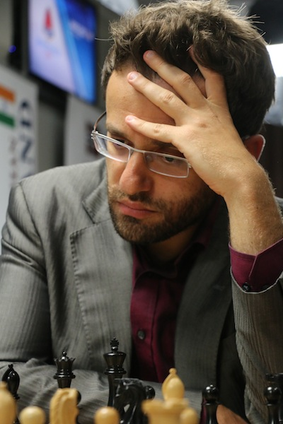
him into number two in world rankings and one of only four players
over 2800 (the other two being Topolov & Anand). In the game
below So follows a line for over 20 moves at great pace considered
favourable to White by computer analysis only to find Nakamura,
the world’s leading expert on the Kings Indian, prepared to show
the engine’s assessment suspect with a swashbuckling sacrificial
king hunt:

WESLEY SO - HIKARU NAKAMURA
2015 Sinquefield Cup
Kings Indian Defence, Main Line
1.d4 Nf6 2.c4 g6
3.Nc3 Bg7 4.e4 d6
5.Nf3 0-0 6.Be2 e5
7.0-0 Nc6 8.d5 Ne7 Levon Aronian
9.Ne1 Nd7 10.f3 f5
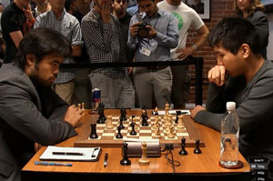
11.Be3 f4 12.Bf2 g5
13.Nd3 Ng6 14.c5 Nf6
15.Rc1 Rf7 16.Kh1(a) h5
17.cxd cxd 18.Nb5 a6(b)
19.Na3 b5(c) 20.Rc6 g4
21.Qc2 Qf8(d) 22.Rc1 Bd7
23.Rc7(e) Bh6(f) 24.Be1 h4
25.fxg f3 26.gxf Nxe4!(g)
27.Rd1 Rxf3 28.Rxd7 Rf1+
29.Kg2 Be3! 30.Bg3(h) hxg3!
31.Rxf1 Nh4+ 32.Kh3 Qh6
33.g5 Nxg5+ 34.Kg4 Nhf3
35.Nf2 Qh4+ 36.Kf5 Rf8+ Nakamura (L) v So
37.Kg6 Rf6+! 38.Kxf6 Ne4+
39.Kg6 Qg5#

a) This proves a worse square for the king.
b) Giving Black the unpleasant choice of sacrificing his a pawn or weakening his queenside.
c) Keeping the knight from b6 via c4.
d) So the queen defends d6 after …Bd7.
e) White cannot break through despite control of the open file: alternatives 23.Rb6 and 23.Nb4 Bxc6 24.dxc6 seem no better.
f) Eyeing the rook on c1 and threatening 23…g3.
g) Taking the rook would stabilise White’s kingside and end Black’s attack. If now 27.fxe4 Rf1+ 28.Kg2 h3+ 29.Kxh3 Rg1wins or 27.Rxd7 Rxf3! 28.Bxf3 Qxf3+ 29.Qg2 Qxd3 30.Rd1 Bd2! 31.Bxd2 Nf4 32.Be1 Nf2+! 33.Qxf2 Qe4+ 34.Kg1 Nh3+ 35.Kf1 Nxf2 36.Bxf2 Qxg4 winning one of the rooks.
h) Not 30.Bxf1 h3+.

THE GUFELD CUP (Grand Prix event) will be played Sat 26/Sun 27 September at Leeming Primary. Check on cawa.org.au for details. Entries and information 0439798607.

SOLUTION: 1.Rxc5! Black resigns (1…Qxc5 2.Nf6+ gxf6 3.Qxc5).

