Karthikeyan – Shamsidden (World Junior Championship 2015): Black to play and win (6 moves):
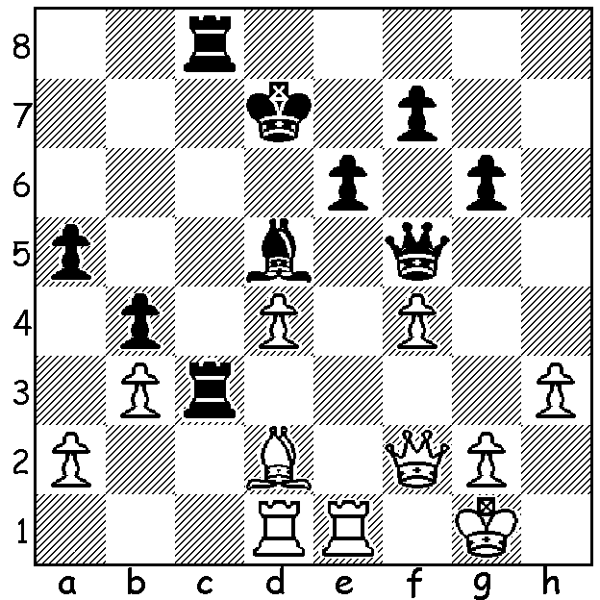
The 2015 World Junior Open and Girls (Under 20) were
played this month in Khanty-Mansiyak, Russia, with 61
Open and 47 girls competing including a number of
Grandmasters. In the final round Mikhail Antipov (Russia) with
+8 -1 =4 caught leader and favourite Jan-Krzysztof Duda from
Poland (+7 =6)to win the title on count-back.
Girls winner was Nataliya Buksa (Ukraine) also with 10/13.
Below is a fascinating game between the first and third ranked
players in the Open where a queen and bishop are pitted against
rook, bishop and two knights:

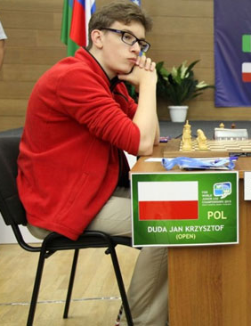
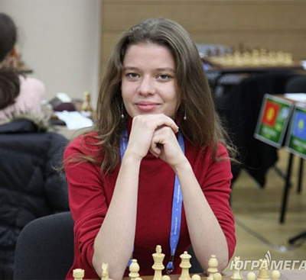
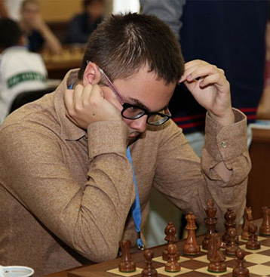

Jan-Krzysztof - Karen Grigoryan
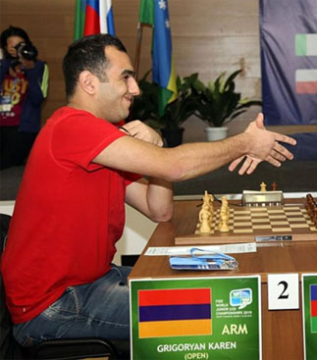
2015 World Junior Championship
Four Knights, Rubinstein Variation
1.e4 e5 2.Nf3 Nc6
3.Nc3 Nf6 4.Bb5 Nd4
5.Ba4 Bc5 6.Nxe5 0-0
7.Nd3 Bb6 8.e5 Ne8
9.0-0 d5 10.Kh1(a) c6
11.Ne2 Qh4 12.Ng3 Bg4
13.f3 Be6 14.c3 Nf5
15.Ne2 d4 16.Bc2 Rd8
17.c4 f6 18.b3 fxe5
19.Ba3 Rf6 20.Qe1 Qh6
21.Nxe5 d3 22.Ng4 dxe2!!(b)
23.Nxh6+ Rxh6 24.Rf2(c) Bxf2 Pictures (from top & left)
25.Qxf2 Rxd2 26.Qc5 Ned6 Mikhail Antipov
27.Qa5 Rxc2!(d) 28.Qd8+ Kf7 Nataliya Buksa
29.Qc7+ Ke8 30.Re1 Rd2 Jan Krzysztof Duda
31.Kg1 Rd1?(e) 32.Kf2 Rxe1 Karen Grigoryan

33.Kxe1 Nc8 34.Kxe2 Bd7 35.Qxb7 Rxh2
36.Kf2 Rh6 37.Bc5 Nfd6 38.Qb8 a6
39.Qa8 Rf6 40.Kg1 a5 41.Bd4 Rg6
42.Qxa5 Nf5 43.Bf2 Rd6 44.Qe1+ Kf7
45.Bc5 Re6 46.Qd2 Ke8 47.a4 Nfd6
48.Ba3 resigns(f)

a) The Rubinstein Variation gambits a pawn to gain an advantageous position with White having problems with development.
b) A well calculated and imaginative sacrifice: 22…Qg5 would leave White with the advantage – eg 23.Nc3 Rg6 (23…dxc2? 24.Ne4 winning) 24.Bd1 Bd4 25.Rc1 Ned6 26.Bxd6 Nxd6 27.f4 Qe7 28.Ne5 Rh6 29.Nf3 Nf5 30.g4 Bxc3 31.Rxc3.
c) Better than 24.Rg1 - 24…Bc7 25.g3 Nd4 26.Be4 Nf6 27.Bb2 Nxe4 28.Bxd4 Rxd4 29.fxe4 Bg4 30.Rg2 Rxe4 31.Rc1 Bf3 32.Kg1 Bxg2 33.Kxg2 Ba5.
d) The air has cleared after the amazing complications. Black has done well materially gaining rook and two knights for the queen but unfortunately his king is exposed, his queenside pawns weak and his pieces unable to coordinate.
e) 31…Bd7 32.Kf2 Rxa2 33.Rxe2+ Rxe2+ 34.Kxe2 eliminates White’s dangerous a pawn.
f) Seems premature but Black sees no way to cope with the passed pawn.

THE GUFELD CUP (6 round Grand Prix event) will be played this weekend, Sat 26/Sun 27 Sept,10.30 each day, at Leeming Primary, Meharry Rd.. Check on cawa.org.au for details. Entries and information 0439798607.

2015 WA JUNIOR ALLEGRO CHAMPIONSHIPS will be played Monday 28 Sept, 11am – 5pm, at N Woodvale Primary, Trappers Dr.. Closing date for entry today. Details cawa.org.au & enquiries & entry Norbert.muller@iinet.net.au or 94099579.

SOLUTION: 1…Rxh3! and if 2.gxh3 Qxh3 3.Qh2 (3.Qe2 Qh1+ 4.Kf2 Qg2+ 5.Ke3 Qg3+) 3…Qg4+ 4.Kf2 Qf3+ 5.Kg1 Rh8! 6.Qxh8 Qg2# or 4.Kf1 Rh8! 5.Qg1 Qf3+ 6.Qf2 Rh1#

The disparity of pieces in the game, queen v rook & two pieces, reminded me of a game of mine against the legendary Gary Koshnitsky in the 1976 Australian Closed Championship, Rd 13:

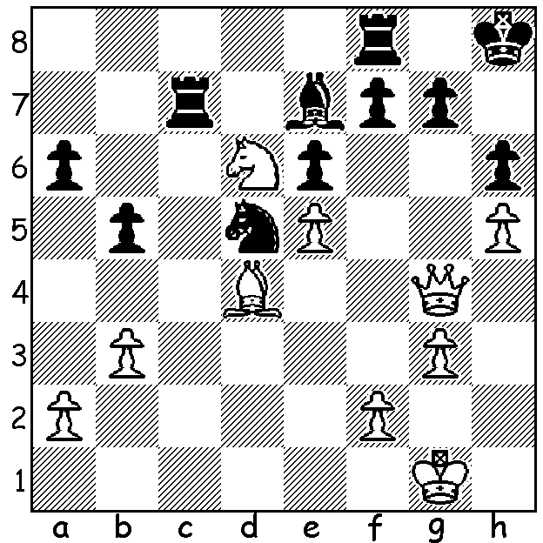
KOSHNITSKY - ELLIS
Play continued
41.Nxf7+! Rxf7 42.Qxe6 Nf4! 43.Qxf7(a) Ne2+
44.Kg2 Nxd4 45.f4 Rc2+ 46.Kh3 Bb4
47.f5 Nf3 48.Qe8+ Kh7 49.f6 Ng5+
50.Kg4 Rc7 51.e6 gxf 52.Qg6+ Kh8
53.Qxf6+ Rg7 54.Qd8+ Kh7 55.Kf5 Be7
56.Qb6 b4 57.Qxa6 Nh3 58.Qa7 Ng5
59.Qc7 Bf8 60.Qd8= Kg8 61.Qb8 Nh7
DRAW

- 43.gxf4 Rxf4 44.Be3 Rf8 45.Qxa6 Bc5! and Black’s rooks become very active although White’s extra pawns are most dangerous.

