SCHLECHTER – MEITNER 1899:
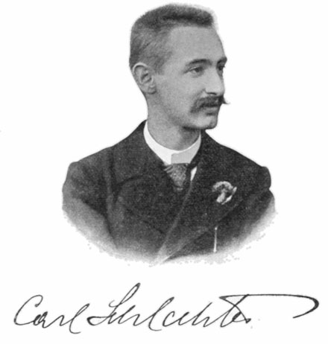
White mates in 4:

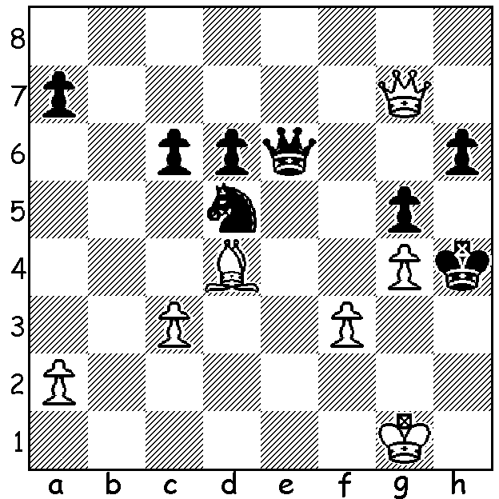

The formation of the Southern Suburbs Chess Club at Leeming Primary School, created and run by Andrew and Kathryn Hardegen, has provided much needed opportunites for players south of the river to indulge their pastime. The club has already in its first year run a successful Open Tournament (won by Ihsan Ferozkohi 6.5/7 with Adam Kelly 6/7 runner-up), as well as Lightning, Rapidplay and Fisher Random tournaments. Its strength was shown in winning the 1st & 2nd Divisions of the Interclub Championships and it recently completed all-play-all tournaments in three divisions and will start its club championship this month. The A Division of the all-play-all was won by 14 year old Arian Bagheri, a recent arrival from Iran, who score 6.5/9, losing only to WA Womens Champion Kathryn Hardegen. Michael Horstmann, who went through undefeated, and Adam Kelly (also losing only to Kathryn), were =2nd on 6. Ihsan Ferozkohi & David Ellis (5.5) were =4th, closely followed by Kathryn Hardegen & Akef Saleh on 5. The B Division was won convincingly by WA Under 14 Champion Sri Dharmapuri with 8/9 followed by Gavin Adam & Simon Ayling (6.5). Latest information on the C Division has Alan Fardoe leading with 7/8 but still to play Aayush Bhardwaj on 6/8. Here are two games from the event:

KATHRYN HARDEGEN – ARIAN BAGHERI
English Opening
1.c4 e6 2.e4 d5
3.Nc3 d4 4.Nce2 e5
5.d3 Bb4+ 6.Bd2 Bxd2+
7.Qxd2 Ne7 8.f4 f6
9.Nf3 Nd7 10.g3 c5
11.Bg2 Qc7 12.0-0 0-0
13.f5 a6 14.a4 b6
15.g4 Bb7 16.g5 b5
17.b3 bxc 18.bxc Nc6
19.gxf gxf 20.Ng3 Kh8
21.Qh6 Rg8 22.Nh4 Ne7
23.Nh5 Qd6 24.Rf3 Raf8
25.Rh3 Qb6 26.Rf1 Qb2
27.Rg3 Rf7 28.Ng6+ Nxg6
29.fxg6 Re7 30.g7+ resigns

LORENZO ESCALANTE – IHSAN FEROZKOHI
Nimzoindian Defence
1.d4 Nf6 2.c4 e6
3.Nc3 Bb4 4.Qc2 d5
5.e3 0-0 6.Nf3 b6
7.Bd2 Bb7 8.cxd Nxd5
9.Be2 c5 10.0-0 Nc6
11.a3 cxd 12.Nxd4 Nxd4
13.exd4 Bxc3 14.bxc3 Rc8
15.Qd3 Qh4 16.Bf3 Rc7
17.g3 Qh3 18.Bg2?? Qxg2+!
19.Kxg2 Nf4+ 20.Kg1 Nh3#

THE GUFELD CUP (6 round WA Grand Prix event,) played last weekend, at Leeming Primary, was won by WA’s top player Tristan Boyd with 6/6. Second with possibly his best ever result was Ned Tomic with 5.
Ned’s victims included 2010 WA champion Tim Hare and current Australian Under 16 Champion Patrick Gong. Rating prizes were won by WA Junior Champion Ignatius Yap (Under 1800) and another junior Darcy Frazer (Under 1500), both scoring 3/6.

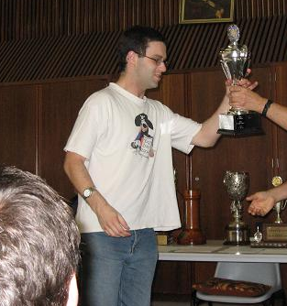
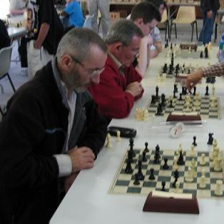

SOLUTION: 1.Qxh6+!!
(putting Black’s queen out of play)
1…Qxh6 (giving up the queen
with 1…Kg3 delays the loss)
2.Kh2 Ne3 3.Bxe3 / 4.Bf2#.

Tristan Boyd Ned Tomic

