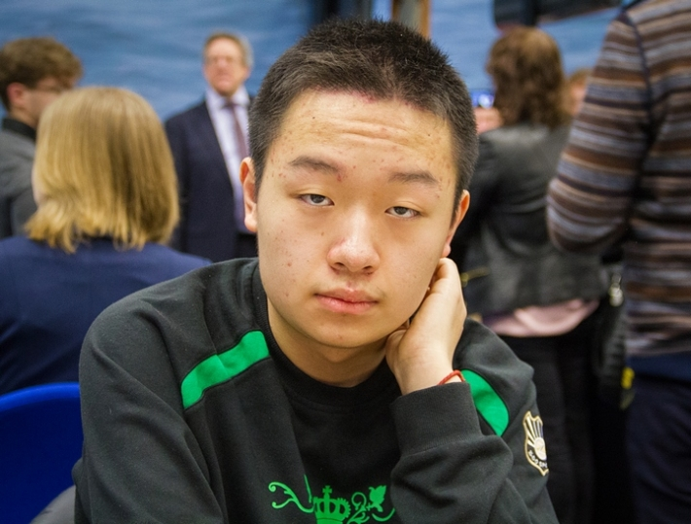
SVIDLER – WEI YI (World Cup 2015):
a tactical resource saves White from a long
struggle to save the game (3 moves):

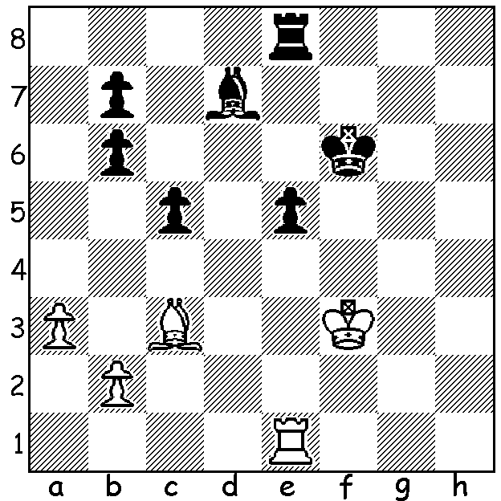 Wei Yi

The CHESS WORLD CUP, played in Baku, Azarbaijan, between September 11 and October 5, a knock-out event with 128 qualifying competitors, proved a particularly exhausting experience for the two finalists who had each played over 30 games by the end of the event. Most of the world’s leading players were there including Nakamura, Caruana, Topalov, Aronian, Giri, So, Kramnik, Grischuk, Vachier-Lagrave, Ding, Wei Yi, Gelfand, Adams and women’s world champion Hou Yifan. Each round until the final comprised an initial two games with classic (slowish) time controls, with two series of two rapidplay games and then pairs of blitz games available if scores were level. The two leading players who had not already qualified would gain entry to the 2016 Candidates tournament to decide the next challenger to world champion Magnus Carlsen. Australian champion Max Illingworth lost his Round 1 match to Pentala Harikrishna, one of India’s top players, 0.5-1.5. The two finalists were both Russians, Sergey Karjakin and Peter Svidler, with Svidler getting off to a great start in the final (detailed report on final next week):

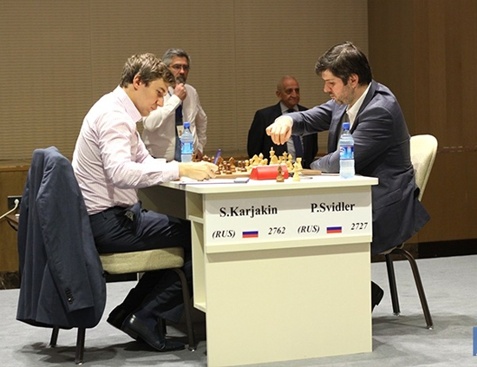
PETER SVIDLER - SERGEY KARJAKIN
2015 World Cup Final, Game 1
Kings Indian Attack.
1.Nf3 Nf6 2.g3 d5
3.Bg2 e6 4.0-0 Be7
5.d3 0-0 6.Nbd2 c5
7.e4 Nc6 8.Re1 b5
9.exd(a) Nxd5(b) 10.Ne4 Bb7
11.c3 a6 12.a4 b4
13.Bg5 f6 14.Bd2 e5
15.Rc1 Rf7 16.d4! bxc
17.bxc cxd 18.cxd Nxd4(c)
19.Nxd4 exd4 20.Qb3 Rb8(d)
21.Rb1 Qd7(e) 22.Rec1(f) Qe6(g)
23.Nc5 Bxc5 24.Rxc5 Rd8
25.Ba5! Rd6(h) 26.Qc4(i) Nc3
27.Rxb7 Qe1+ 28.Bf1 Ne2+ Svidler (W) v Karjakin (Game 1)
29.Qxe2 resigns(j)

a) 9.e5 Nd7 10.Nf1 was a favourite of Bobby Fischer.
b) Usually Karjakin plays 9...exd which Svidler had prepared for.
c) 18…exd was better as the exchange of knights increases the power of the g2 bishop.
d) This self-imposed pin leads to trouble: better 20…Qd7.
e) Not 21…Rf8? 22.Bf4.
f) If 22.Ng5 fxg5 23.Bxd5 Bxd5 24.Qxb8+ Rf8 with ample compensation for the exchange.
g) If 22…h6 23.Nc5 Bxc5 24.Rxc5 (24.Bxd5? Bxd5 25.Qxb8+ Rf8 & wins) 24…Nc3 25.Bxc3 dxc3 26.Bxd5 winning.
h) If 25...Rdd7 26.Re1 Qf5 (26…Qd6 27.Bb4! & if 27…Nxb4 28.Re8+ wins the queen) 27.Qxb7!! Rxb7 28.Rc8+ Rf8 29.Bxd5+)
i) 27.Rxb7 cannot be prevented.
j) After 29…Qxe2 the zwischenzug 30.Rb8+ wins.

The recent deaths have been reported of two well-known WA players.
John Butcher was for many years a prominent member of the Metropolitan Club during which time he held all the major positions there.
Klaas Pieter Zylstra was a stalwart of the Fremantle Club before joining Metro.
To both families the Chess Association expresses its sympathy.
Today’s service details can be found on cawa.org.au (Metropolitan Club).

SOLUTION: 1.Rxe5! Rxe5 2.Kf4 / 3.Bxe5 with an easy draw.

