Last week we saw Peter Svidler’s win in the first game against Sergey Karjakin in the final of the CHESS WORLD CUP, played in Baku, Azarbaijan. Svidler also won the second game after a Karjakin blunder and, after trapping Karjakin’s knight in Game 3, seemed headed for a quick victory. However successive blunders gave the game to Karjakin who also won the fourth game. This led to two rapid-play games with firstly a win to Karjakin and then an equalizing win to Svidler. After two more rapid-play games failed to find a winner, Karjakin won two successive blitz games to take the title 6-4 and prize of $96,000US with Svidler earning $64,000US and, like Karjakin, a place in next year’s Candidates Tournament to find a challenger to world champion Magnus Carlsen. The proliferation of blunders in the final can be explained by the tension combined with time pressure and tiredness with each of the finalists playing over 30 games in 25 days - ‘fatigue plus time pressure equals fallibility’ (a Facebook comment). In remarking on his loss, the sports-loving Svidler’s metaphor is apposite: ‘If you miss as many shots at an open goal as I did in the final, you don’t deserve to win’. The ten games with no draws certainly provided excitement for the millions following the tournament live on the many chess sites throughout the world. Here are some of the blunders (it’s not just us woodpushers who make the bad moves):
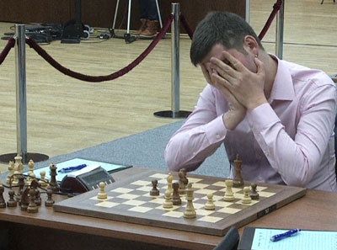
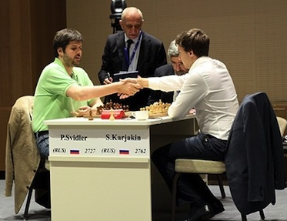

A distraught Svidler on losing Game 10

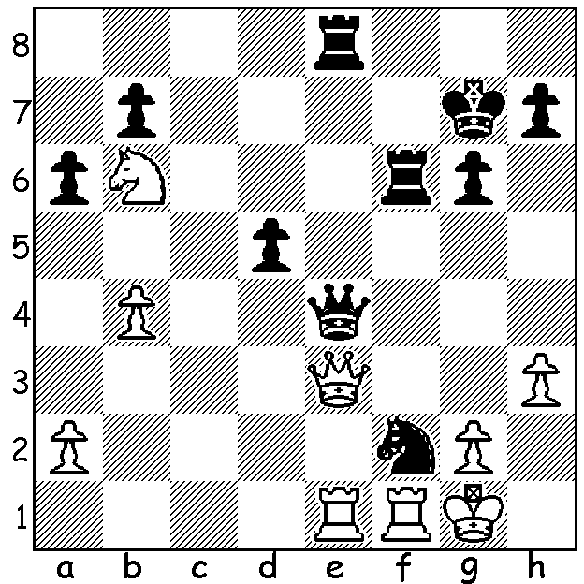
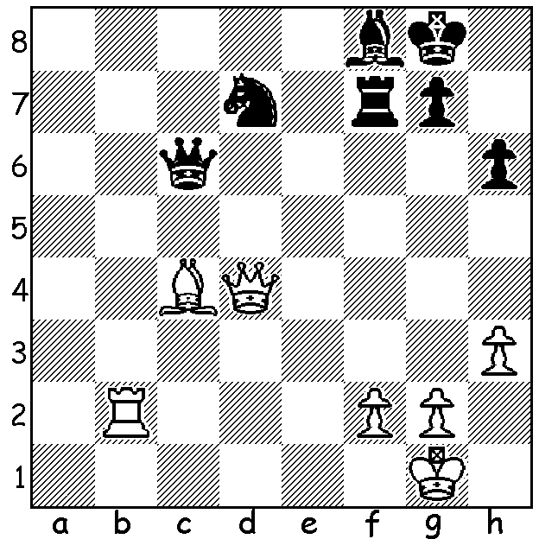

A) Karjakin – Svidler (Final, Game 2): B) Svidler – Karjakin (Game 3):
White plays 1.Rb5?? White plays 1.Rxf2?? (1.Qd2 would almost
How does Black now win a piece? certainly have won) with the clever idea
---------------------------------------------- 1…Qxe3 2.Qxe3 Rxe3 3.Rxf6 Kxf6 4.Nxd5+.
However Black plays 1…Qh4! when best is 2.Qxe8 Qxf2+ 3.Kh2 Qxb6 with reasonable drawing chances for White. Instead he played 2.Qd2?? allowing 2…Rxf2 & if 3.Qxf2 Rxe1+. White played 3.Qc3+ but after 3…d4 resigned (4.Qc7+ Rf7).
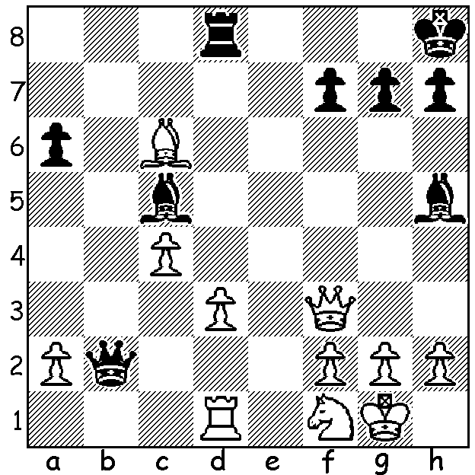
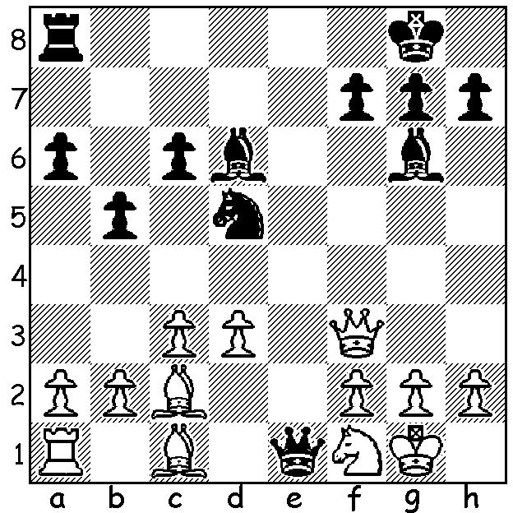

C) Karjakin – Svidler (Game 9): D) Karjakin – Svidler (later in Game 9):
Black has gained a tremendous position After 1…Bh5! White cannot play 2.Qxh5
from a Ruy Lopez, Marshall Gambit. (2…Qxf2+ 3.Kh1 Qg1#): Instead
What should he now play? White played 2.Rb1?? What is a better White
move & how should Black reply to 2.Rb1?

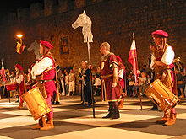
LIVING & LIGHTNING CHESS: CAWA will
be taking part in the CARNIVAL MACABRE on
Sat 31 October at the Northbridge Piazza. There
will be a Lightning Tournament 4-6pm (free entry
to first 24 entrants & generous prizes to most players).
This will be followed at 7pm by a display of Living
Chess. Turn up for both or just one of the activities
and help bring Chess into the public eye. Further info
& entries to 0439798607 or ellisd19@bigpond.com

SOLUTIONS: A) 1…Kh8 releasing the pin and if 2.Bxf7 Qxb5. White should have played 1.Qd5 (1…Qxd5 2.Bxd5 g5! 3.Rb7 Ne5 with a likely draw).
C) Black missed 1…Nxc3! 2.bxc3 Qxc3 forking R & B.
D) 2.g4! so if 2…Bxg4 3.Qxg4 defends g1. After 2.Rb1 best is 2…Bxf3 3.Rxb2 Bxc6 winning a piece. Instead Svidler chose the inferior 2…Qxb1 and after 3.Qxh4 still seemed headed for victory.
Then with about a minute left to his opponent’s seconds he allowed his rook to be taken for nothing.

