Capablanca – Fonaroff 1910:
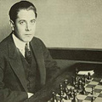
White to play and win (4 moves):

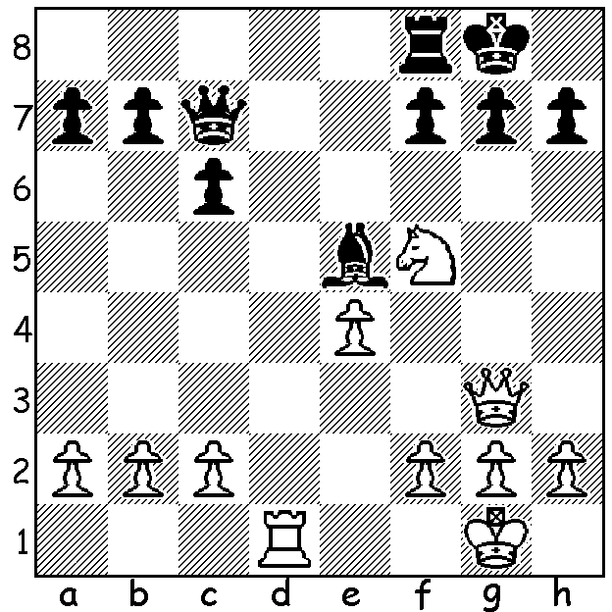

LIVING & LIGHTNING CHESS:

CAWA will be taking part in the CARNIVAL MACABRE on Sat 31 October at the Northbridge Piazza. There will be a Lightning Tournament 4-6pm (free entry to first 24 entrants & generous prizes to most players). This will be followed at 7pm by a display of Living Chess. Turn up for both or just one of the activities and help bring Chess into the public eye. Further info & entries to ellisd19@bigpond.com or 0439798607. This will be the third display I have been involved in, having previously produced one for the celebration of Canning becoming a city and one for a half time entertainment at an Eagles match when the songs from the musical Chess were performed.

Living Chess is a choreographed stage show performed by actors representing the pieces on the board. My recent research has seen a claim that it was introduced around AD735 by Charles Martel, Duke of Austrasia. The most famous example of Living Chess is the biannual display at Marostica, near Venice, which was first performed in 1923. It commemorates a story (fictional) from 1454 in which the lord of the region was approached by two suitors for the hand of his eldest daughter. However, not wishing to alienate the family of either of the two young knights, he was reluctant to choose. When the two men proposed to duel, the lord, unwilling to see either wounded or killed, decreed that their duel be not with swords but on a chess board with pieces. He had a large board set up in the town square, enlisted citizens to be the pieces and proclaimed a day of celebrations at which the populace could witness the contest for his daughter’s hand.

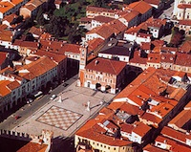
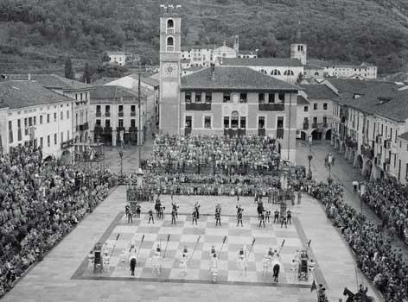

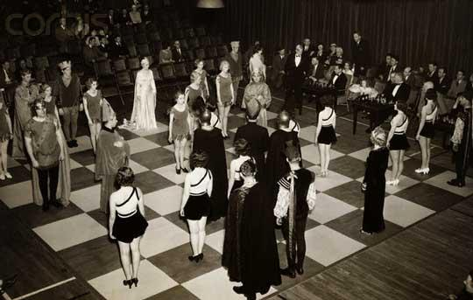
Below is a game of Living Chess played by a former
world champion Jose Raul Capablanca and a three-times
US champion Herman Steiner. The game was played at
Steiner’s club in Los Angeles with Cecil B de Mille the
referee and the game pre-arranged by Capablanca:

Jose Raul CAPABLANCA – Herman STEINER
Kings Pawn, Four Knights

1.e4 e5 2.Nf3 Nc6 Capablanca & Steiner – Living Chess
3.Nc3 Nf6 4.Bb5 Bb4
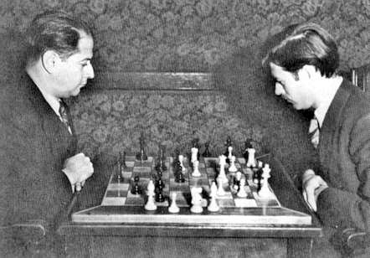
5.0-0 0-0 6.d3 d6
7.Bg5 Bxc3 8.bxc3 Ne7
9.Nh4 c6 10.Bc4 Be6
11.Bxf6 gxf6 12.Bxe6 fxe6
13.Qg4+ Kf7 14.f4 Rg8
15.Qh5+ Kg7 16.fxe dxe
17.Rxf6! Kxf6 18.Rf1+ Nf5
19.Nxf5 exf5 20.Rxf5+ Ke7
21.Qf7+ Kd6 22.Rf6+ Kc5
23.Qxb7 Qb6 24.Rxc6+! Qxc6
25.Qb4# Friendly game - Capablanca & Steiner

KINGSLEY OPEN (WA Grand Prix event) this Sat & Sun, 10.30 start, venue North Woodvale Primary, Trappers Drive. See cawa.org.au for details & submit entries asap to
g-dunlop64@bigpond.com or 93686412.

SOLUTION: 1.Nh6+! Kh8 2.Qxe5! Qxe5 3.Nxf7+! Rxf7 (3…Kg8 4.Nxe5 leaves White a piece up)
4.Rd8+ mating.

