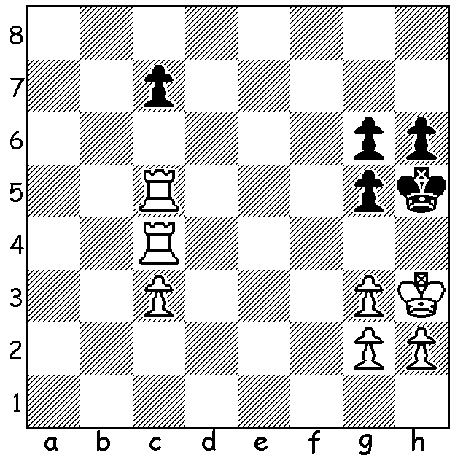

Selfies are all the rage so here’s a
chess selfie, a Selfmate, in which
White plays and FORCES Black to
mate in 3 moves:

In WA championships there is each year an award to the player who is deemed to have played the best game. The adjudicator for the past few years has been the many times WA champion Wolfgang Loenhardt. Here is his choice for best game and runner up:

George Carolin-Unkovich - Robin Shaw
2015 WA Championship
French Defence, Winawer Variation
1.e4 e6 2.d4 d5
3.Nc3 Bb4 4.e5 c5
5.Bd2 cxd 6.Nb5 Be7
7.Nxd4 Nc6 8.Ngf3 Bd7
9.Nb3 Qc7 10.Bf4 a5
11.a4 h5 12.Qd2 Nh6
13.Be2 Nf5 14.0-0 h4
15.Bd3 g6 16.c3 Qb6
17.Bc2 0-0-0 18.Bg5 Bxg5
19.Qxb5 Rdg8 20.Qd2 g5
21.Rfc1 g4 22.Nfd4 Nxe5
23.Nxf5 exf5 24.Qxd5 g3!
25.Qc5+ Qxc5 26.Nxc5 gxh2+
27.Kxh2 h3! 28.g3 Ng4+
29.Kg1 h2+ 30.Kg2 c6+
31.f3 Ne3+ 32.Kf2 Nxc2
33.Rxc2 h1=Q
White resigns

Akef Saleh - Yita Choong
2015 WA Championship
Queens Gambit, Slav Defence
1.d4 d5 2.c4 c6
3.Nf3 Nf6 4.Nc3 dxc
5.a4 Bf5 6.e3 e6
7.Bxc4 Bb4 8.0-0 0-0
9.Qb3 Qe7 10.Bd2 a5
11.Ne2 Bd6 12.Ng3 Bg6
13.Rac1 Qc7 14.Rfe1 Nbd7
15.Bd3 Rfe8 16.Bxg6 hxg6
17.e4 e5 18.Ng5 Re7
19.dxe Bxe5 20.Nf1 Ng4
21.Nf3 Bd6 22.h3 Ngf6
23.Ng5 Nc5 24.Qc2 b6
25.f3 Rd8 26.Rcd1 Nd3
27.Re2 Red7 28.Be3 Nb4
29.Qb3 Bh2+ 30.Nxh2 Rxd1+
31.Nf1 Nh5 32.Rd2 R1xd2
33.Bxd2 Nd3 34.Be3 c5
35.Nd2 Ne5 36.f4 Nd3
37.g4 & resigns
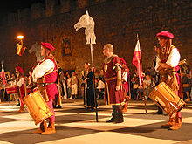

CAWA is hoping the chess community
will be strongly supporting CARNIVAL
MACABRE on Sat at the Northbridge
Piazza. There are still places available
for the Lightning Tournament 4-6pm
with prizes to most players. This will be
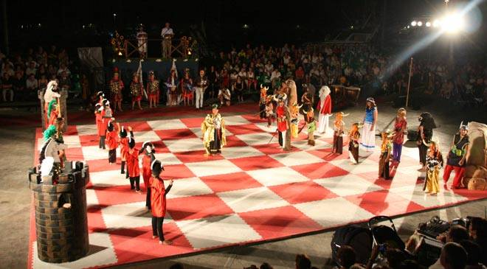
followed at 7pm by a display of Living
Chess which is a choreographed stage
show performed by actors representing
pieces on the board. Further info
cawa.org.au & entries to
ellisd19@bigpond.com or 0439798607.

SOLUTION: 1.Ra4 c6 2.Rca5 c5 3.c4 g5#.

