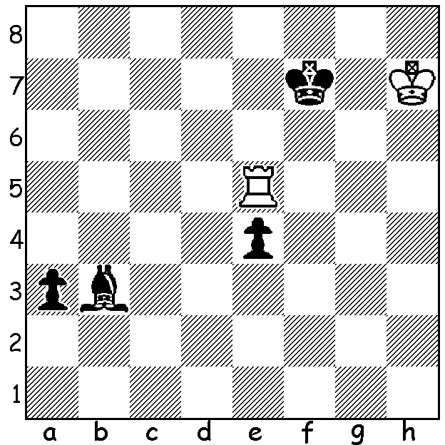

This endgame study could be called ‘Theme and Variation’.
White to play and gain a drawn position in 4 moves
(you may believe you have gained the draw after your
2nd White move but Black doesn’t cooperate):

Last week we saw the two games from the 2015 WA Championship judged the best by adjudicator Wolfgang Leonhardt, an eight times winner of the title between 1954 and 1972. This week the best two games from the Reserves Championship, won by our leading female players, Natalie Taylor, a three-times winner of the Reserves and multi winner of the WA Womens Championship, and Kathryn Hardegen, winner of the 2015 Reserves and Womens title.


Natalie Maris - Sri Krishnan Dharmapuri *
2015 WA Reserves Championship, Rd 1
Sicilian: Morra Gambit
1.e4 c5 2.d4 cxd 3.c3 dxc
4.Nxc3 e6 5.Nf3 Bb4 6.Bd2 Nf6
7.e5 Bxc3+ 8.Bxc3(a) Nd5 9.Bd2 Nc6
10.Bc4 Nb6 11.Bb3 d5 12.0-0 0-0
13.Rc1 h6 14.Re1 Bd7 15.Bf4 Rc8
16.Qd2 Re8(b) 17.Bxh6! Nxe5 18.Rxe5 gxh6
19.Rxc8 Nxc8 20.Qxh6 f5 21.Qg6+ Kf8
22.Ng5 Re7 23.Nh7+ Rxh7 24.Qxh7 Qc7
25.Qh8+ Ke7 26.Re1 Nd6 27.h4 Ne4
28.Qg7+ Ke8 29.Bd1 Qa5 30.Bh5+ Kd8
31.Qf8+ Kc7 32.Rc1+ Bc6 33.Qe7+ Kb8
34.b4 Qb6 35.Rc2 a5 36.a3 Ba4
37.Re2 Bd1 38.Rxe4! dxe4 39.Bxd1 e3
40.Qc5 Qd8 41.Bf3 Qxh4 42.Qe5+ Ka7
43.Qxa5+ Kb8 44.Qe5+ Ka7 45.Qxe3+ resigns

* 2015 WA Under 14 Champion.
a) 8.bxc3 looks even better – 8…Nd5 9.c4 Ne7 10.Bc3.
b) Underestimating White’s coming sacrifice - 16…Ne7 to give added protection
to the king was needed.


Kathryn Hardegen - Gordon Dunlop*
2015 WA Reserves Championship, Rd 3
Queens Indian Defence
1.d4 Nf6 2.c4 e6 3.Nf3 b6
4.Nc3 Ba6 5.e3 Bb4 6.Bd3 0-0
7.0-0 d5 8.cxd Bxd3 9.Qxd3 exd
10.Bd2 Re8 11.Rac1 Nbd7 12.Nb4 Bxd2
13.Nxd2 c5 14.b3 a6 15.Nc3 b5
16.Qf5 cxd 17.exd(a) Qb6 18.Nf3 Qd6
19.h3 Rac8 20.g4!(b) g6 21.Qg5 Kg7
22.Nh4 Kh8 23.Ng2 b4 24.Na4 Ne4
25.Qf4 Qf8 26.Ne3 Nd2 27.Rxc8 Rxc8
28.Rd1 Ne4 29.Nxd5 Nc3 30.Ndxc3 bxc3
31.Rc1 Qe7 32.Qe3 Qxe3 33.fxe3 c2
34.Nc5! Nf6(c) 35.Rxc2 Nd5 36.Kf2 Nb4
37.Rd2 resigns

* Seven times winner of the Reserves title between 1985 and 2013.
a) Although both sides now have isolated d pawns, it’s Black’s that’s much more
vulnerable.
b) Designed to drive the knight away from defence of d5.
c) If 34…Nxc5 35.Rxc2!

CAWA would like to express its thanks to the City of Perth for sponsoring the Carnival Macabre Lightning tournament and cooperating with the Association in putting on the exhibition of Living Chess at the Northbridge Piazza last Saturday.

SOLUTION: 1.Rxe4!! Bc2 2.Kh8 (now 2…Bxe4 is stalemate but Black has another winning attempt) 2…a2! 3.Re1 Bb1 4.Re5!! Now 4…a1=Q is again stalemate while 4…a1=R! is a technical draw (although White would well attempt to win).

