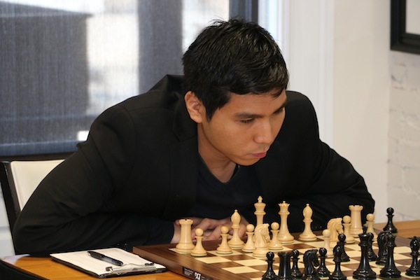
Wesley So - Victor Laznickna 2011:
White to play and win (2 moves):

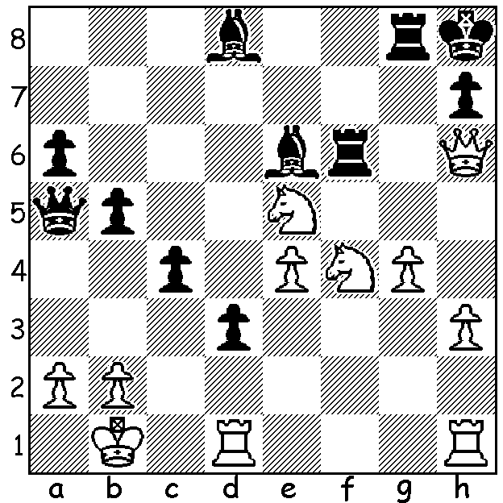

The recent trend in Chess to follow other sporting codes in awarding 3 points for a win and one for a draw, hoping to reward attacking play and discourage safety first strategy, seems on the surface to have failed in the recent tournament in the Basque region of Spain in which 16 of the 18 games in the Bilboa Masters were drawn. However the draws were generally long and almost all hard fought (the Rd 3 Ding – Giri going for 174 moves). The four contestants, all among the world’s top10, were three of the leading younger generation, Ding Liren, 22, (China), Wesley So, 21, born in the Philippines, now USA, and Anish Giri, 21, (Netherlands), plus ex-world champion Viswanathan Anand, 45, (India). The event finished with a tie for first place between So, who defeated Ding in their first game, and Giri who beat Anand in their second game. A play-off decided the winner, but more of that next week. Usually the most publishable Kings Indian Defence games are spectacular kingside attacks by Black but here’s a game where the fireworks come from White:

WESLEY SO - DING LIREN
2015 Bilboa Masters, Rd 2
Kings Indian Defence

1.d4 Nf6 2.c4 g6
3.Nc3 Bg7 4.e4 d6
5.Nf3 0-0 6.Be2 e5
7.0-0 Nc6 8.d5 Ne7
9.Ne1 Nd7 10.Be3 f5
11.f3 f4 12.Bf2 g5
13.Rc1 Ng6 14.c5 Nxc5
15.b4 Na6 16.Nd3 h5
17.Nb5 b6(a) 18.Be1 Rf7
19.Bd2 Bf6 20.Nf2(b) Qe8(c)
21.Qa4 Bd8 22.Qa3 g4
23.fxg hxg 24.Nc3! Nxb4!(d)
25.Qxb4 f3 26.Bb5 Qe7
27.g3 Rh7 28.Qc4!(e) Rh8
29.Qc6 Qh7 30.h3 Rb8(f)
31.Ncd1 a6 32.Qe8+ Kg7
33.Qxd8!!(g) Rxd8 34.Rxc7+ Bd7 L-R Ding Liren, Wesley So, Vishy Anand, Anish Giri.
35.Rxd7 Rxd7 36.Bxd7 gxh3 Winner So is wearing a txapela, a traditional Basque beret.
37.Kh2!(h) Rb7 38.Be6 Nf8
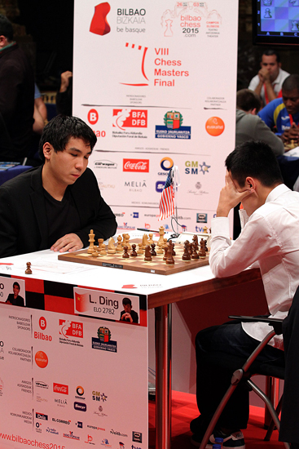
39.Bf5 Qh5 40.Ng4 Nd7
41.Bh6+ Kh8 42.Nde3 Rc7
43.Bxd7 Rxd7 44.Rxf3 Rf7
45.Rf5!(i) Rxf5 46.exf5 Qf7
47.Bg5 b5 48.Nh6 Qf8
49.f6 Kh7 50.Nef5 Kg6
51.Bh5 e5 52.f7 e3
53.Be7 e2 54.Nh4+! Kh7 (j)
55.Bxf8 e1=Q 56.Bxd6 Qf2+
57.Kxh3 Qf1+ 58.Kg4 Qc4+
59.Bf4 Qe2+ 60.Nf3 resigns(k)

a) For his pawn White has accelerated his queenside
attack, pushed the knight to the side, weakened Black’s
white squares and gained pressure against the c pawn
on the half-open file.
b) Gives protection to the knight and discourages …g4. So (L) v Ding
c) A novelty: 20…Rg7 is a good alternative.
d) The best chance: if 24…Nb8 25.Nxg4 Rg7 26.Nd1 and White remains with queenside pressure while Black’s kingside attack is stalled.
e) To meet 28…Nf4 with 29.Qc6 (not 29.gxf4? Rxh2! Mating) 29…Rb8 30.Qe8+.
f) If 30…Nf4 31.Bxf4 exf4 32.Qxa8 fxg3 33.Qxc8 gxf2+ 34.Rxf2 Qxh3 35.Qxd8+ wins.
g) A sensational move breaking Black’s dangerous attack, breaking through on the queenside and finishing with three minor pieces for the queen.
h) The pawn can be captured at any time, now it’s used to shield the king.
i) Obtaining a passed pawn which can be nursed to the queening square by the minor pieces. If 45…Qg6 46.Bf8 wins the centre pawns.
j) If 54…Kxh6 55.Bxf8+ / 56.Nf3.
k) 60…Kg7 61.Be5+ Kf8 62.Bd6+.

SOLUTION: 1.Nxe6! resigns (1…Nxh6 2.Nf7#).

