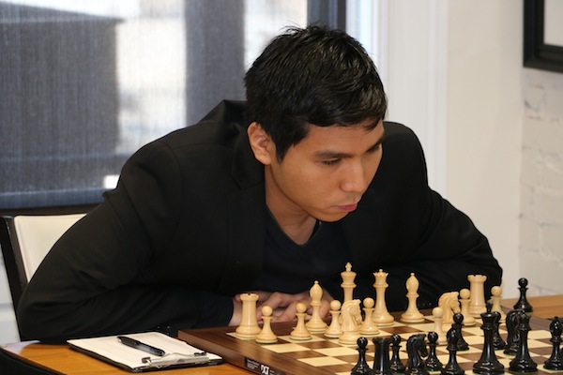
Wesley So - Ahmed Adly 2008:
White to play and win (2 moves):
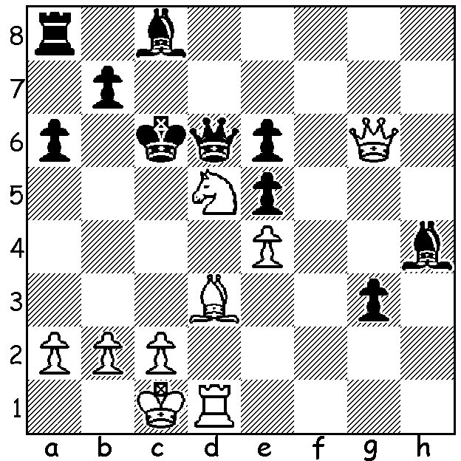

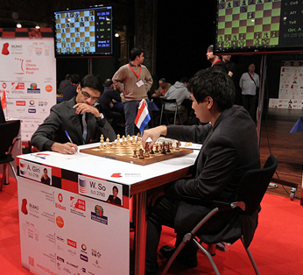
As promised here is a report and game from
the recent Bilboa Masters Play-Off between
Wesley So and Anish Giri after they finished
level ahead of Ding Liren and Viswanathan
Anand. The two-game play-off was played
with a time limit of 4 mins + 3 sec increments.
In the first Giri, with R + N v R + B, had a pawn
plus, passed on the b file. He subsequently lost
a central pawn but then forked the rook and
bishop, briefly thinking he had won a piece.
However it was So who came out a piece up
with his reply forking king and knight. In the
second Giri was again in the box seat but missed
a complicated win of two pawns and then a simple
two move combination which would have won
So’s queen. Giri did win a pawn but it proved
insufficient to win in a rook and opposite colour
square bishops and the game ended in a draw after
more than 90 moves (an average of 6 sec a move),
leaving So the winner. Giri (W) v So, Rd 2

ANISH GIRI - WESLEY SO
2015 Bilboa Masters, Play-Off Game 2
Giuoco Piano
1.e4 e5 2.Nf3 Nc6
3.Bc4 Bc5 4.d3 Nf6
5.0-0 a6 6.c3 Ba7
7.Bb3 h6 8.Nbd2 d6
9.Re1 0-0 10.h3 Be6
11.Bc2 Re8 12.Nf1 d5
13.exd Nxd5 14.Ng3 Qd6
15.Nh4 Qd7 16.Qf3 Qe7
17.Nhf5 Qf8 18.Bb3 Rad8
19.Nh5 Bxf5 20.Qxf5 Nde7
21.Qf3 Ng6 22.Re4 Na5
23.Bc2 f5 24.Re1 Kh8
25.Ng3 Nh4 26.Qh5 Qf6
27.d4 e4 28.Bf4 Bb6
29.Qe2(a) Nc6 30.Nh5 Qf8
31.Bg3 Ng6 32.Qe3 Re7
33.b4 Rde8(b) 34.Bb3 Nce5
35.Bxe5 Nxe5 36.Nf4 Kh7
37.Nd5 Nd3 38.Nxe7 Nxe1
39.Nxf5(c) Nxg2 40.Kxg2 Qxf5
41.Bc2 Kh8 42.Re1 Qf7
43.Bxe4 c6 44.a4 Bc7
45.Re2 Qh5 46.Qf3 Qg5+
47.Qg4 Qxg4+ 48.hxg4 a5
49.b5 Bd6 50.f3 c5
51.dxc Bxc5 52.Rd2 b6
53.Bg6 Rf8 54.Rd7 Rf6
55.Be4 g5 56.Kf1 Kg8
57.Ke2 Rd6 & DRAW after 91 moves

a) White can win 2 pawns with 29.Be5 Qg5 30.Bxg7+! Kxg7 31.Qxh4! Qxh4 32.Nxf5+.
b) The advance of White’s b pawn gives Black the chance of 33…Nxd4 34.cxd4 Bxd4 35.Qc1 Bxa1 36.Qxa1 f4 37.Bh2 Qf5 with good prospects.
c) 39.Bg8+ Kh8 40.Ng6+ wins the queen.

CHRISTMAS OPEN: Sat 28 & Sun 29 Nov at Leeming Primary, 10.30 start each day.
Entry & contact Andrew Hardegen andrewhardegen@iinet.net.au or 0407 421 084.

SOLUTION: 1.Qe8+ Qd7 (1…Kc5 leads to a quick mate) 2.Bb5+! axb5 3.Nb4+ Kc5 4.Rxd7.

