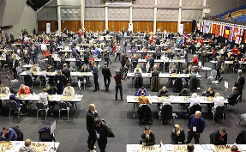
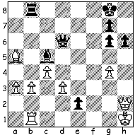

Gajewski – Eljanov (Euro. Teams Ch. 2015):
White’s skewer on Queen & Rook seems to
win the dangerous passed pawn but Black’s
stunning reply gains a speedy win (3 moves):

Play at Reykjavik

The European Teams Championship concluded this week with Russia winning both the Open & the Women’s Championship, held in Reykjavik, Iceland. The Russian Open team of Peter Svidler, Alexander Grischuk, Evgeny Tomashevsky, Ian Nepomniachti and Dmitry Jakovenko went through undefeated with six wins and three draws. Second to fourth place went to Armenia, Hungary and France, all with +5, =3, -1. The French team, although failing to win a medal, earned great respect with the shadow of the Paris massacres hanging over their heads. Remakably, with Maxime Vachier-Lagrave beating Aronian, France defeated Armenia on the day news came through of the atrocities. For MVL it was a case of deja vu as he was starting the Tata tournament in Wijk aan Zee when the Charlie Hebdo killings occurred, with one of the murdered cartoonists known to him personally. World champion Magnus Carlsen had a poor tournament, losing rating points after losses to Levon Aronian and Yannick Pelletier (Switz), the latter through a rudimentary blunder in the endgame.

The victorious Russian team Armenia v France with
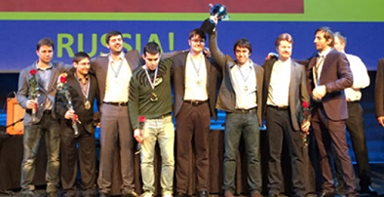
Aronian v Maxime Vachier-Lagrave in foreground
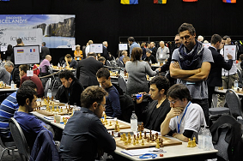

Vassily Ivanchuk (Ukraine) – Peter Svidler (Russia)
2015 European Teams Championship, Rd 4 An underperforming Magnus Carlsen at Reykjavik
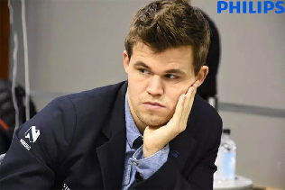
Ruy Lopez, Marshall Gambit
1.e4 e5 2.Nf3 Nc6
3.Bb5 a6 4.Ba4 Nf6
5.0-0 Be7 6.Re1 b5
7.Bb3 0-0 8.c3 d5
9.exd Nxd5 10.Nxe5 Nxe5
11.Rxe5 c6 12.d3 Bd6
13.Re1 Bf5 14.Qf3 Re8
15.Rxe8+ Qxe8 16.Nd2 Qe1+
17.Nf1 Bg6 18.g3 b4
19.h4 h5 20.c4(a) Nf6
21.Bd1 Re8 22.Bd2 Qe5
23.Rc1 Bc5 24.a3 a5
25.axb axb 26.Rc2 Ng4 QUIZ: This chess table was on display at Reykjavik
27.Ne3 Qd6 28.Nxg4 hxg4 When was it first played on and at what event?
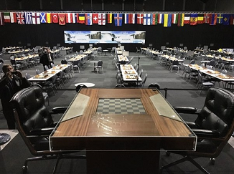
29.Qxg4? Bh5! 30.Qxh5 Qxg3+
31.Kh1 Qxf2 White resigns

- 20.Bxd5 cxd5 21.Qxd5 Rd8 22.Bg5! is a known game which
ended in a draw (22…Qxa1 23.Bxd8 bxc! 24.bxc Bf8)
b) If 32.Qg5 Qf1+ 33.Kh2 Bd6+.

A spectacular miniature from the Women’s:
Alexandra Kosteniuk (Russia) – Elisabeth Paehtz (Germany)
2015 European Womens Team Ch., Rd 9
Caro-Kann
1.e4 c6 2.Nc3 d5
3.Nf3 Bg4 4.Be2 e6
5.d4 Nf6 6.h3 Bh5
7.e5 Nfd7 8.g4 Bg6 9.h4 h5 10.gxh Bf5
11.Ng5 c5 12.Bg4 cxd 13.Bxf5 dxc3 14.Nxf7 Kxf7
15.Bxe6+ Kxe6 16.Qg4+ Kf7 17.Qg6+ Kg8 18.Qe6+ Kh7
19.Qg6+ Drawn by perpetual check

The CHRISTMAS OPEN (final Grand Prix event of the year) will be played tomorrow and Sunday at Leeming Primary, Meharry Rd., starting at 10.30 each day. Information on cawa.org.au & entries, today please, to andrewhardegen@iinet.net.au or 0407421084.

SOLUTION: 1…Qxd3!! 2.Qxb8+ Kh7 3.Rg1 Bd6 winning (White played 4.Qxd6 but resigned seven moves later).
QUIZ: The table was usedin the Spassky – Fischer World Championship match in Reykjavik 1972

