CHESS FRIDAY 4 DECEMBER 2015

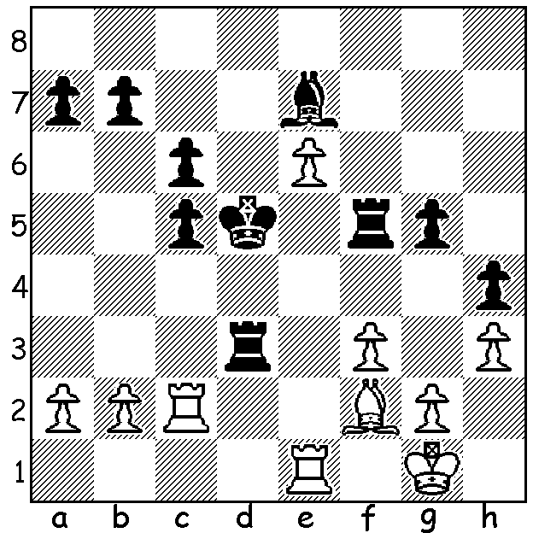

Laurant Fressinet (France) –
Pavel Eljanov (Ukraine)
2015 European Teams Championship:
White to play and win (3 moves):

Last week I reported on the European Team Championships in which Russia came top in both the Open and Women‘s tournament. The game this week also comes from that event with a most exciting battle, starting with an irregular opening with both kings in danger and abounding in tactical ideas:

Aloyzas Kveinys (Lithuania) - Ivan Ivanisevic (Serbia)
2015 Euro. Team Champ., Bd 1, Rd 1.
Queens Pawn, Irregular
1.Nf3 d5 2.d4 Bf5
3.Bg5 f6 4.Bf4 Nc6
5.e3 e6 6.Nh4 Be4
7.f3 Bg6 8.Nxg6 hxg6
9.c4 e5(a) 10.cxd(b) Qxd5(c)
11.Nc3 Bb4 12.dxe Qc5
13.Qd3 g5 14.exf6(d) Nxf6
15.Bxc7 Rc8 16.Bg3 Ke7(e)
17.Rc1 a6 18.Be2 Rhd8
19.Qc2 Qxe3 20.Bf2 Qe5
21.0-0 Nd4 22.Bxd4 Qxd4+
23.Kh8 Rh8 24.g3(f) Bd6
25.f4!(g) gxf 26.Qg6 Rcg8
27.Rcd1 Qb6?(h) 28.Bc4 fxg
29.Rfe1+ Kd8 30.Qxg3! Qc6+
31.Kg1 Qc5+ 32.Re3 Kc8
33.Be6+ Kc7 34.Rxd6! Qxd6
35.Nb5+! resigns (i)

a) A sharp novelty – in previous games 9…Bd6 was played.
b) If 10.dxe fxe 11.cxd exf4 12.dxc6 Qxd1+ 13.Kxd1 0-0-0+ is fine for Black.
c) 10…exf4 11.dxc6 bxc6 12.exf4 is better for White.
d) 14.e6! was stronger.
e) Very logical, uniting the rooks but the immediate 16…Rd8!! was even better (17.Qg6+ Ke7! 18.Qxg7+ Ke6 when Black exposed king is surprisingly safe and his better developed force has winning threats (eg 19.Kf2 Bxc3 20.bxc3 Qxc3 21.Re1 Ne/g4+! winning the queen).
f) 24.Rfe1? allows 24…Rxh2+! mating while if 24.h3 Qf4 25.Qg6 Bd6 White needs to find 26.Qxf6+! followed by the knight fork of king & queen.
g) A fine tempo-gaining interruption sacrifice as the immediate 25.Qg6? again allows 25…Rxh2+ 26.Kxh2 Qh4+! mating.
h) The losing move: he had to play 27…Qc5 and after 28.Nd5+! Nxd5 29.Qe4+ Kd8 30.Rxd5 Re8!! 31.Qd3 Rxe2 32.Rxd6+ Kc7 33.Qxe2 Qxd6 34.Qc4+ Kb8 35.Qxf4 and Black can fight on.
i) 35…axb5 36.Rc3+ winning the queen & mating.

The CHRISTMAS OPEN (WA Grand Prix event), was played last weekend with 22 competitors, including three players rated over 2200 and seven juniors. Winner was WA champion Yita Choong on 5.5/6 (draw with Butsenko). Second was Igor Butsenko, a recent arrival from Ukraine with 5 (draws with Choong & Gong), and third Australian Under 16 champion Patrick Gong with 4.5 (loss to Choong & draw with Butsenko). Igor Colic and Ignatius Yap (3.5) shared the Under 1900 prize while David Spatar (3) was the top Under 1500.

CHRISTMAS LIGHTNING & PRIZEGIVING will take place on Sunday 13 December at 1pm at Leeming Primary.

SOLUTION: 1.Bxc5! resigns (1…Bxc5+ 2.Rxc5+! Kxc5 3.e7) – a common endgame tactic, sacrifice to promote.

