CHESS FRIDAY 11 DECEMBER 2015

A quiz to begin this week: who are these eight players and where are they now playing?

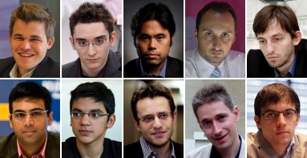

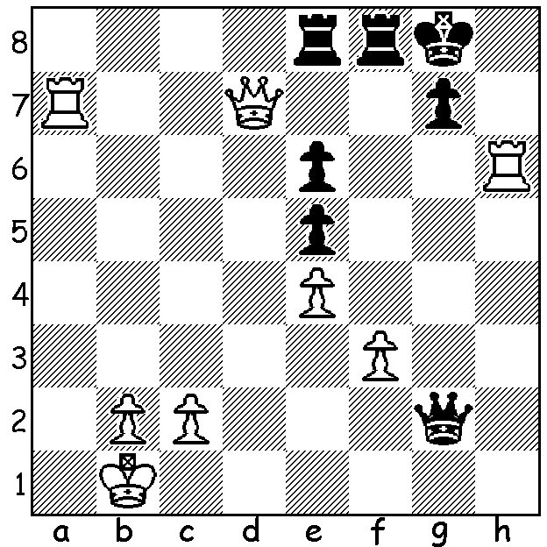

Friso Nijboer – Anish Giri:
Black seems to be in trouble with all
White’s pieces aggressively placed
and a potential losing endgame.
However he finds a winning combination
(Black to play, 5 moves):

The London Chess Classic began last week with 8 of the world’s top players, ranging from 1 to 20, competing, making this the strongest tournament ever played in the UK. Seven of the players are competing in the Grand Chess Tour which comprises three tournaments with the Sinquefield Cup and Norway Chess 2015 being the two completed events and the Classic being the third. The prize fund for the Classic is $300,000 with an additional $150,000 going to the top three in the Grand Tour. In Rd 1 Anand - Adams, Maxime Vachier-Lagrave – Carlsen, Grischuk - Nakamura and Caruana – Aronian were drawn while Giri defeated Topalov with a fine sacrificial attack:

Veselin Topalov – Anish Giri
2015 London Chess Classic, Rd 1
Schlechter Slav Defence
1.d4 Nf6 2.c4 g6
3.g3 c6 4.Bg2 d5
5.Qa4 Nfd7 6.cxd Nb6
7.Qd1 cxd 8.Nc3 Nc6
9.e3 Bg7 10.Nge2 0-0
11.0-0 Re8 12.b3 e5
13.dxe Nxe5 14.h3 Bf5
15.Nd4 Bd3 16.Re1 Ba6
17.Qd2 Nd3 18.Rd1 Bxd4
19.exd4 Qf6 20.a4 Qxd4
21.a5 Nd7 22.Ra4 Qe5
23.Nxd5 Nxc1 24.Rxc1 Nf6
25.Nc7 Rad8 26.Qf4 g5
27.Qb4 Qb2 28.Raa1 Re2
29.Qc5 h6 30.Nxa6 bxa6
31.Rab1 Qd2 32.Bf3 Ne4
33.Qxa7?(a) Nxf2! 34.Bxe2 Nxh3+
35.Kf1(b) Qd5 36.Bh5(c) Qh1+
37.Ke2 Qg7+ 38.Ke1 Re8+
39.Kd1 Nf2+ 40.Kc2 Ne4+
White resigns

- 33.Bxe4 is equal.
- If 35.Kg/h2 Qxe2+ 36.Kxh3 Rd2 mates.
c) Better is 36.Kf1 but Black still gains a winning position – 36…Qh1+ 37.Bf1 Qf3 38.Rb2 Qxg3+ 39.Rf2 Re8+ 40.Be2 Nf4 41.Qxa6 (41.Rc2 Ng2 & 42…Ne3+ wins) 41…Rxe2+ 42.Qxe2 Nxe2 43.Kxe2 Qe5+ 44.Kf1 Qxa5.

CHESS ASSOCIATION 2015 WINDUP will be held on Sunday (Dec 13) at Leeming Primary, Meharry Rd., There will be a Lightning tournament starting at 1pm. Early enrolment would be appreciated (g-dunlop64@bigpond.com) but if enrolling at venue please arrive by 12.30. A Junior Lightning will also be played if sufficient entries. Prizegiving for the Lightning and other events is planned for 4pm.

AUSTRALIAN JUNIOR CHAMPIONSHIPS: WA players intending to play should contact me (0439798607) regarding financial assistance from CAWA.

ANSWER: All eight are playing in the London Chess Classic. They are (with FIDE rating places)
World champion Magnus Carlsen (1), Fabiano Caruana (7), Hikaru Nakamura (5), Veselin Topalov (2)
Alexander Grischuk (17), Viswanathan Anand (3), Anish Giri (8), Levon Aronian (6), Michael Adams (20),
Maxime Vachier-Lagrave (11).

SOLUTION: 1…Qg1+ 2.Ka2 Qxa7+! 3.Qxa7 Ra8 4.Qxa8 Rxa8+ 5.Kb1/3 gxh6.

