CHESS FRIDAY 18 DECEMBER 2015

A recap of last week’s quiz: who are these ten players and which tournament have they just completed?

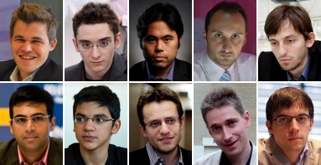

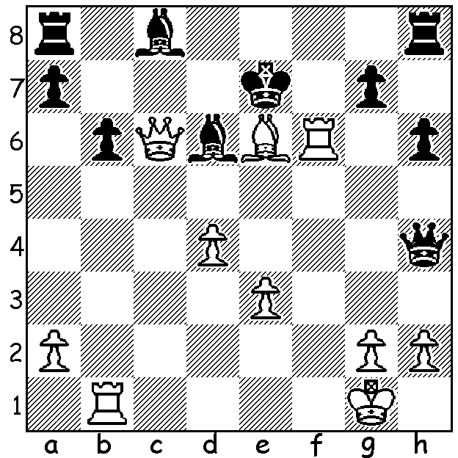

Magnus Carlsen – Atle Groenn 2005:
White has a mating attack:

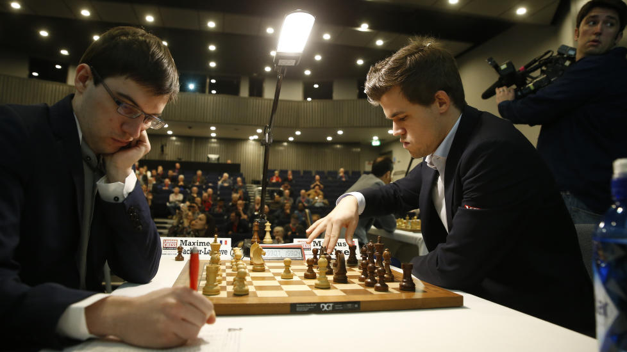
The London Chess Classic, the strongest
tournament ever played in the UK with 8
of the world’s top players, ranging from 1
to 20 competing, finished in a triple tie
between world champion Magnus Carlsen,
Maxime Vachier-Lagrave and Anish Giri.
A Rapidplay play-off (25 min + 5 sec a
move) saw Carlsen defeat MVL 1.5-0.5
after the Frenchman had come through
against Giri, holding a draw with Black
against Giri in an Armageddon game where
White receives more time than Black but
must win. Final scores: Carlsen, MVL,
Giri 5.5 (+2 =7), Levon Aronian 5 (+1 =8), Vachier-Lagrave v Carlsen in Play-off
Fabiano Caruana & Michael Adams 4.5 (=9), Alexander Grischuk 4.5 (+1 =7 -1), Hikaru Nakamura 4 (+1 =6 -2), Vishy Anand 3.5 (+1 =5 -3), Veselin Topalov 2.5 (=4 -4). Despite only 10 of the 45 ending in victory, games were interesting with many going into long endgames. Nine (not seven as I stated last week) of the players competed in the Grand Chess Tour comprising the London Classic, Sinquefield Cup and Norway Chess 2015. Overall winner was Carlsen followed by Giri, who went through the three tournaments undefeated, Aronian and Vachier-Lagrave. After trailing throughout in London Carlsen lifted himself to tied first place with the only win in the final round (his first win was in Rd 7).

Magnus Carlsen - Alexander Grischuk
2015 London Chess Classic, Rd 9
Sicilian, Rossolimo Attack
1.Nf3 c5 2.e4 d6
3.Bb5+ Nd7 4.0-0 a6
5.Bd3 Ngf6 6.Re1 b5
7.c4 g5(a) 8.Nxg5 Ne5
9.Be2 bxc 10.Nc3(b) Rb8
11.Rf1(c) h6 12.Nf3 Nd3
13.Ne1 Nxb2 14.Bxb2 Rxb2
15.Bxc4 Rb4 16.Qe2 Bg7
17.Nc2 Rb6 18.Rab1 0-0
19.Rxb6 Qxb6 20.Ne3 e6
21.f4 Kh8 22.f5 a5
23.a4 Qd8 24.h3 Qe7
25.Ba6 Bxa6 26.Qxa6 Nh5
27.Rf3 Rg8 28.Nb5 Be5
29.Ng4 Qh4 30.fxe fxe(d)
31.Nxe5 dxe5 32.Qxe6 Qe1+?(e)
33.Kh2 Rxg2+ 34.Kxg2 Qd2+(f)
35.Kg1 Qe1+ 36.Rf1 Qe3+
37.Rf2 Qe1+ 38.Kg2 resigns

a) Introduced by Topolov when he beat Carlsen in the Sinquefield Cup in August.
b) In that game Carlsen played 10.Na3.
c) Prophylaxis – defending against a future …Nd3.
d) Black should play 30…Rxg4! – 31.hxg4 Qh2+ 32.Kf2 Nf4 33.Rg3 Nxe6 34.Rf3 Kg7.
e) 32…Qg5! & Black is ok: 33.g4 Nf4 34.Qf5 Qg7.
f) Black can win back the rook with 34…Qe2+ 35.Kg1 Qxf3 but the ending is winning for White after 36.Qxh6+ Kg8 37.Qe6+ Kf8 38.Qf5+ Qxf5 39.exf5.

AUSTRALIAN JUNIOR CHAMPIONSHIPS: WA players intending to play should contact me (0439798607) regarding financial assistance from CAWA.

ANSWER: All ten competed in the London Chess Classic. They are (with FIDE rating places)
World champion Magnus Carlsen (1), Fabiano Caruana (7), Hikaru Nakamura (5), Veselin Topalov (2) Alexander Grischuk (17), Viswanathan Anand (3), Anish Giri (8), Levon Aronian (6), Michael Adams (20), Maxime Vachier-Lagrave (11).

SOLUTION: 1.Rf7+! Kd8 (1…Kxe6 2.Qc4#) 2.Rd7+! Ke8 3.Rxa7+ and soon mates.

