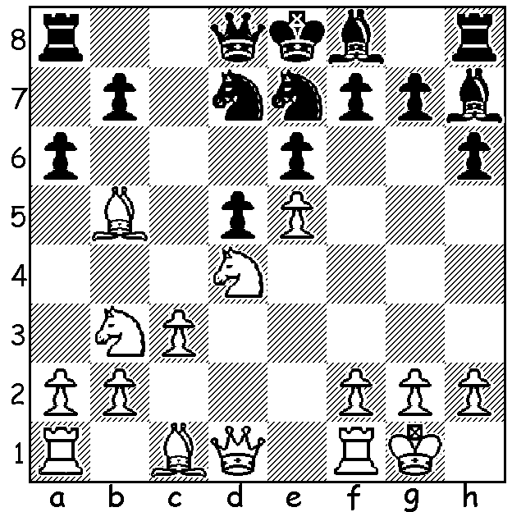

Benjamin Bok – Tim Rogers
(London FIDE Open 2015):
Black’s 1…a6? (1…Rc8 should
be played) is met by a surprise
refutation – at least to the victim
(5/6 moves):

In describing an event such as the London Chess Classic with the best players in the world competing, it is possible to forget that such a high ranked tournament may be only a small part of the total picture. Played at the Olympia Exhibition Centre which can cater for up to 10,000, the London Chess Classic provided competitions for many more chess enthusiasts than the top ten GMs. There were a FIDE Open with 247 players including 28 GMs, won by young Netherlander Benjamin Bok, weekend and weekday events, a Super Rapidplay with 365 players won by Luke McShane as well as the English Junior Rapidplay Championship. Of particular appeal were the semi-finals and final of the British Knockout Championship which came close to providing a fairy tale ending with Nick Pert, who only gained entry after Nigel Short withdrew, reaching the final. Pert played with a refreshing aggression but was unable to overcome former British champion David Howell, losing the six game final 2-4. Other activities included Simultaneous Displays in which three leading British Grandmasters, Luke McShane, Jon Nunn and Jon Speelman, each took on 20 to 30 opponents simultaneously, the Pro Biz Cup in which business leaders were paired with the Classic GMs, and Schools Coaching and Tournaments which were limited to 400 and completely booked out each day. Here’s Nick Pert’s exciting win against the current British champion on the way to the finals:
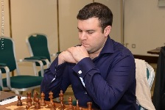
Jonathan Hawkins – Nick Pert
2015 British Knockout Championship
Reti Gambit, Advance Defence
1.Nf3 d5 2.c4 d4
3.g3 Nc6 4.Bg2 e5
5.0-0 e4 6.Ne1 h5
7.Bxe4 Bh3 8.Qb3 Qc8
9.Qb5 Ne7 10.Ng2 Qd7
11.Qxb7 Rb8 12.Qa6 f5 Nick Pert
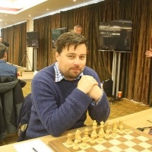
13.Bf3 d3 14.Re1 Nd4
15.Nf4 Bg4 16.Qxa7 Rd8
17.Bxg4 hxg4 18.Nxd3 Qd6(a)
19.Nc3 Qh6 20.Qa4+ c6
21.h4 g5 22.Nb4?(b) gxh
23.d3 Qh7 24.Ncd5 Kf7
25.Bf4 hxg 26.fxg cxd5(c)
27.Kf2 Qh2+ 28.Ke3 dxc4
29.Qa6 Rh6 30.Qxc4+ Re6+
31.Kd2 Nf3+ 32.Kc2 Rc8
33.Bc7 Nxe1+(d)
Jonathan Hawkins

a) For his four pawns Black has excellent attacking chances.
b) White had to play 21.Kg2 - 21...gxh (21…f4 22.Nxf4! gxf4 23.d3 Ng6
24.Rh1) 22.Rh1 Qf6 23.Qd1 Ng6 24.Nf4.
c) There is a 7 move mate with 25…Nf3+.

d) And wins easily with his rook plus.

THE AUSTRALIAN CHAMPIONSHIP begins tomorrow in Melbourne.
Leading players include Max Illingworth, Vasily Papin (Russia), Anton
Smirnov, Bobby Cheng and Darryl Johansen. State champion, Yita Choong,
will be competing in the Championship while Australian Under 16 champion
Patrick Gong, Adam Kelly, Robin Shaw and Richard Lilly will be playing in
the Reserves.

SOLUTION: The unprotected d6 square allows 1.Nc5! axb5 2.Nxb7 and if
2…Qb6 3.Nd6+ Kd8 4.Nxf7+ Kc7 (4…Ke8 5.Nd6+ Kd8 6.Nxe6#) 5.Nxh8
and the knight will escape. David Howell

