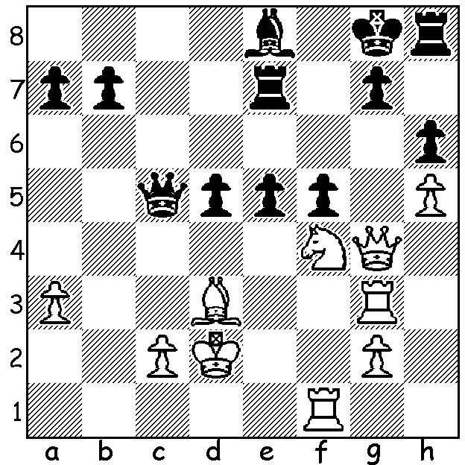

Vitiugov – Zhang Zhong (2015 Qatar Open):
With three pawns for a piece Black with 1…f5
has protected g7 and if 2.Qxf5 exf4 recovers
the piece. However White has a devastating
alternative which causes the utter collapse of
Black’s defences:

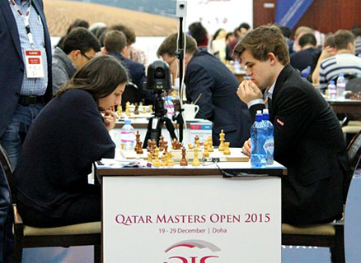
An Open tournament is very often a more interesting
event to follow than a round robin (all play all). There
are likely to be more spectacular games, much fewer
draws and chances of big upsets, particularly in the early
rounds where players of widely different ratings meet.
The Qatar Open in Doha has 76 Grandmasters among
the 132 competitors, headed by world champion Magnus
Carlsen, who certainly received a shock in Rd 1 when
paired against the Georgian Women’s champion Nino
Batsiashvili, rated 336 points below him, with their game
drawn after 56 moves with a knight & pawn each. However
the biggest upset was the loss by GM Pavel Tregubov who
lost to a 12 year old unrated Iranian Firouzja Alireza. A
number of the world’s top females are playing including
number 1 Hou Yifan who had a spectacular win in Rd 5. Batsiashvili v Carlsen

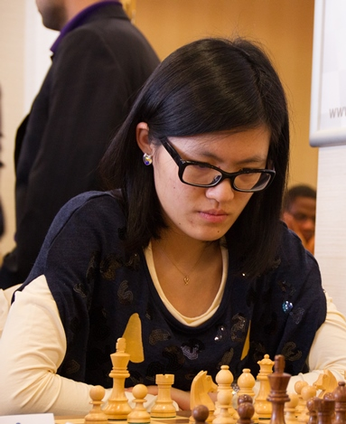
HOU YIFAN - BORIS ESEN
2015 Qatar Open, Rd 5
Sicilian, Najdorf Variation
1.e4 c5 2.Nf3 d6 3.d4 cxd
4.Nxd4 Nf6 5.Nc3 a6 6.h3 e6
7.g4 Nfd7 8.g5 b5 9.a3 Bb7
10.Be3 Nc6 11.h4 Be7 12.Qd2 0-0
13.0-0-0 Rc8 14.Kb1 Nde5 15.Nxc6 Nxc6
16.h5 b4 17.axb Nxb4 18.h6 gxh(a)
19.Qa5 Bd3 20.Bd3 Rc7 21.Rdh1 Rfc8
22.Bb6!!(b) Qxb6 23.Rxh7 Nxd3 24.Qxd3 Rxc3
25.Rh8+ Kg7 26.R8h7+ Kg8 27.Rh8+ Kg7
28.R1h7+ Kg6 29.Qd1 Bxe4 30.Qh5+ Kf5
31.g6+ Bg5?(c) 32.Rxf7+ Ke5 33.Qxg5+ Bf5
34.f4+ Ke4 35.Qg2+ Kxf4 36.Rh4+ Ke5
37.Qh2+ Kd5 38.Qd2+ Bd3(d) 39.Qg2+ Ke5
40.Qg3+ Kd5 41.Qf3+ Kc5 42.cxd3 Qb5
43.Qe3+ Kc6 44.Qe4+ resigns Hou Yifan

a) Not 18…g6 as 19.Qd4 wins the loose knight on b4.
b) Fantastic! Sacrificing a bishop to slow Black’s attack by deflecting the queen from the a file.
c) Losing – 31…Kf4 and White has nothing better than drawing with 32.Qh2+ Kf3 33.Qh1+ Kf4 35.Qh2 Kf3.
d) Black consistently plays the best possible defence but after the error on move 31 cannot save the game. Here 38…Rd3 was marginally better but after 39.cxd3 Qg1+ 40.Ka2 Qxg6 41.Rd7 White maintains a winning position.

AUSTRALIAN CHAMPIONSHIP: After four round overseas player Kan Izzat leads with 4/4, with young Australians Karl Zelesco and a former champion Bobby Cheng both on 3.5. WA champion Yita Chong is on 1.5. In the Reserves WA’s Patrick Gong, Adam Kelly (both 3.5) and George Carolin-Unkovich (3) are all in contention for top places.

SOLUTION: 2.Ne6!! and Black resigns: if 2...fxg4 3.Rf8#; if 2…Rxe6 3.Qxg7#: after 2…Qa5+ 3.Kd1 White threatens 4.Qxg7+! Rxg7 5.Rxg7# and if 3…g5 4.Qxf5 leaves Black helpless.

