Carlsen – Yu Yangi (2015 Qatar Open play-off):
in the first 5 min blitz Carlsen finds a combination which leaves his opponent helpless:
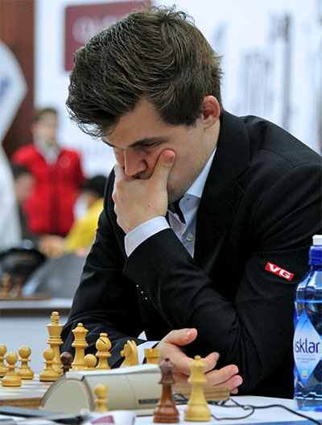

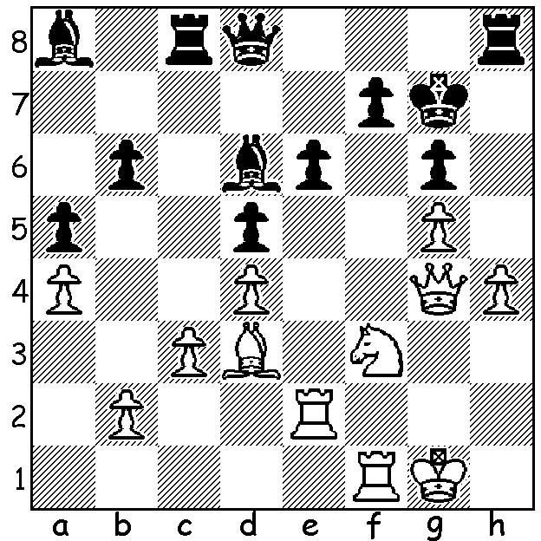

Magnus Carlsen quickly recovered from his Rd 1 draw against Georgian women’s champion Nino Batsiashvili
to peel off five successive wins and take the lead in the Qatar Open last month. He then played three successive draws including a final round game against former world champion Vladimir Kramnik. His final draw allowed last year’s winner Yu Yangi to draw level after a 77 move victory against Wesley So, winning the endgame of rook and four pawns against rook and knight. However in the blitz play-off (5 mins + 3 sec increments) Yu was no match for the world champion, losing 0-2. It is thought Carlsen’s appearance was the first in an open by a reigning world champion since Boris Spassky in Vancouver 1971. Final leading scores: Carlsen (Norway), Yu Yangi (China) 7/9, Russians Kramnik, Sergey Karjakin, Sana Sjugirov, veteran Vassily Ivanchuk (Ukraine), Ni Hua (China) 6.5. Prizes totalled US$130,000 with Carlsen pocketing $27,000. There were prizes for the top 20, top woman, top Arab, top junior and rating prizes.
Fellow Norwegian Johan-Sebastian Christiansen only finished with 2.5 but he did produce the most spectacular combination of the event. Then, with Christiansen the exchange up in an endgame, his Russian opponent managed to win the pawn race to queen. See how the game unfolded and concluded:

Johan-Sebastian Christiansen – Jouri Goriatchkin
2015 Qatar Open, Rd 9
Catalan Opening
1.c4 e6 2.g3 d5 3.Bg2 Nf6
4.Nf3 Be7 5.d4 0-0 6.0-0 dxc
7.Qc2 a6 8.a4 Nbd7 9.Nbd2 Nb6
10.Rd1 Nfd5 11.a5 Nb4 12.Qb1 N6d5
13.Nxc4 b5 14.axb6 cxb 15.e4 Nf6
16.Ng5 g6 17.e5 Nfd5 18.Ne4 f5
19.exf6 Bxf6 20.Bh6 Bg7 21.Bxg7 Kxg7
22.h4 Ra7 23.h5 gxh 24.Ne5 Rc7
25.Rd2 Bd7 26.Qd1 Be8 27.Rc1 Rxc1
28.Qxc1 Bg6 29.Re2 Bf5 30.Ng5 h6
31.Ngf7!! Rxf7(a) 32.Qxh6+!!(b) Kxh6(c) 33.Nxf7+ Kg6
34.Nxd8 Kf6 35.Be4 Bxe4 36.Rxe4 Nc7
37.Re5 Nd3 38.Rxh5 Kg6 39.g4 Nxb2(d)
40.Nc6 a5 41.Ne5+ Kg7 42.Rg5+ Kh7
43.Nd7 Nc4 44.f4 Nd5 45.Nf8+ Kh8
46.Nxe6 Nce3 47.Kf2 a4 48.Kf3 a3
49.Rg7 Nc4 50.Ra7 Na5 51.g5(e) a2
52.f5 Nf6(f). 53.gxf6 a1=Q 54.Ra8+ Kh7
55.Ng5+ resigns(g)

a) The knight must be taken but doesn’t this just lose 2 knights for a rook?
b) The brilliant idea behind the sacrifice.
c) Perhaps Black could decline the pseudo-queen sacrifice with 32…Kg8 - 33.Nxf7 Kxf7 34.Qxh5+ when White has R & p for 2N.

d) Black secures distant united passed pawns and the race is on to queen.
e) 53.Nc5! stops the pawn but White plans a mate.
f) If 52…a1=Q 53.Ra8+ Kh7 54.g6+ Kh6 55.Rh8#.
g) 55…Kh6 56.Nf7+ Kh5/7 57.Rh8#.

The 2016 AUSTRALIAN CHAMPIONSHIP was won by Kanan Izzat
from Azerbaijan with 8.5/11. Second and Australian champion was
Bobby Cheng (8). In the P we have cause for
celebration with local schoolboy and 2015 Australian Under 16 champion
Patrick Gong winning the title with the excellent score of 9.5/11 (+8 =3).
Other WA scores: Championship - Yita Choong 5: Reserves – Adam Kelly 7,
George Carolin-Unkovich 5.5, Richard Lilly 5, Graeme Mc Quilkin 4.5.

SOLUTION: 1.Rxe6! fxe6 2.Qxe6 Qe8 (Black must defend against
3.Qxg6+) 3.Qxd6 White has only a knight & pawn for the rook but
Black is in a straitjacket: play continued 3…Rc6 4.Qe5+ Qxe5 5.Nxe5
Rxh4 (there is nothing better) 6.Rf7+ Kg8 7.Ra7 Rc8 8.Bxg6 (the rook Patrick Gong
on h4 is lost) 8…Bc6 9.Bf7+ Kf8 10.Ng6+ resigns at 2015 Australian Junior

