Spectacular sacrifices enable White to mate in 3:

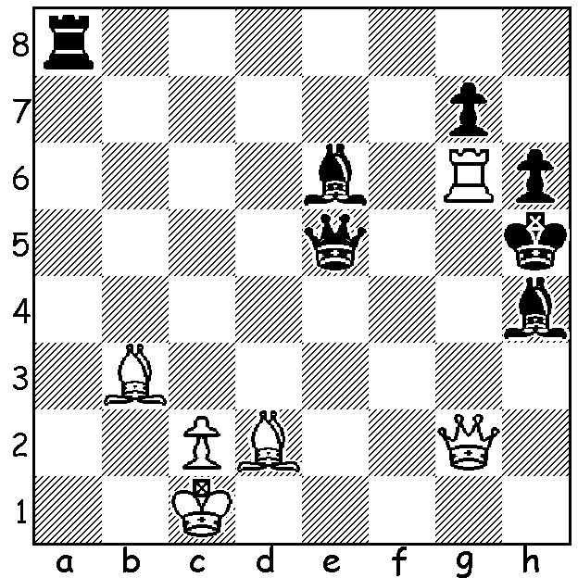

Breaking down the 34 contestants in the Australian Championship into age groups shows a trend which appears very contrary to the public view of chess. Eleven were teenagers, 13 were in their twenties, five were 30 – 49 and 5 were 50 – 69. Furthermore the top three places (1st Kanan Izzat 19, 2nd Bobby Cheng 17, 3rd Karl Zelesco 16) were all teenagers, as were two of the four =4th (Anton Smirnov 13, Justin Tan 18). Add to this the winner of the Reserves Championship WA’s Patrick Gong 16 and we see chess is very much a young person’s game.
WA champion Yita Choong, who started making an impression in Australian chess circles at the Queenstown Classic, NZ, at the age of 12, had many hard-fought games in his score of 5/11 with the most spectacular being his short Round 6 encounter with Eugene Schon which was followed live throughout the world:

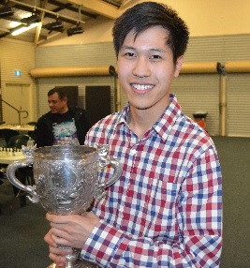
YITA CHOONG - EUGENE SCHON
2016 Australian Championship, Rd 6
Quenns Gambit, Semi-Slav, Anti-Meran
1.d4 Nf6 2.Nf3 d5
3.c4 c6 4.Nc3 e6
5.Bg5 dxc 6.e4 b5
7.e5 h6 8.Bh4 g5
9.Nxg5 hxg5 10.Bxg5 Nbd7
11.g3 Bb7 12.Bg2 Qb6
13.exf6 c5 14.d5 0-0-0
15.0-0 b4 16.Rb1(a) Qa6(b)
17.dxe Bxg2 18.e7! Bxf1
19.Qd5(c) Bxe7(d) 20.fxe7 Bd3
21.Ne4(e) Bxb1 22.Nd6+ Kc7
23.Bf4 Kb6 24.Nxc4+(f) Kb5
25.Nd6+(g) Kb6 26.Nc4+ Kb5
27.Nd6+ DRAW

a) The main line is 16.Na4 Qb5 17.a3 exd 18.axb d4 19.Bxb7+ Kxb7 20.Nxc5+ Nxc5 21.Qf3+ Ne4 22.Qxe4 Qd5 23.Qxd5 Rxd5 24.h4 Bxb4 with some advantage to White.
b) 16…Bh6 17.Na4 Qb5 18.Bxh6 Rxh6 19.Nc3 bxc3 20.bxc Qa6 21.dxe Bxg2 22.exd7+ Rxd7 23.Qc1 Rxh2 24.Kxh2 25.Bxf1 26.Qxf1 Qxf6 is slightly better for White.
c) Both players are well prepared for the game, being very familiar with these moves and consequently using up no time on their clocks. Now White has his first serious thought – 5 mins.
d) 19…Bh6! 20.Qa1+ (20.exd8=Q+ Rxd8 21.Bxh6 Bd3 22.Qa8+ Nb8 23.Re1 bxc3 24.Bf4 Qb6 25.bxc3 Bf5 26.Bxb8 Qxb8 27.Qc6+ Qc7 28.Qa8+ draw) 20…Nb8 21.exd8+ Rxd8 22.Bxh6 Bd3 23.Re1 bxc3 24. bxc3 Bg6 25.Re7 Rd1+ 26.Kg2 Qc6+ 27.Qxc6+ Nxc6 28.Rc7+ Kd8 29.f3 Rd2+! 30.Kh3 Nb8 31.Rxf7! Bxf7 32.Bxd2 with an interesting ending.
e) Now a 10 min think. White might try 21.exd8=Q+ first – 21…Rxd8 22.Ne4 Bxb1 23.Nd6+ Kc7 24.Bf4 Kb6 25.Nxc4+ Kb5 26.Nd6+ Kb6 27.a4! bxa3 28.Nc4+ Qxc4 29.Qxc4 a2 30.Qa4 with a difficult position to play for both sides.
f) Now 17 mins thought. Again dxe8=Q+ seems appealing - 24…Rxd8 25.Nxc4+ Kb5 26.Nd6+ Kb6 27.a4! bxa3 28.bxa3 Bd3 29.Nxf7 Rc8 30.a4 Bc4 31.a5+ Kxa5 32.Qxd7 Kb6 33.Qd6+ Rc6 34.Qb8+ Qb7 35.Qxb7+ Kxb7 36.Nd8+ Kb6 37.Nxc6 Kxc6 38.h4 with winning chances.
g) Searching for a win White uses up over 50 mins, leaving himself seconds on the clock. Finding no clear win he takes the draw by repetition.

SOLUTION: 1.Qg4+!! (a deflection sacrifice) 1…Bxg4 2.Rxh6+! (now a clearance sacrifice) 2…gxh6 3.Bf7#.

