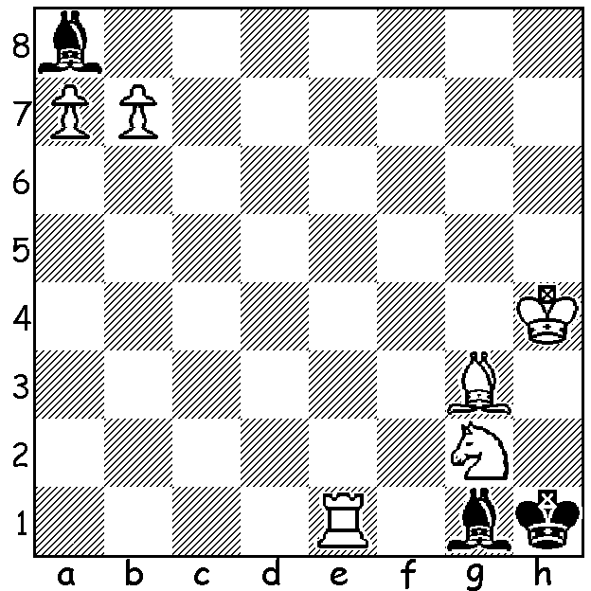

Here’s an early problem by
the legendary Sam Loyd:
White to play and mate in 3:

In Chess, perhaps more than in any other sport, we are constantly seeing generational change with developing juniors forging ahead of established and highly thought of mature adults. Generational change was apparent when Magnus Carlsen became number 1 in rankings at the age of 19 and at 23 took the world title from Viswanathan Anand who was over 40. Similarly it was the brilliant teenage Hou Yifan who swept to the top in women’s chess. Looking through results and games of this year’s Australian Championship I was struck by the success of the younger players who dominated their more senior rivals. One such player is 15 year old Karl Zelesco and in the following game he outplays 51 year old Stephen Solomon. Solomon was Australian Junior champion in 1980 and has represented Australia at 10 Olympiads. He tied first in the 1994 Australian Championship, losing a playoff to Darryl Johansen, and won the title in 2008.

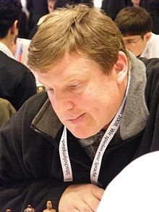
Stephen Solomon - Karl Zelesco
2016 Australian Championship
French Tarrasch, Guimard Variation
1.e4 e6 2.d4 d5
3.Nd2 Nc6 4.Ngf3 Nf6
5.e5 Nd7 6.Nb3 a5
7.a4 Be7 8.c3 0-0
9.Bd3 b6 10.h4 f5
11.exf6 Nxf6 12.Qe2 Bd6
13.Ne5 Ne7(a) 14.Bg5 c5
15.Nd2 cxd 16.cxd Nf5
17.Ndf3 Bb4+ 18.Kf1 Bb7
19.h5 Qd6 20.g4 Ne7
21.h6 g6 22.Kg2 Ne4
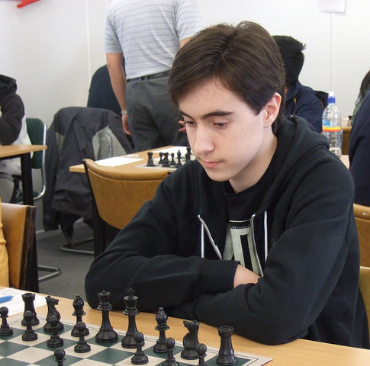
23.Bh4 Rf4 24.Bg3 Nxg3
25.fxg3 Re4! 26.Qf2 Nc6(b)
27.Rac1(c) Nxd4 28.Nf7 Qe7
29.Nxd4 Bc5! 30.Bxe4 dxe4
31.Kh3 Rf8 32.Qf4 Rxf7
33.Qb8+ Rf8 34.Qe5 Bd5
35.Nb5 e3 36.Rhf1 Rf2
37.Qb8+ Qf8 38.Qxf8+ Kxf8
39.Rxf2+ exf2 40.Nc7 Be3
41.Ra1 Bc4 42.Kg2 e5
43.Nb5 e4 44.Nc3 Bc5
45.Nxe4 Bd5 46.Kf3 g5!
47.Rd1 Ke7! 48.Rc1 Ke6
49.Rd1 Bc6 White resigns(d)

a) An interesting alternative was 13…Bxe5 14.dxe5 Ne4! 15.Bxe4 dxe4 16.Qxe4 when White is behind in development and has weaknesses on e5, h4 and b3.
b) Necessary was 26…Rf8.
c) White misses his opportunity – 27.Nxg6! hxg6 28.h7+ Kg7 29.Bxe4 dxe4 30.Ng5 Qe7 (30…Rf8? h8=Q+!) 31.Raf1 Ba6 32.Qf7+ Qxf7 33.Rxf7+ Kh8 34.Rd7 Rf8 35.Nxe6 Rc8 36.Nf4 winning.
d) The knight is lost after …Ke5.

SOLUTION: 1.bxa8=N! Kxg2 (now Black’s bishop threatens the blocked a pawn) 2.Nb6! (protecting the pawn) 2…Bxb6 or any other move 3.a8=Q or B#.

